Name: ________________________________ Date: ________________________
Integers – Real World Applications Part I
Classwork

Example 1: Take it to the Bank
For Tim’s 13th birthday, he received $150 in cash from his mom. His dad took him to the bank to open a savings account. Tim gave the cash to the banker to deposit into the account. The banker credited Tim’s new account $150 and gave Tim a receipt. One week later, Tim deposited another $25 that he had earned as allowance. The next month, Tim asked his dad for permission to withdraw $35 to buy a new video game. Tim’s dad explained that the bank would charge $5 for each withdrawal from the savings account and that each withdrawal and charge results in a debit to the account.

Directions: Read Example 1 silently. In the first column, write down any words and definitions you know. In the second column, write down any words you do not know.

Words I Already Know: | Words I Want to Know: | Words I Learned:

In the third column, write down any new words and definitions that you learn during the discussion.

Exercises 1–2
1. Read Example 1 again. With your partner, number the events in the story problem. Write the number above each sentence to show the order of the events.

For Tim’s 13th birthday, he received $150 in cash from his mom. His dad took him to the bank to open a savings account. Tim gave the cash to the banker to deposit into the account. The banker credited Tim’s new account $150 and gave Tim a receipt. One week later, Tim deposited another $25 that he had earned as allowance. The next month, Tim asked his dad for permission to withdraw $35 to buy a new video game. Tim’s dad explained that the bank would charge $5 for each withdrawal from the savings account and that each withdrawal and charge results in a debit to the account.

2. Write each individual description below as an integer. Model the integer on the number line using an appropriate scale.

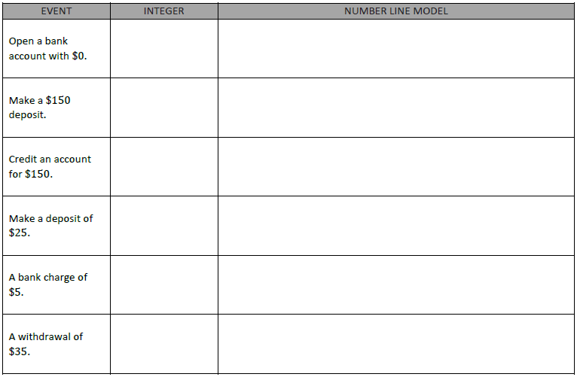

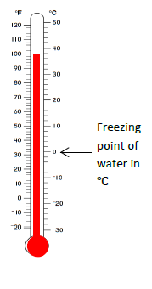
Example 2: How Hot, How Cold?
Temperature is commonly measured using one of two scales, Celsius or Fahrenheit. In the United States the Fahrenheit system continues to be the accepted standard for non-scientific use. All other countries have adopted Celsius as the primary scale in use. The thermometer shows how both scales are related.

a. The boiling point of water is 100℃. Where is 100 degrees Celsius located on the thermometer to the right?

b. On a vertical number line, describe the position of the integer that represents 100℃.

c. Write each temperature as an integer.

i. The temperature shown to the right in ℉:

ii. The temperature shown to the right in ℃:

iii. Freezing point of water in Celsius:

d. If someone tells you your body temperature is 98.6°, what scale are they using? How do you know?

e. Does the temperature 0 degrees mean the same thing on both scales?

Exercises 3–5
3. Write each word under the appropriate column, “Positive Number” or “Negative Number”.

Gain Loss Deposit Credit Debit Charge Below Zero Withdraw Owe Receive

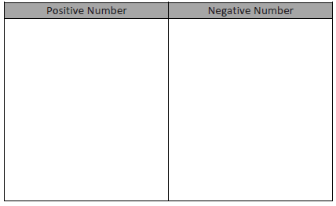

4. Write an integer to represent each of the following situations:

a. A company loses $345,000 in 2011. ________________________

b. You earned $25 for dog sitting ________________________

c. Jacob owes his dad $5. ________________________

d. The temperature at the sun’s surface is about 5,600℃. ________________________

e. The temperature outside is 4 degrees below zero. ________________________

f. A football player lost 10 yards when he was tackled. ________________________

5. Describe a situation that can be modeled by the integer −15. Explain what zero represents in the situation.

Problem Set
1. Express each situation as an integer in the space provided.
a. A gain of 56 points in a game. _________________

b. A fee charged of $2.50. _________________

c. A temperature of 32 degrees below zero. _________________

d. A 56 yard loss. _________________

e. The freezing point of water in Celsius. _________________

f. A $12,500 deposit. _________________

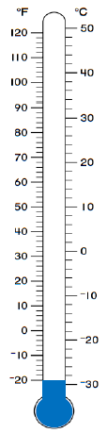
For questions 2–5, use the thermometer to the right.
2. Each sentence is stated incorrectly. Rewrite the sentence to correctly describe each situation.
a. The temperature is −10 degrees Fahrenheit below zero.

b. The temperature is −22 degrees Celsius below zero.

3. Mark the integer on the thermometer that corresponds to the temperature given.
a. 70°F

b. 12℃

c. 110℉

d. −4℃

4. The boiling point of water is 212°F. Can this thermometer be used to record the temperature of a boiling pot of water? Explain.

5. Kaylon shaded the thermometer to represent a temperature of 20 degrees below zero Celsius as shown in the diagram. Is she correct? Why or why not? If necessary, describe how you would fix Kaylon’s shading.

Name: ________________________________ Date: ________________________
Integers – Real World Applications Part I
Exit Ticket
1. Write a story problem that includes both integers −8 and 12.

2. What does zero represent in your story problem?

3. Choose an appropriate scale to graph both integers on the vertical number line.
Label the scale.

4. Graph both points on the vertical number line.

