Name: ________________________________ Date: ________________________
From Equations to Inequalities – Part II
Classwork
Example 1
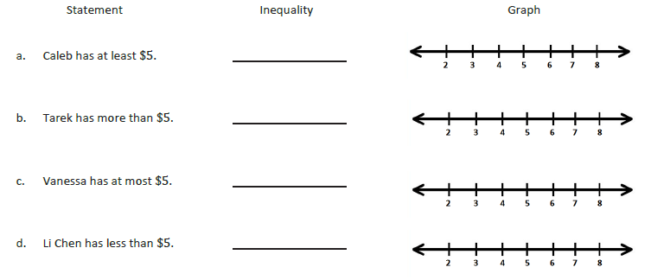
Example 2
Kelly works for Quick Oil Change. If customers have to wait longer than 20 minutes for the oil change the company does not charge for the service. The fastest oil change that Kelly has ever done took 6 minutes. Show the possible customer wait times in which the company charges the customer.

Example 3
Gurnaz has been mowing lawns to save money for a concert. Gurnaz will need to work for at least six hours to save enough money but he must work less than 16 hours this week. Write an inequality to represent this situation, and then graph the solution.

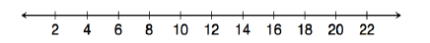

Exercises
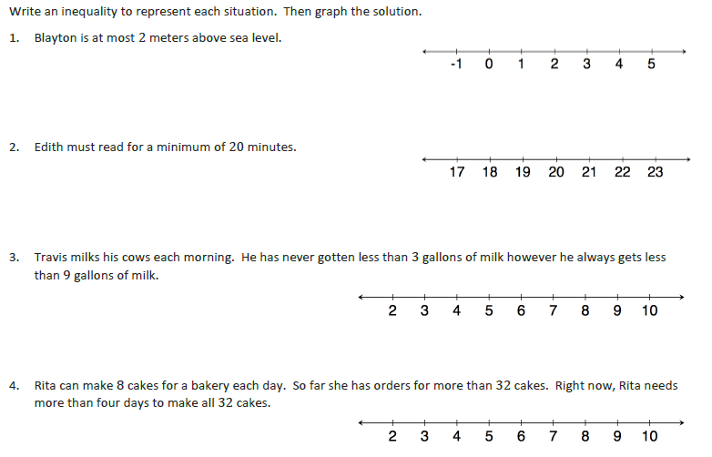
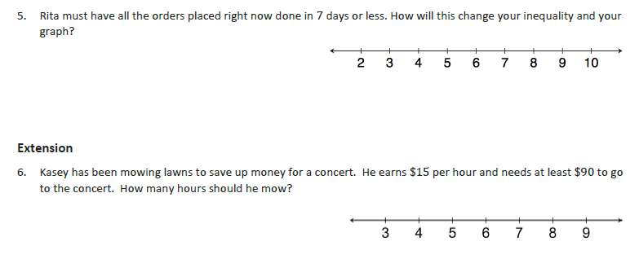
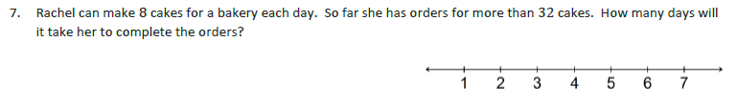
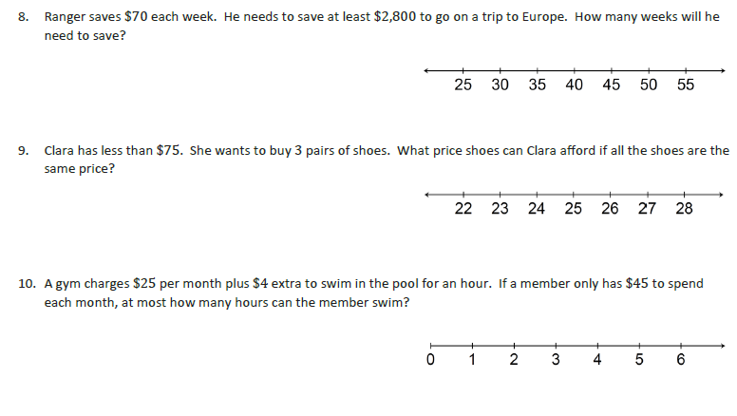
Problem Set
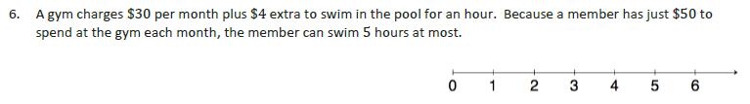
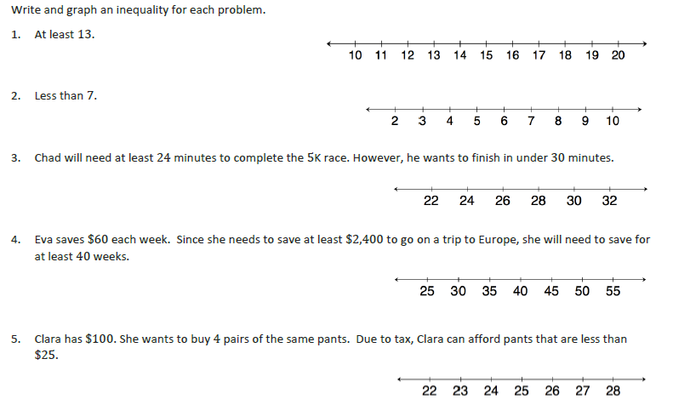

Name: ________________________________ Date: ________________________
From Equations to Inequalities – Part I

Exit Ticket
