Name: ________________________________ Date: ________________________
Percent Applications – Part II
Classwork

Example 1
If an item is discounted 20%, the sale price is what percent of the original price?

If the original price of the item is $400, how much is the dollar amount of the discount?

How much is the sale price?

Exercise 1
The following items were bought on sale. Complete the missing information in the table.
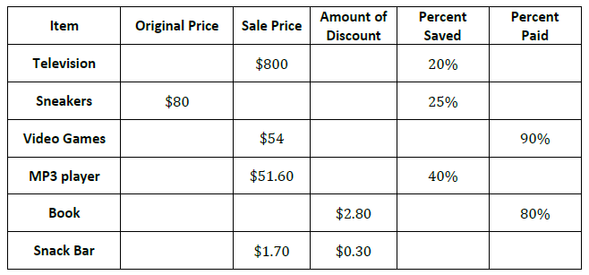

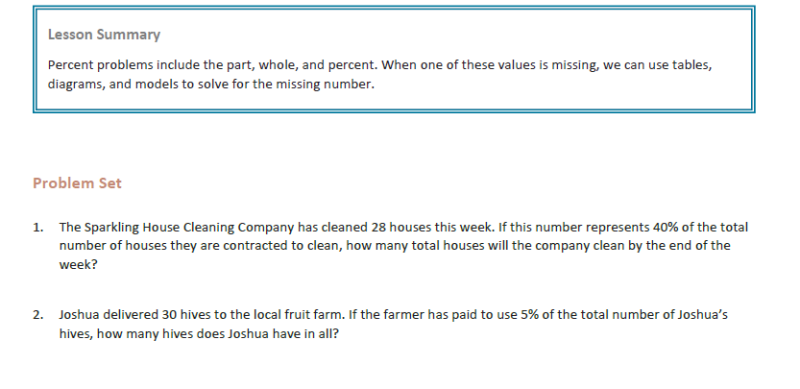

Name: ________________________________ Date: ________________________
Percent Applications – Part II

Exit Ticket

1. Write one problem using a dollar amount of $420 and a percent of 40%. Provide the solution to your problem.

2. The sale price of an item is $160 after a 20% discount. What was the original price of the item?

