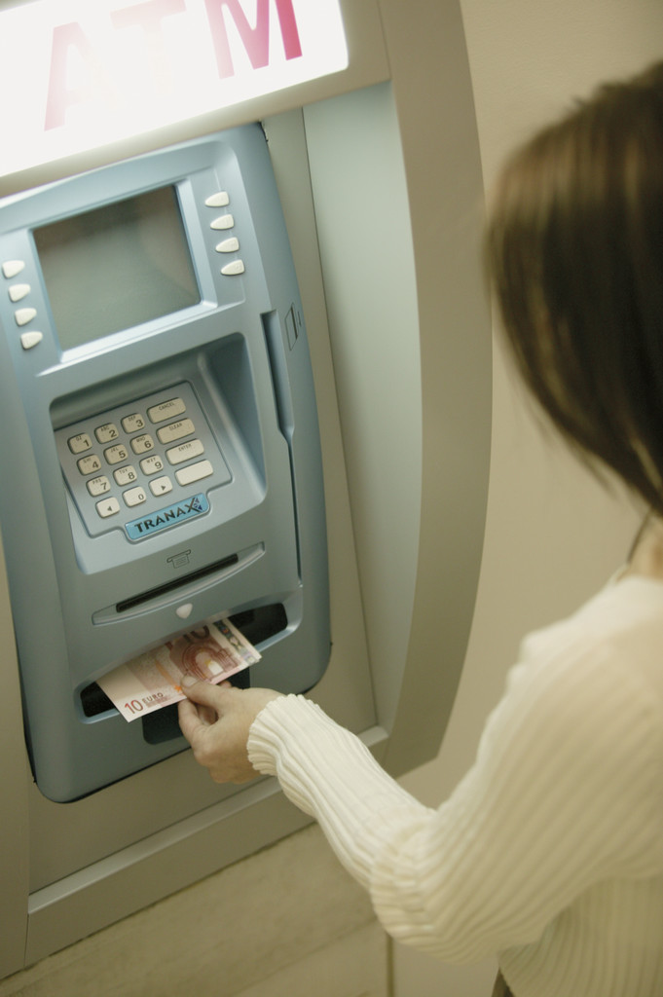

Authors:

Michelle Stephan, Ed.D.

Michelle.stephan@uncc.edu

George McManus

George_McManus@scps.k12.fl.us

Jennifer Smith

Jenniferd_Smith@scps.k12.fl.us

Ashley Dickey

Ashley_Dickey@scps.k12.fl.us

Contributors: This unit could not have been written without the support of our Principal Robin Dehlinger, Assistant Principal Tonya Fennell and the parents and students at Lawton Chiles Middle School.

*Common Core State Standards*

The intent of this instructional sequence is to teach integer addition and subtraction for understanding and in a manner consistent with the Common Core State Standards. Teaching in a standards-based environment means not only attending to the content but also the eight mathematical practices outlines in the Standards:

1. *Make sense of problems and persevere in solving them*
2. *Reason abstractly and quantitatively*
3. *Construct viable arguments and critique the reasoning of others*
4. *Model with mathematics*
5. *Use appropriate tools strategically*
6. *Attend to precision*
7. *Look for and make use of structure*
8. *Look for and express regularity in repeated reasoning*

*Classroom environment*. To accomplish these practices with this instructional sequence it is important to establish a classroom environment in which students feel obligated to explain their reasoning, ask questions when they do not understand, critique and understand the reasoning of others, and use mistakes as sites for learning opportunities. It is also imperative that the teacher poses problems and encourages students to persevere in solving them. The role of the teacher in this environment is to listen to students as the work on problems, encourage them to persevere when stuck, and orchestrate productive whole class discussions in which the mathematical ideas of the sequence become public for debate. The teacher does not tell students how to solve the problems, but rather encourages them to work either independently or with each other until they have some type of solution, whether right or wrong.

*Modeling mathematics*. The instructional sequence was designed so that students are introduced to negative numbers within the realistic context of finance. Throughout the sequence, the tasks and their wording change to encourage students to create their own models for reasoning about integers. The problems are sequenced to help students move from the concrete, realistic context of working with net worth, debts and assets toward the more quantitative, abstract, symbolic operations. The tasks encourage students to observe patterns and structures to curtail their thinking into more efficient operations. A vertical number line is presented as a tool for students to use throughout the sequence as a means of organizing and modeling their integer work.

*Classroom Organization.* Typically the class period is organized in a Launch, Explore, Discussion (LED) cycle or several cycles. The teacher begins the class period by launching the task for the day, typically taking less than five minutes.

The ***launch*** may consist of a bellwork, followed by the teacher reminding students of their discussion yesterday and ending with introducing the problem(s) for the day.

There are minutes set aside for ***student exploration***, typically 5-20 minutes depending on the problem. We have found it helpful to allow for a few minutes of independent think-time followed by partner conversation, but any arrangement is fine. During explore time, the teacher’s role is NOT to help students who are stuck find an answer. In fact, if students do not have a way the teacher should encourage them to work with a partner. The teacher’s main role during explore time IS to collect data on the way students are solving the problem so that she can know how to lead the follow up discussion.

The class debriefs their work in a whole class ***discussion*** led by the teacher. Because the teacher has collected data on student reasoning, she knows who she will call on to present and in what order. Often times, the discussion session begins with the teacher listing all the different answers students have constructed to a problem on the board. She can then ask students to decide which answer or answers they believe are correct and then have the authors of those answers defend them. During this conversation the teacher is making sure that students are attempting to understand their classmate’s arguments, ask questions when they do not understand, critique the solution, determine whether they have a different way, and contribute when they have a more sophisticated or efficient method.

There are other formats that can be just as effective as the LED cycle and teachers must decide which teaching formats have been effective in their own practice.



LAUNCH

*Oprah Winfrey Net Worth*

When you come into school that morning, google Oprah Winfrey and Net Worth to find a site that lists the net worth of various celebrities. Show a few celebrities’ net worths and ask students what they think net worth means. Gather a few ideas, then ask students what things they think go into figuring out Oprah’s net worth. They may offer items such as cash, penthouse, OWN network, school in Africa, etc. Write these contributions on the left side of the board in a column. Rarely do students offer that she might have debts. Ask students if they think Oprah has debt and ask them to list things they think give her debt. Record these items on the right side of the board. When you have a fairly decent list of items in both categories, tell students that the things that Oprah owns are called assets. Put the term asset on the top of the column as its label along with “what she owns” in parentheses next to the term. Ask students if they know the word associated with the other column and label it debts (what you owe). Ask students to copy this in their notebooks. Tell students that both what you own and what you own are things that are considered when a person calculates their net worth. Do NOT tell them how to calculate it.

NOTES:

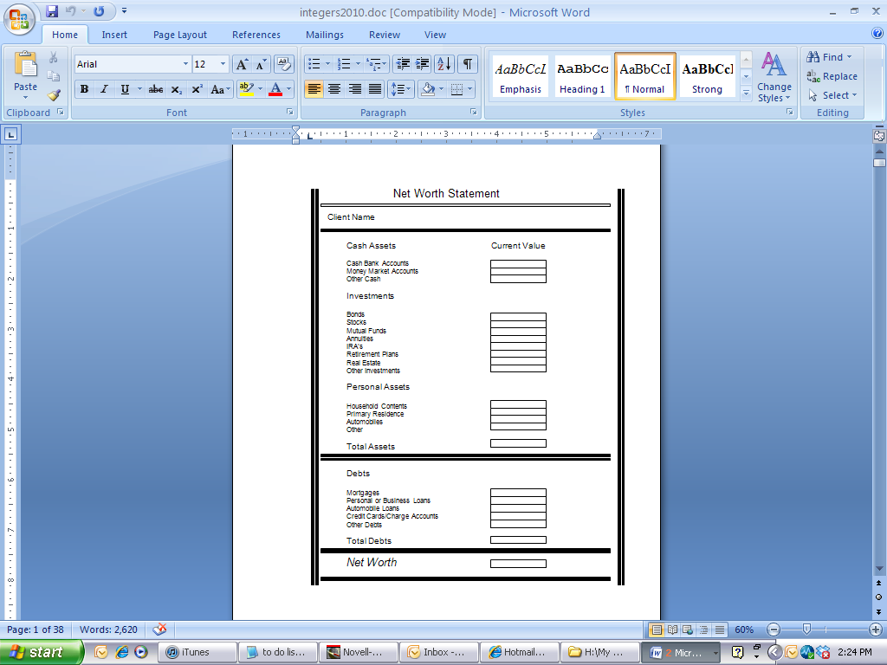

**Anticipated Student Thinking:**

**Big Mathematical Idea(s):** None

**Rationale:** Students get to know the finance context a bit more.

**Teacher Notes:**

**Anticipated Student Thinking:**

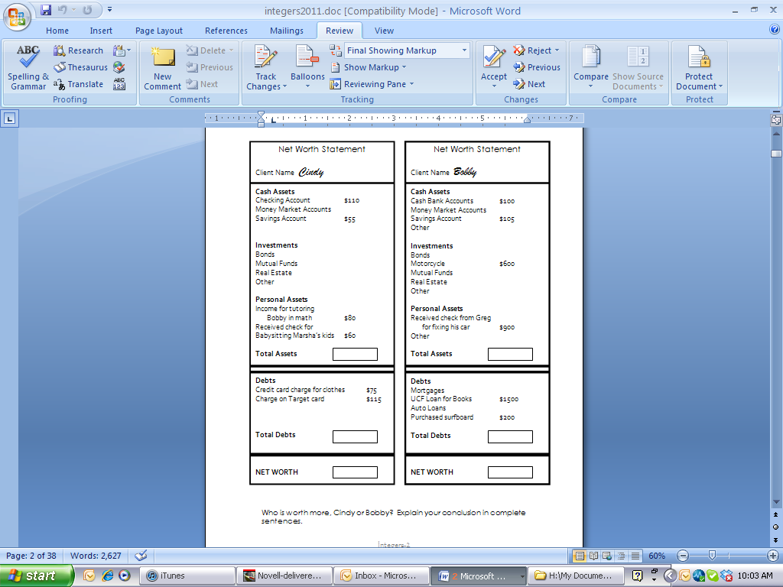

**Big Mathematical Idea(s):** Net worth as the combination of Total Assets and Total Debts

**Rationale:** How do students combine assets and debts to determine net worth?

**Teacher Notes:**

**Anticipated Student Thinking:**

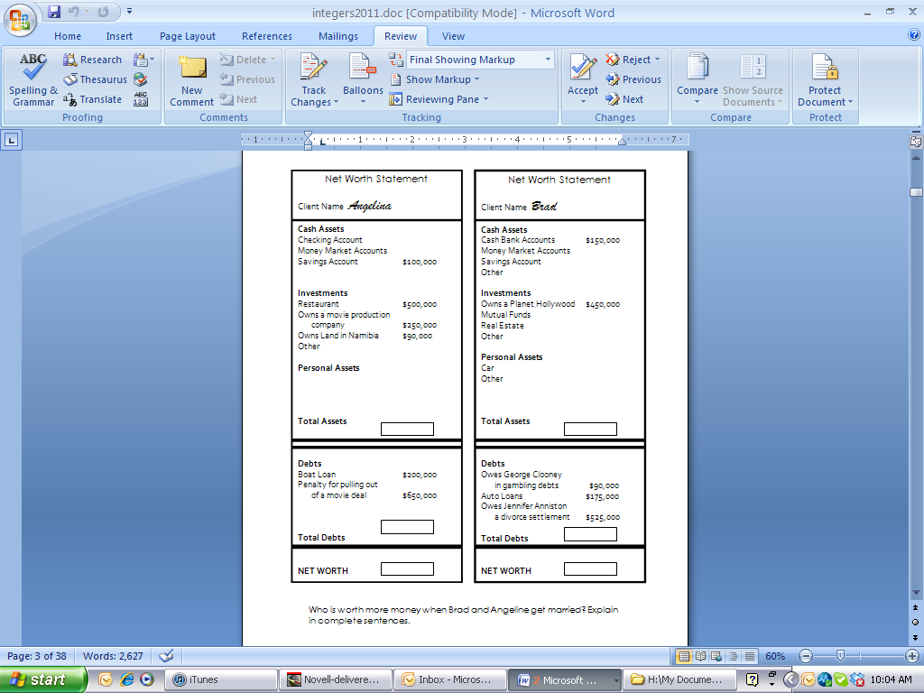

**Big Mathematical Idea(s):** Negative net worth as debts overwhelming assets; different algorithms for combining assets and debts

**Rationale:** How do students combine assets and debts to determine negative net worth?

**Possible Metaphors/Gestures:** Payoff idea

**Teacher Notes:**

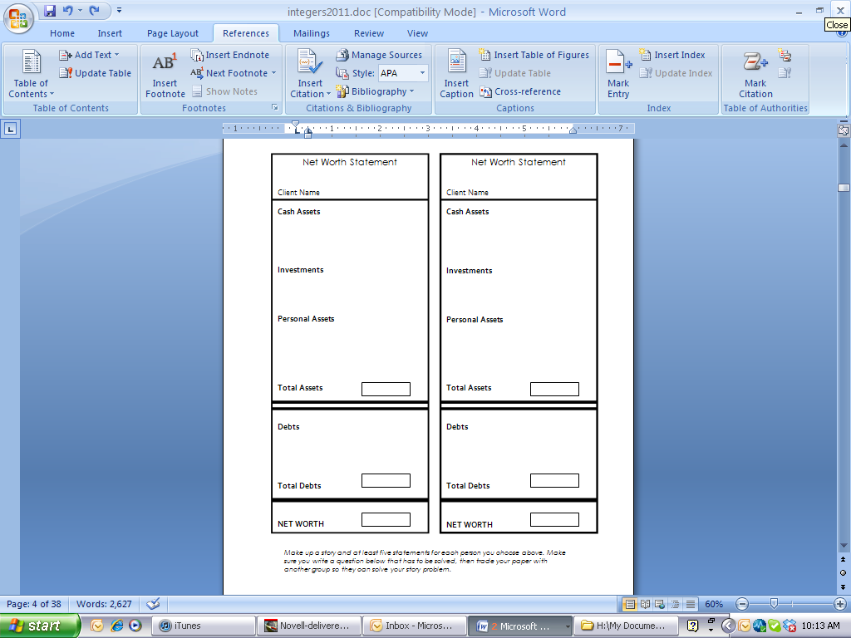

**Anticipated Student Thinking:**

**Big Mathematical Idea(s):** None

**Rationale:** Do students put real-world items in the right category of assets and debts?

**Possible Metaphors/Gestures:**

**Teacher Notes:**

**Anticipated Student Thinking:**

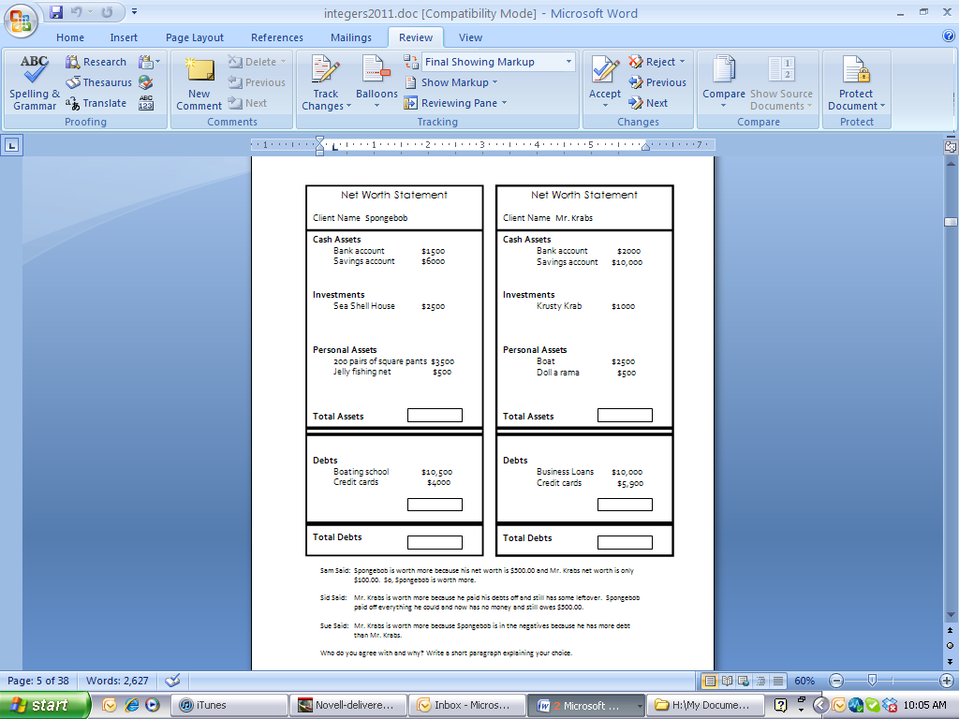

**Big Mathematical Idea(s):** Net worth as an abstract quantity composed of assets and debts

**Rationale:** Do students make net worth judgments based only upon total assets or total debts rather than net worth?

**Possible Metaphors/Gestures:** Pay off; up and down movement of arms

**Teacher Notes:**

**Anticipated Student Thinking:**

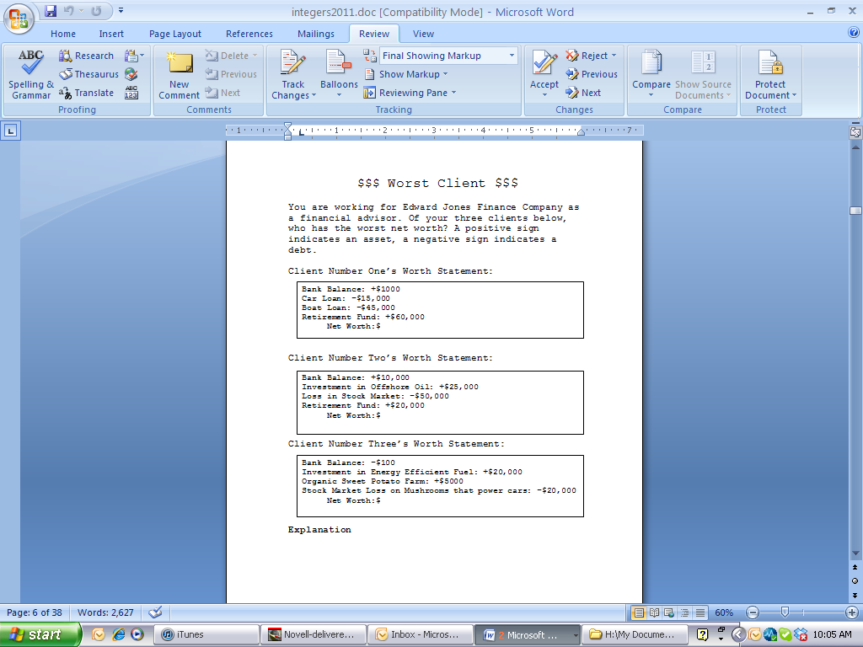

**Big Mathematical Idea(s):** Students’ strategies for finding net worth

**Rationale:** Movement towards more abstract symbols of + and –

**Possible Metaphors/Gestures:**

**Teacher Notes:**

**Anticipated Student Thinking:**

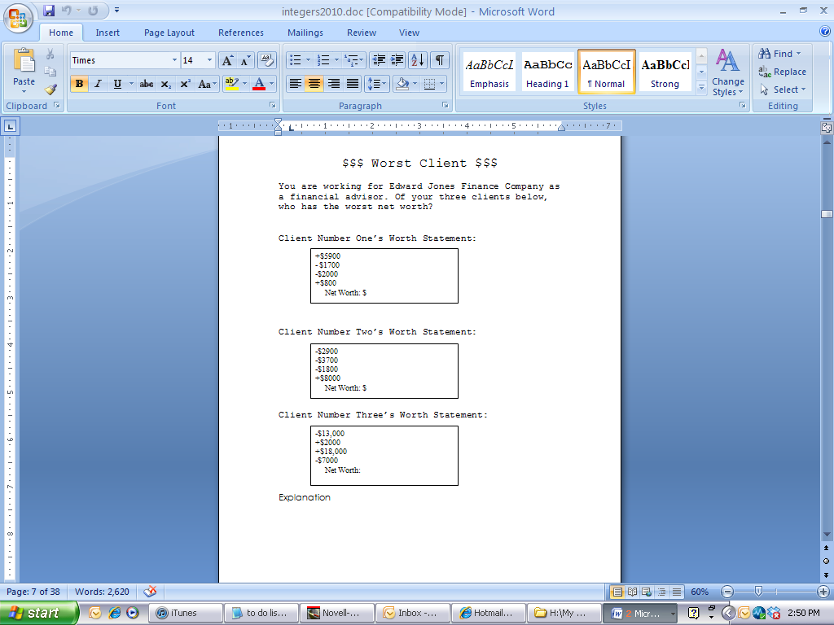

**Big Mathematical Idea(s):** Students’ strategies for finding net worth; negative net worth as debts overwhelming assets

**Rationale:** Which is worse, 0 or negative net worth?

**Possible Metaphors/Gestures:** pay off

**Teacher Notes:**

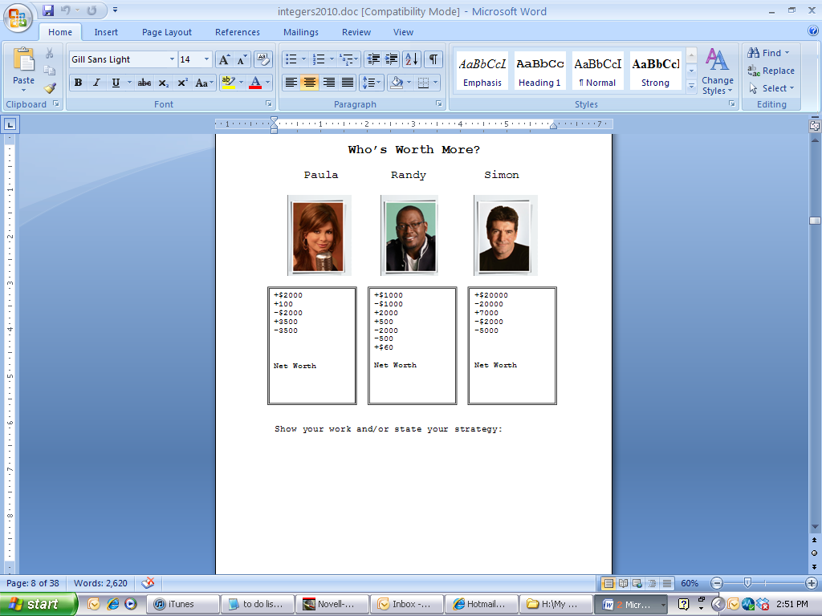

**Anticipated Student Thinking:**

**Big Mathematical Idea(s):** Finding net worth

**Rationale:**

**Possible vocabulary:** Additive inverse

**Possible Metaphors/Gestures:**

**Teacher Notes:**

**Anticipated Student Thinking:**

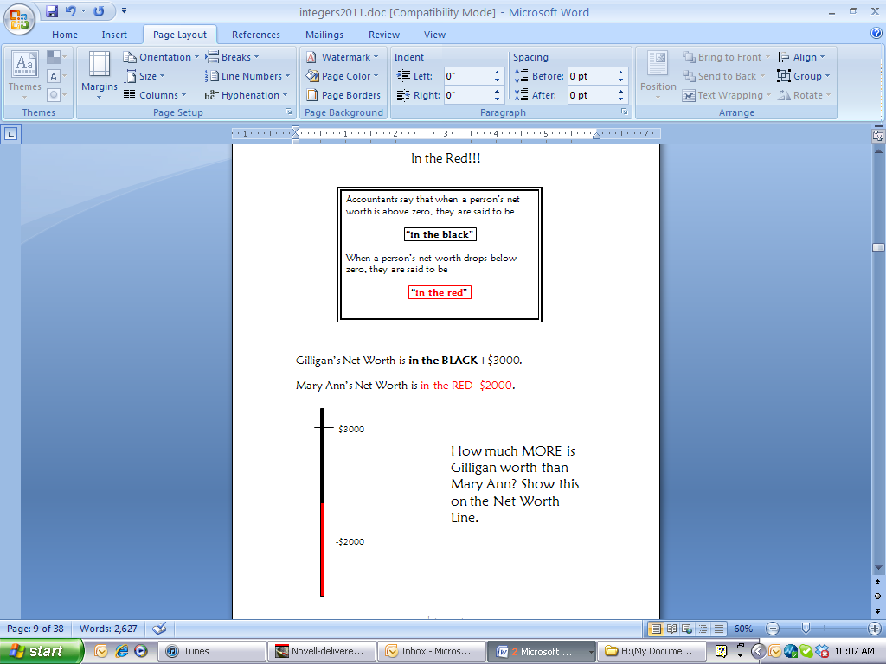

**Big Mathematical Idea(s):** Comparing net worth (no longer finding it); strategies for finding difference

**Rationale:** How do students structure the space between two integers? Introduction of vertical number line (VNL)

**Possible Metaphors/Gestures:** Payoff idea; Up and down movement with arms

**Teacher Notes:**

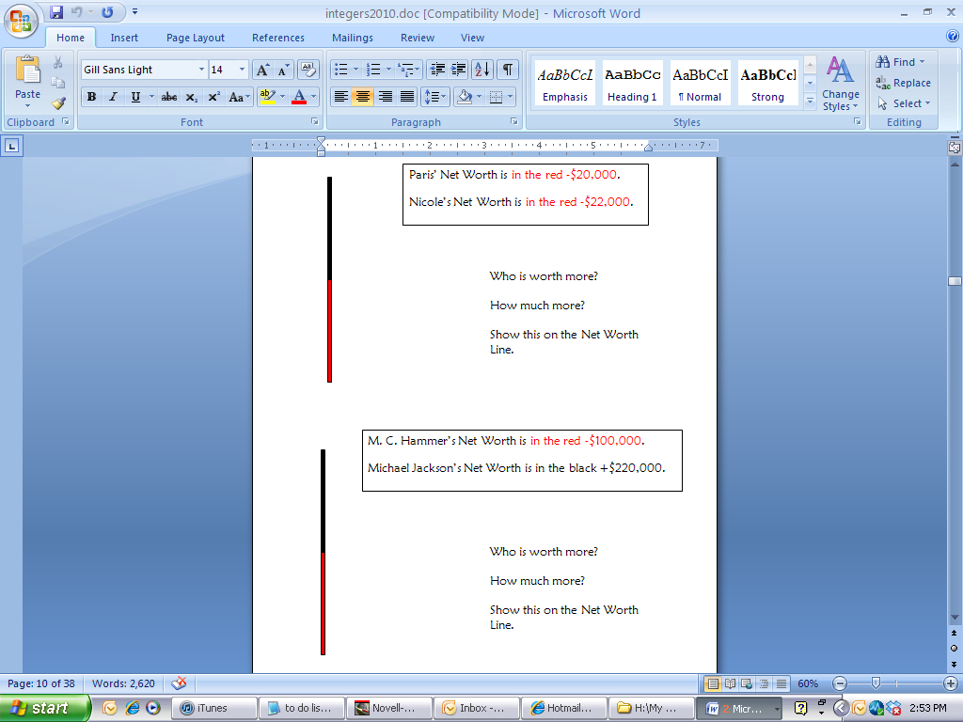

**Anticipated Student Thinking:**

**Big Mathematical Idea(s):** Comparing net worth (no longer finding it); strategies for finding difference; order of integers

**Rationale:** How do students structure the space between two integers?

**Possible Metaphors/Gestures:** Payoff idea; Up and down movement with arms

**Teacher Notes:**

**Anticipated Student Thinking:**

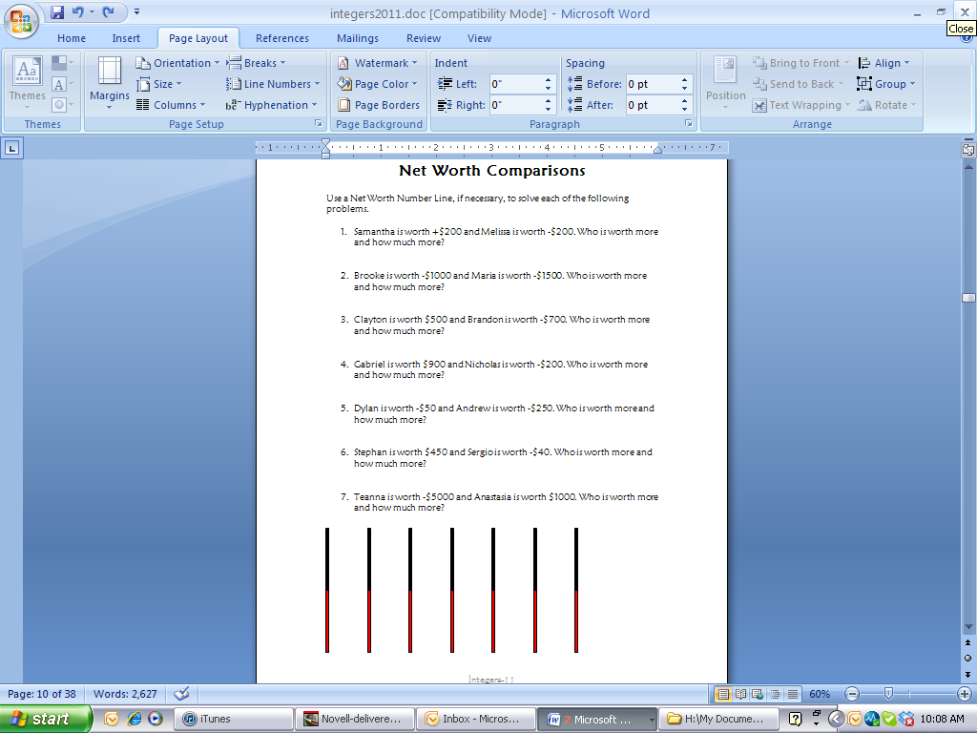

**Big Mathematical Idea(s):** Comparing net worth; strategies for finding difference; order of integers; possible conjectures

**Rationale:** How do students structure the space between two integers?

**Possible Metaphors/Gestures:** Payoff idea; Up and down movement with arms

**Teacher Notes:**

**Anticipated Student Thinking:**

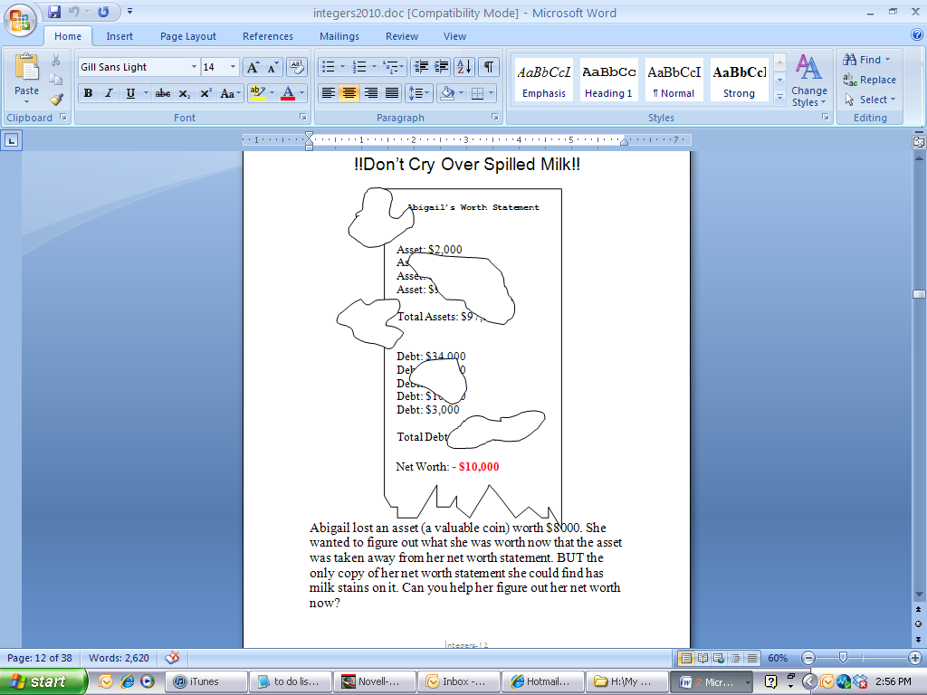

**Big Mathematical Idea(s):** Net worth as an object that can be changed

**Rationale:** Introduction of transaction idea; pre-assessment of transactions

**Possible Metaphors:**

**Teacher Notes:**

**!!??Good or Bad Decision??!!**

***Which of the following students made bad decisions about their finances?***

**Ann**: She took away an asset of (+$200) from her net worth statement

**Bradley**: He added an asset of (+$3000) to his net worth statement

**Christian**: He took away an asset of (+$50) from his net worth statement

**Devon**: He added a debt of (-$650) to his net worth statement

**Ernie**: He took away a debt of (-$5400) from his net worth statement

**Fran**: She took away an asset of (+$201) from her net worth statement

**Gracie**: She added a debt of (-$67) to her net worth statement

**Herbert**: He took away an asset of (+$450) from his net worth statement

**Anticipated Student Thinking:**

**Big Mathematical Idea(s):** the effect that transactions have on net worth

**Rationale:** Making meaning for transactions and then writing them in symbols

**Possible Metaphors:**

**Teacher Notes:**

**Anticipated Student Thinking:**

**!!??Good or Bad Decision??!!**

***Which of the following students made bad decisions about their finances?***

**India**: She took away an asset of (+$7500) from her net worth statement

**Jackie**: He added two assets of (+$6000) to his net worth statement

**Kathy**: She took away six assets of (+$50) from her net worth statement

**Levon**: He added four debts of (-$650) to his net worth statement

**Miguel**: He took away a debt of (-$530) from his net worth statement

**Natalie**: She took away 20 debts of (-$20) from her net worth statement

**Oscar**: He added 17 debts of (-$70) to his net worth statement

**Penelope**: She took away an asset of (+$4530) from her net worth statement

**Big Mathematical Idea(s):** the effect that transactions have on net worth

**Rationale:** Making meaning for transactions and then writing them in symbols; introduce multiplication (sets of debts)

**Possible Metaphors:**

**Teacher Notes:**

**Anticipated Student Thinking:**

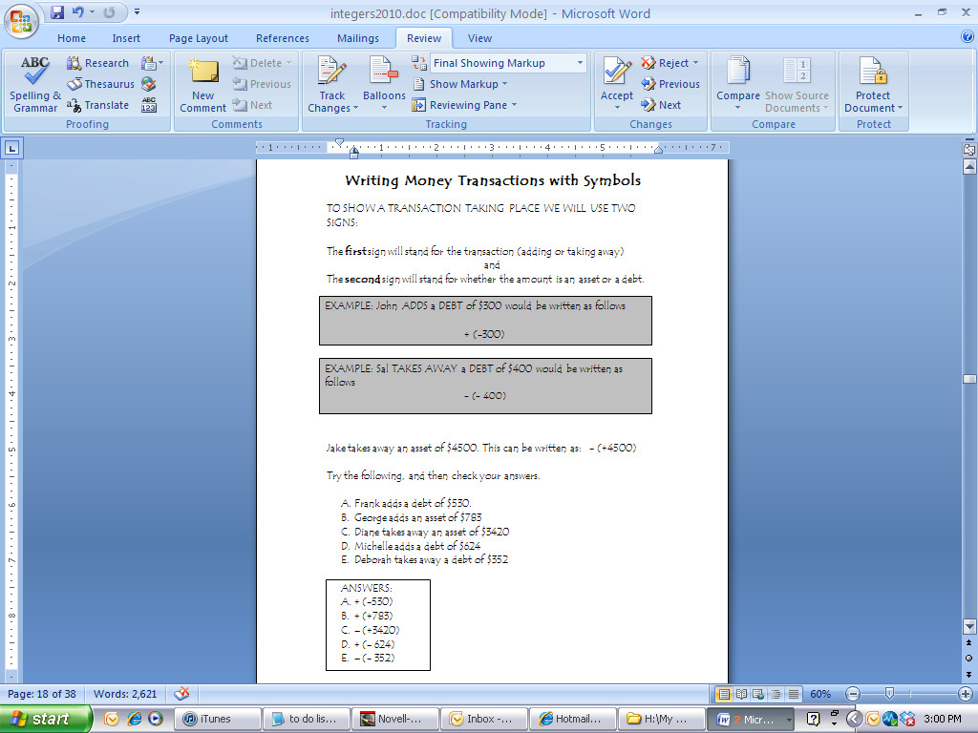

**Big Mathematical Idea(s):** the effect that transactions have on net worth

**Rationale:** Making meaning for transactions and then writing them in symbols

**Possible Metaphors:**

**Teacher Notes:**

Using the words ADD, TAKE AWAY, DEBT and ASSET, describe each transaction below:

1. – (+300)
2. + (-340)
3. + (+534)
4. + 7(342)
5. – (-7344)
6. –3 (+1200)
7. –19 (890)
8. + (- 6832)
9. – 12(- 566)
10. – 1

**Anticipated Student Thinking:**

**Big Mathematical Idea(s):** Making meaning out of transactions (multiplication)

**Rationale:** what effect do transactions have on net worth; efficiency of writing symbols; possible conjecture

**Possible Metaphors:**

**Teacher Notes:**

**Anticipated Student Thinking:**

Rewrite the following transactions in its simplest form (e.g., one sign and one number if possible):

* 1. – (+700)
  2. + (-360)
  3. - 2(+600)
  4. +5 (300)
  5. –4 (-7000)
  6. – 2(+1200)
  7. – 1(890)
  8. + (- 6800)
  9. – 3(- 400)
  10. – (-1)

**Big Mathematical Idea(s):** Making meaning out of transactions (multiplication)

**Rationale:** what effect do transactions have on net worth; efficiency of writing symbols; possible conjecture

**Possible Metaphors:**

**Teacher Notes:**

**Anticipated Student Thinking:**

Another name for transactions is “multiplication.” For the problems below, multiply (rewrite the following transactions in its simplest form):

1. +(+200)
2. +20 (-40)
3. - (+574)
4. - (382)
5. – 6(-12)
6. – 2(+1200)
7. – (90)
8. + 3(-62)
9. – 2(- 550)
10. – 4(-4)

**Big Mathematical Idea(s):** Making meaning out of transactions (multiplication)

**Rationale:** what effect do transactions have on net worth; efficiency of writing symbols; possible conjecture

**Possible Metaphors:**

**Teacher Notes:**

**Anticipated Student Thinking:**

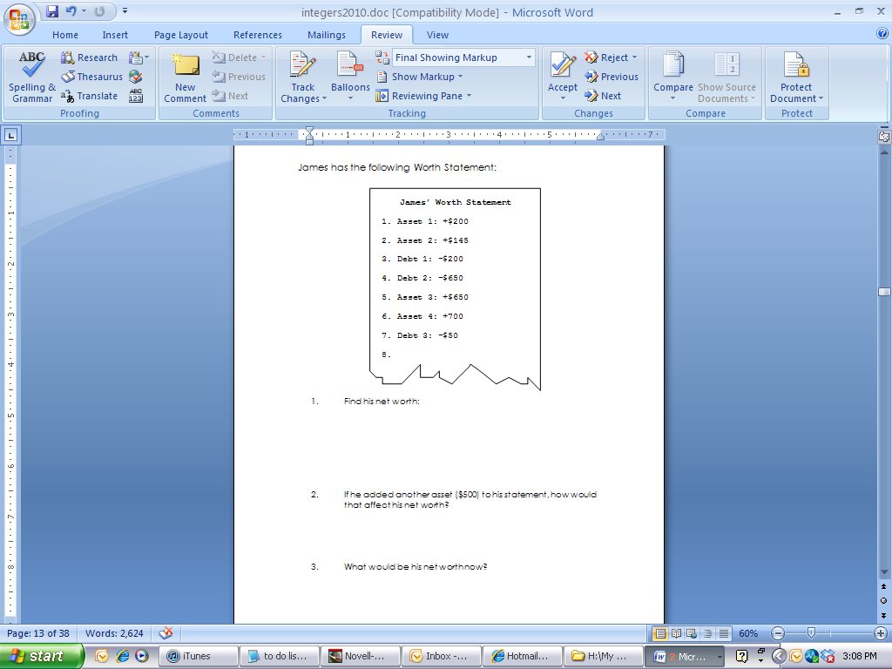

**Big Mathematical Idea(s):** Structuring the integer space with transactions

**Rationale:** How do you use a VNL to help structure transactions

**Possible Metaphors/gesture:** pay off/up and down arm movements

**Teacher Notes:**

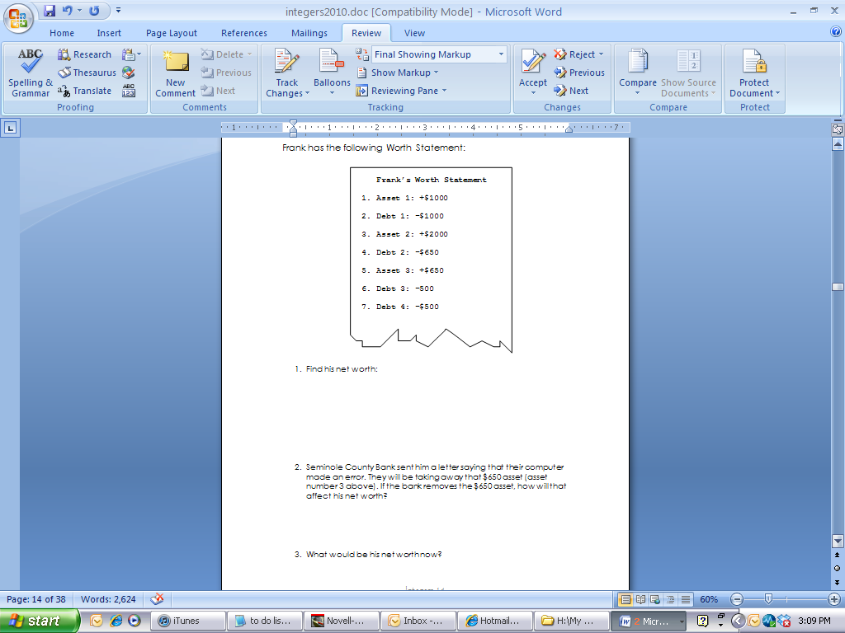

**Anticipated Student Thinking:**

**Big Mathematical Idea(s):** Structuring the integer space with transactions

**Rationale:** How do you use a VNL to help structure transactions

**Possible Metaphors/gesture:** pay off/up and down arm movements

**Teacher Notes:**

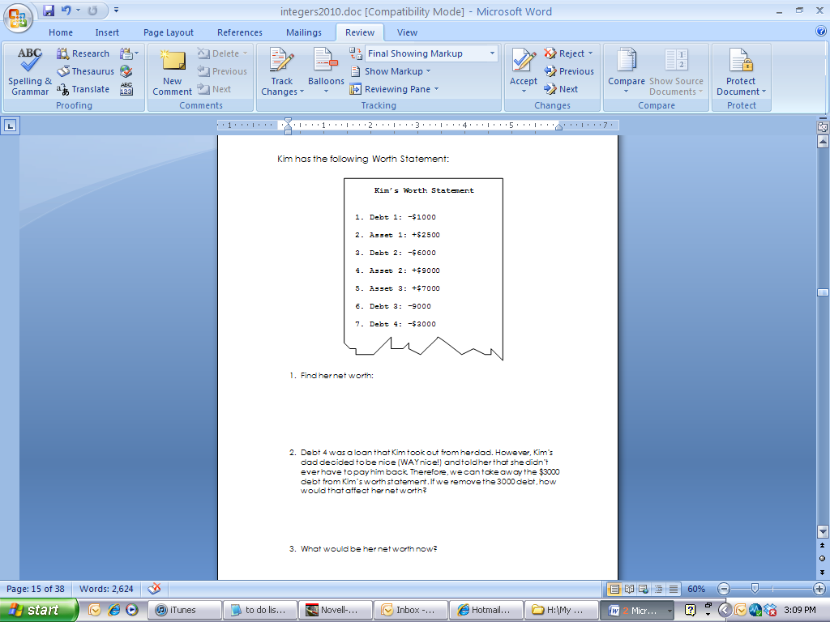

**Anticipated Student Thinking:**

**Big Mathematical Idea(s):** Structuring the integer space with transactions

**Rationale:** How do you use a VNL to help structure transactions

**Possible Metaphors/gesture:** pay off/up and down arm movements

**Teacher Notes:**

Transaction

-(+4000)

Transaction

-(-2000)

Transaction

+(-1000)

Transaction

-(+1000)

Transaction

+(-4000)

**Anticipated Student Thinking:**

**Big Mathematical Idea(s):** Structuring the integer space with transactions

**Rationale:** How do you use a VNL to help structure transactions

**Possible Metaphors/gesture:** pay off/up and down arm movements

**Teacher Notes:**

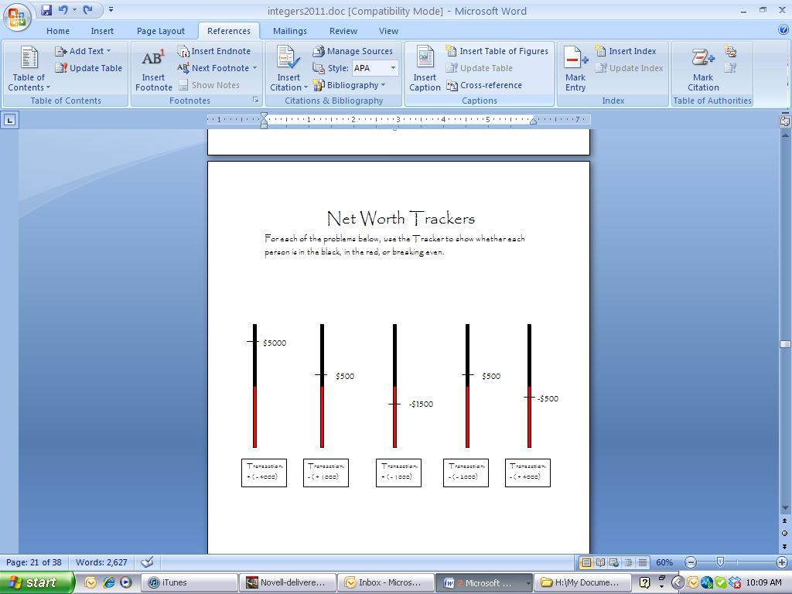

Transaction

-(-500)

Transaction

-(+2000)

Transaction

+(-7000)

Transaction

+(+1000)

Transaction

-(-6000)

**Big Mathematical Idea(s):** Structuring the integer space with transactions

**Rationale:** How do you use a VNL to help structure transactions

**Possible Metaphors/gesture:** pay off/up and down arm movements

**Teacher Notes:**

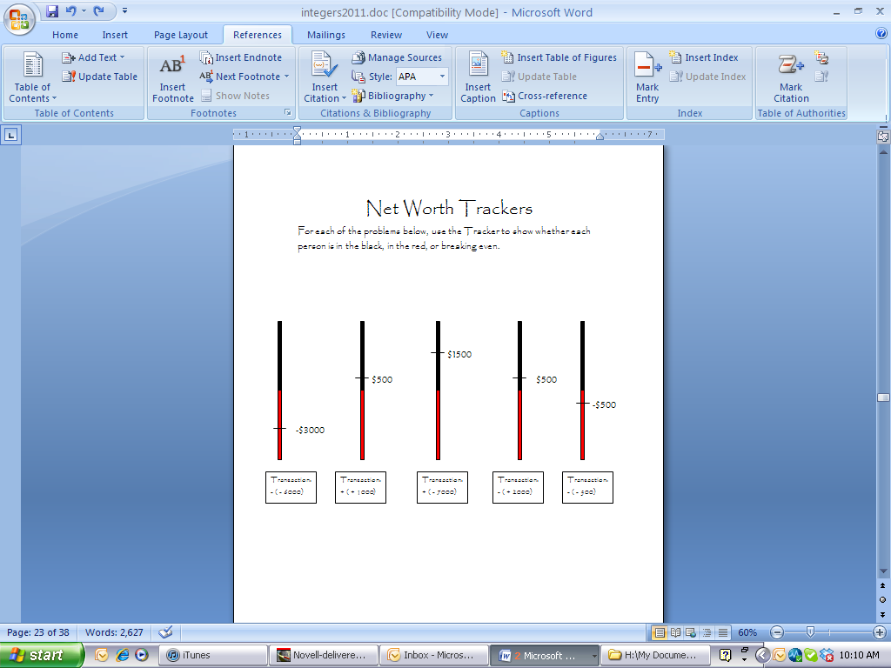

**Anticipated Student Thinking:**

**Anticipated Student Thinking:**

**Big Mathematical Idea(s):** Structuring the integer space with transactions

**Rationale:** How do you use a VNL to help structure transactions

**Possible Metaphors/gesture:** pay off/up and down arm movements

**Teacher Notes:**

Nancy has a net worth of $5000! A debt of $3000 is TAKEN AWAY. Is this good or bad? What is her net worth now! Draw your own Net Worth Trackers to help you figure these out, if you need them.

* 1. Donald has a net worth of -$5000! A debt of $3000 is TAKEN AWAY. Is this good or bad? What is his net worth now!
  2. Meagan has a net worth of -$4300! A debt of $3000 is ADDED. Is this good or bad? What is her net worth now?
  3. Melanie has a net worth of +$600! A debt of $1000 is ADDED. Is this good or bad? What is her net worth now!
  4. Todd has a net worth of +$10,000! An asset of $3000 is ADDED. Is this good or bad? What is his net worth now!
  5. Monica has a net worth of -$7400! An asset of $3000 is TAKEN AWAY. Is this good or bad? What is her net worth now!
  6. Andrea has a net worth of +$2200! A debt of $3000 is ADDED. Is this good or bad? What is her net worth now!

Write number sentences for the following changes that occur to Alice’s net worth (Use a net worth tracker if you need to):

1. Net Worth: $1500

Transaction: Adds a debt of $600

1. Net Worth: $600

Transaction: Adds a debt of $1100

1. Net Worth: - $400

Transaction: Adds a debt of $450

1. Net Worth: - $550

Transaction: Adds an asset of $1900

1. Net Worth: $1250

Transaction: Adds an asset of $350

1. Net Worth: $1600

Transaction: Adds a debt of $400

1. Net Worth: $800

Transaction: Takes away a debt of $200

Write number sentences for the following changes that occur to Alice’s net worth (Use a net worth tracker if you need to):

1. Net Worth: - $2000

Transaction: Adds an asset of $600

1. Net Worth: - $1800

Transaction: Adds a debt of $1200

1. Net Worth: - $2600

Transaction: Takes away a debt of $300

1. Net Worth: - $2000

Transaction: Takes away a debt of $500

**Big Mathematical Idea(s):** Structuring the integer space with transactions

**Rationale:** How do you use a VNL to help structure transactions; transition of symbolizing

**Possible Metaphors/gesture:** pay off/up and down arm movements

**Teacher Notes:**

**Anticipated Student Thinking:**

**Anticipated Student Thinking:**

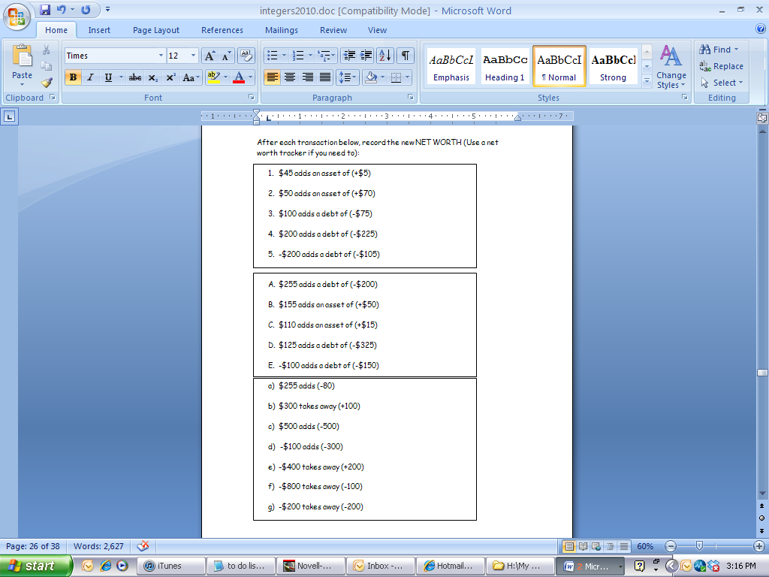

**Big Mathematical Idea(s):** Structuring the integer space with transactions

**Rationale:** How do you use a VNL to help structure transactions

**Possible Metaphors/gesture:** pay off/up and down arm movements

**Teacher Notes:**

**Anticipated Student Thinking:**

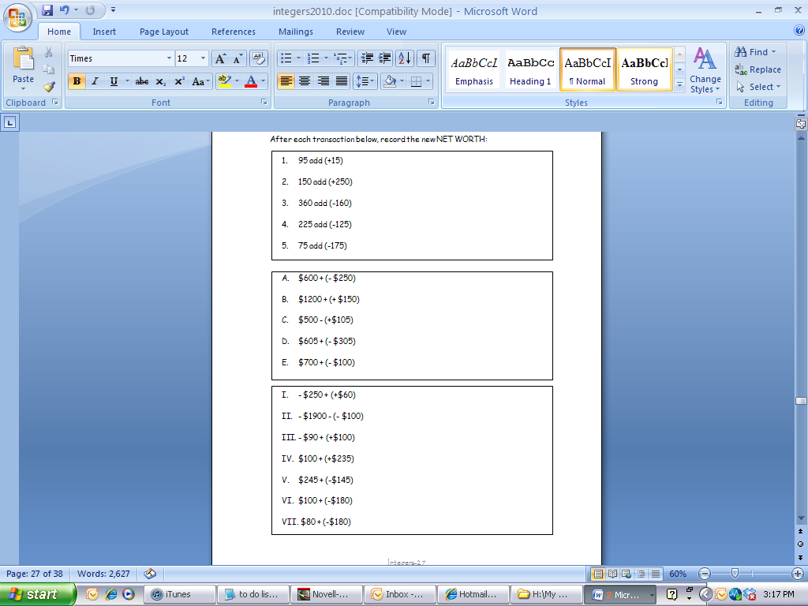

**Big Mathematical Idea(s):** Structuring the integer space with transactions

**Rationale:** How do you use a VNL to help structure transactions; transition of symbolizing

**Possible Metaphors/gesture:** pay off/up and down arm movements

**Teacher Notes:**

**Anticipated Student Thinking:**

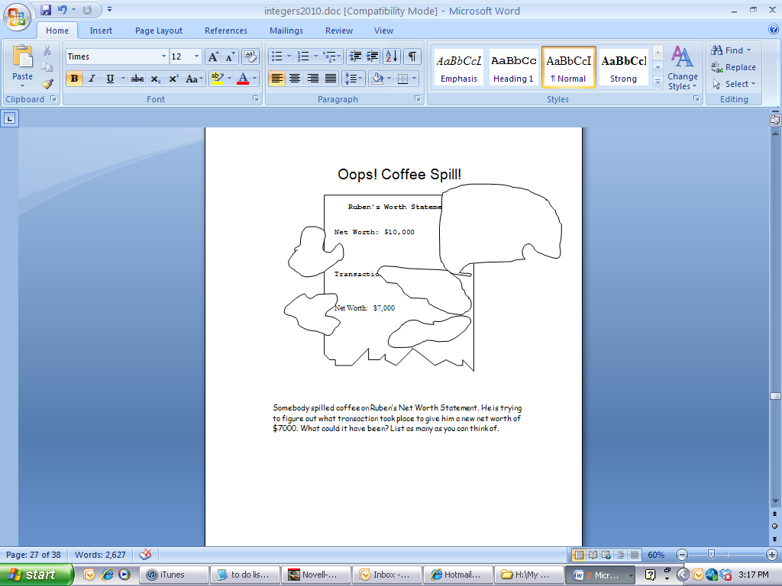

**Big Mathematical Idea(s):** structuring the space of possible transactions

**Rationale:** Missing addend/subtrahend tasks

**Possible Metaphors:**

**Teacher Notes:**

**Anticipated Student Thinking:**

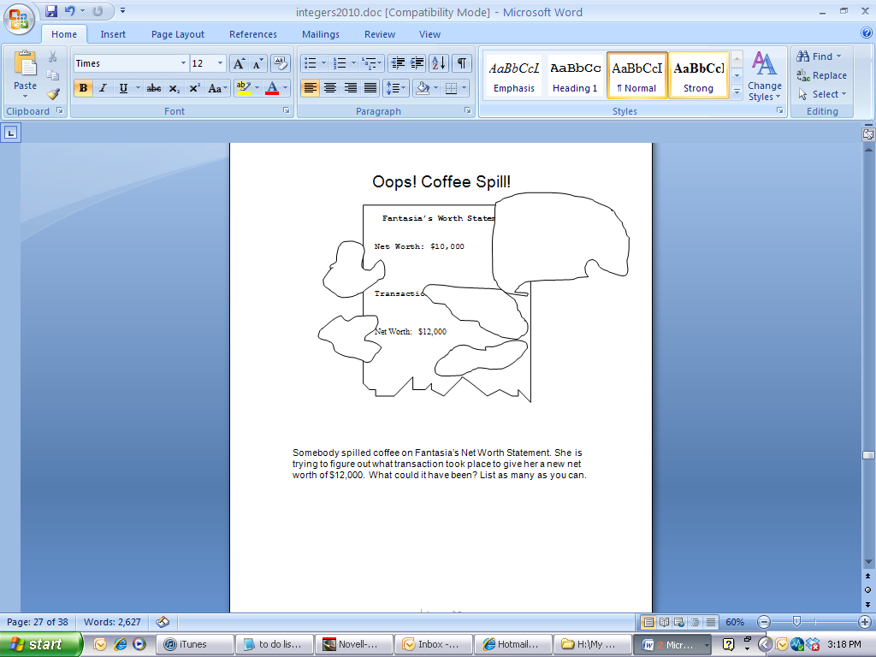

**Big Mathematical Idea(s):** structuring the space of possible transactions

**Rationale:** Missing addend/subtrahend tasks

**Possible Metaphors:**

**Teacher Notes:**

**Anticipated Student Thinking:**

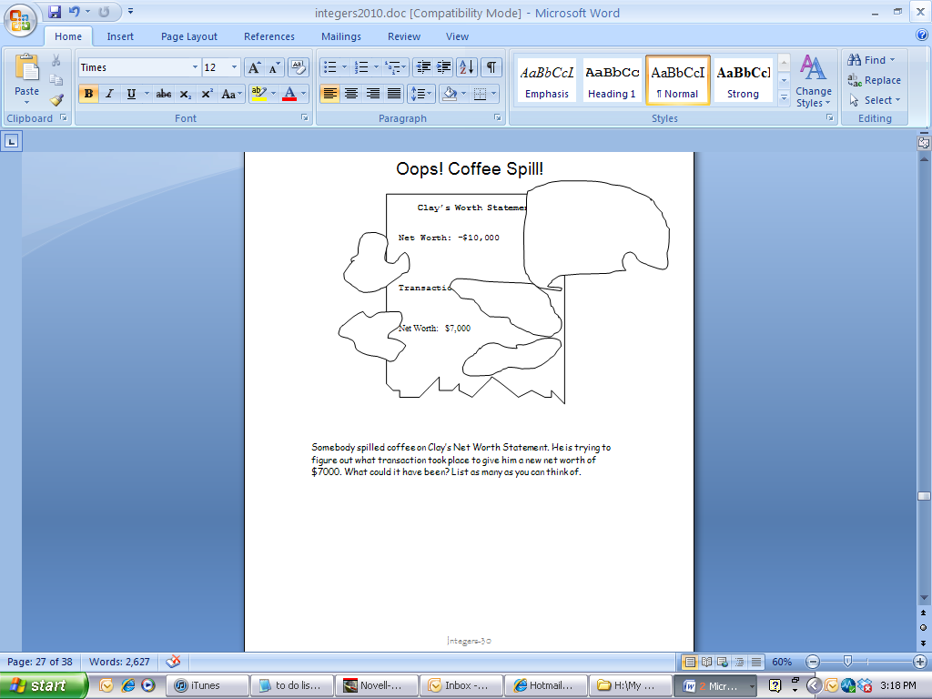

**Big Mathematical Idea(s):** structuring the space of possible transactions

**Rationale:** Missing addend/subtrahend tasks

**Possible Metaphors:**

**Teacher Notes:**

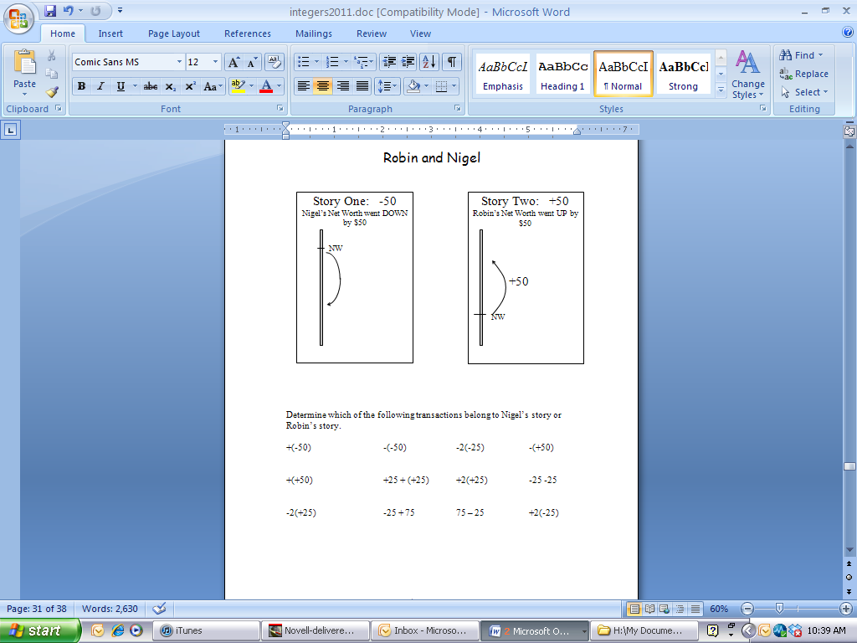

**Anticipated Student Thinking:**

**Big Mathematical Idea(s):** equivalence of integer quantities/expressions

**Rationale:** Students must learn to interpret problems with only one sign

**Possible Metaphors:** good decision/bad decision; going up or down

***Teacher Notes:***

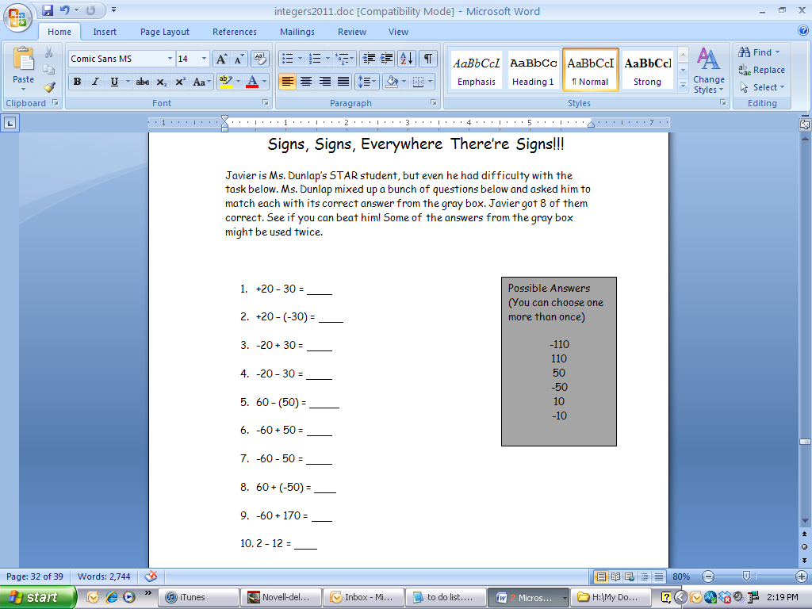

**Anticipated Student Thinking:**

**Big Mathematical Idea(s):** Meaning of the negative sign (take away or negative)

**Rationale:** Students must learn to interpret problems with only one sign

**Possible Metaphors:** good decision/bad decision; going up or down

**Teacher Notes:**

**Anticipated Student Thinking:**

For each problem below, state the person’s beginning NET WORTH, whether the change is a good or bad change, and their new NET WORTH.

* 1. 17 + (-5)
  2. -23 + (+11)
  3. 250 + (-250)
  4. 325 – (-100)
  5. -117 + (-23)
  6. -50 – (-50)
  7. -154 + (-26)
  8. 153 + (524)
  9. 619 – (235)

**Big Mathematical Idea(s):** Solving integer addition/subtraction

**Rationale:** Using pure number sentences

**Possible Metaphors:**

**Teacher Notes:**

Solve the following problems:

1. -45 + (-16)
2. -4 + 2 + (-5)
3. -5 + (-5)
4. 10 + 24 + (-12)
5. 22 – (-10)
6. -3 + 4 – (-23) –10

Solve the following problems:

1. 20 – 5
2. 18 + 7
3. -17 + 7
4. -20 + (-3)
5. 25 – (-10)
6. -25 – (-20)
7. -100 – 50
8. -45 + 70
9. 20 + (-35)
10. -45 + (-20)

**Big Mathematical Idea(s):** Solving integer addition/subtraction

**Rationale:** Using pure number sentences

**Possible Metaphors:**

**Teacher Notes:**

**Anticipated Student Thinking:**