Name

Class

Date



**Multiplying and Dividing Rational Expressions**

There are many types of *complex fractions*.

A complex fraction can be a fraction with one or more additional fractions in the numerator, or in the denominator, or in both the numerator and the denominator.



Is  a complex fraction? Explain.

**Solve**

Ask: Is the numerator a fraction? **→** No. 5*x*3 is not a fraction.

Ask: Is the denominator a fraction? **→** Yes .  is a fraction.

A fraction is in the denominator **→**  is a complex fraction.

**Exercises**

**Tell if the following terms are complex fractions. Explain your reasoning.**

**1.**  **2.  3. **

**4.**  **5.  6. **

**7.**  **8.** **9. **

Name

Class

Date



**Multiplying and Dividing Rational Expressions**

**Simplifying Complex Fractions**

You can use the *Outers Over Inners* method to simplify complex fractions.

The Outers Over Inners method sets up a simplified fraction that looks like this:

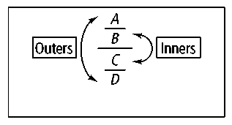

For example, in the fraction: and 6*y* are

the “outer” terms; 5 and 2 are the “inner” terms.

If a numerator or denominator is not a fraction, make it a fraction by rewriting it as  
.



Simplify 

**Solve **

**Check** Rewrite as numerator divided by denominator. 

Rewrite as a multiplication problem. 

**Exercises**

**Simplify using the Outers Over Inners method.**

**10.  11. **