Name



**Practice**

Operations with Radical Expressions

Class

Date

**Simplify each sum or difference.**

**1. 2. 3.**

**4. 5. 6.**

**7. 8. 9.**

**10. 11. 12.**

**Simplify each product.**

**13. 14.**

**15. 16.**

**17. 18.**

**Simplify each quotient.**

**19. 20. 21. **

**22. 23. 24. **

Name

Class

Date



Operations with Radical Expressions

**Practice** (continued)

1. A painting is shaped like a golden rectangle. It’s length is 24 cm. What is the painting’s width to the nearest tenth of a cm?
2. A tomato fits into a 10-in.-long golden rectangle. What is the tomato’s width to the nearest tenth of an inch?

**27** The length of a golden rectangle is. Use the ratio of length to width to find the width of the golden rectangle.



**28. Error Analysis** A student multiplied the radical expressions shown at the right. What mistake did the student make? What is the simplified form of the radical?

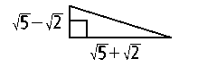

1. **Writing** What is the conjugate of What is the product of the conjugates? Show your work to explain your answer.
2. Find the length of the hypotenuse of the right triangle to the right. Write your answer in simplified radical form.

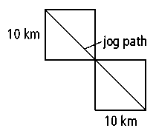

1. **Open-Ended** Make up three differences that are greater than or equal to 10. Use the square roots of 2, 3, 5, or 7 and whole numbers less than or equal to 10. For example,.
2. A large park is designed as two 10-km squares connected at the corner and with diagonals aligned. If Riley jogs along the diagonal from one end of the park to the other end, how many total kilometers will he jog? Give your answer as a simplified radical and to the nearest tenth of a kilometer.