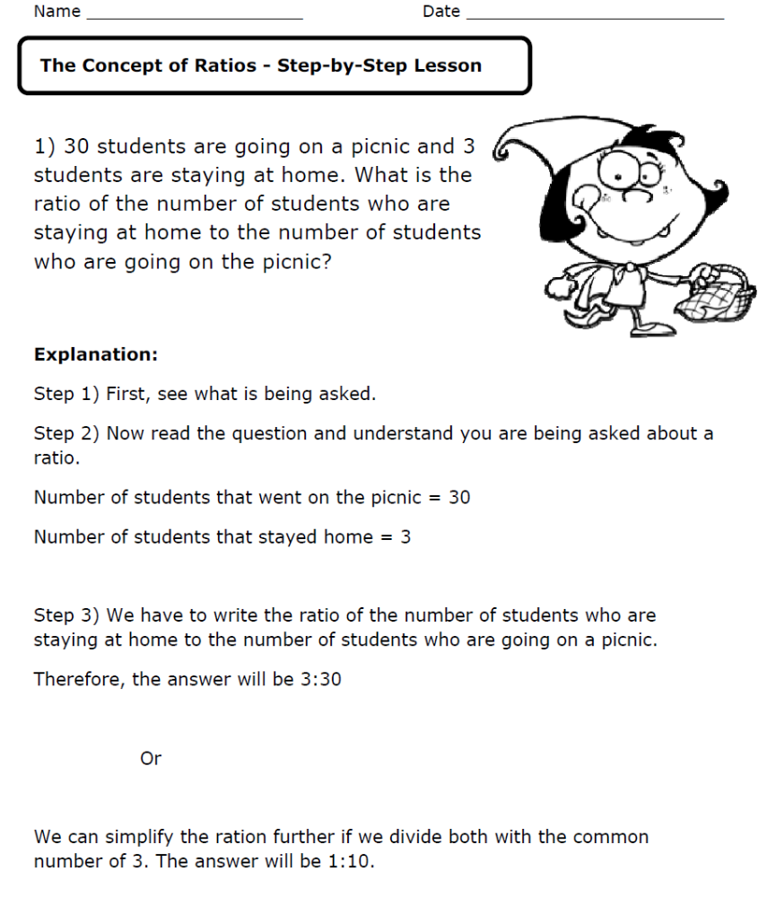

Answer the questions below by writing the ratios for each one. (the first one is done for you)
 | What is the ratio of apples to oranges? 3:7
 | What is the ratio of cats to dogs?
 | What is the ratio of buses to cars?
 | What is the ratio of oranges to apples?
 | What is the ratio of apples to oranges?
 | What is the ratio of tables to chairs?
 | What is the ratio of cars to buses?
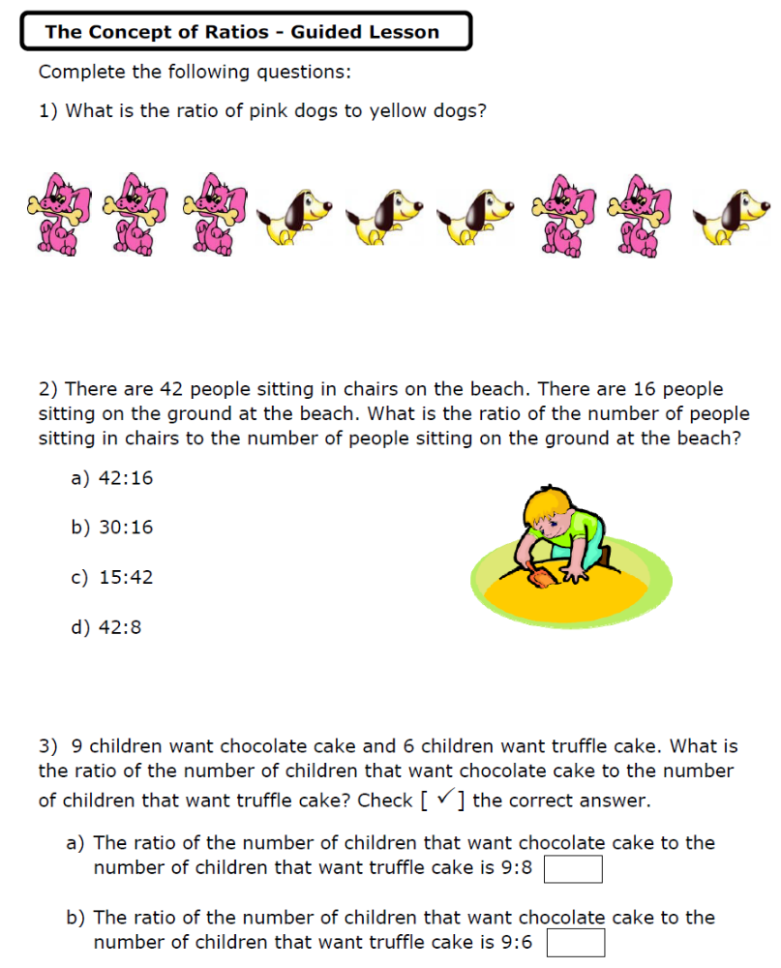
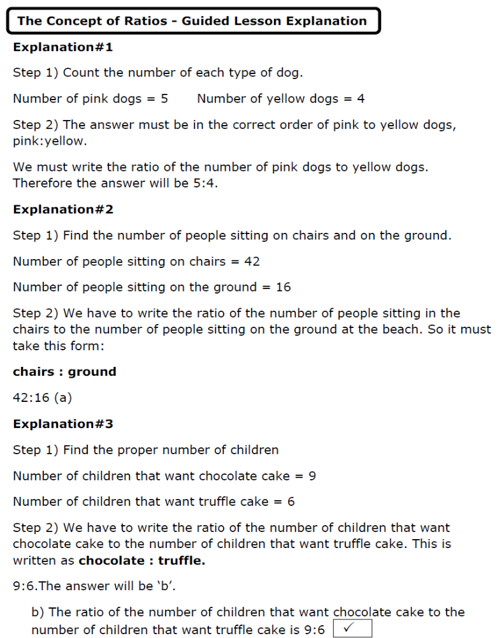
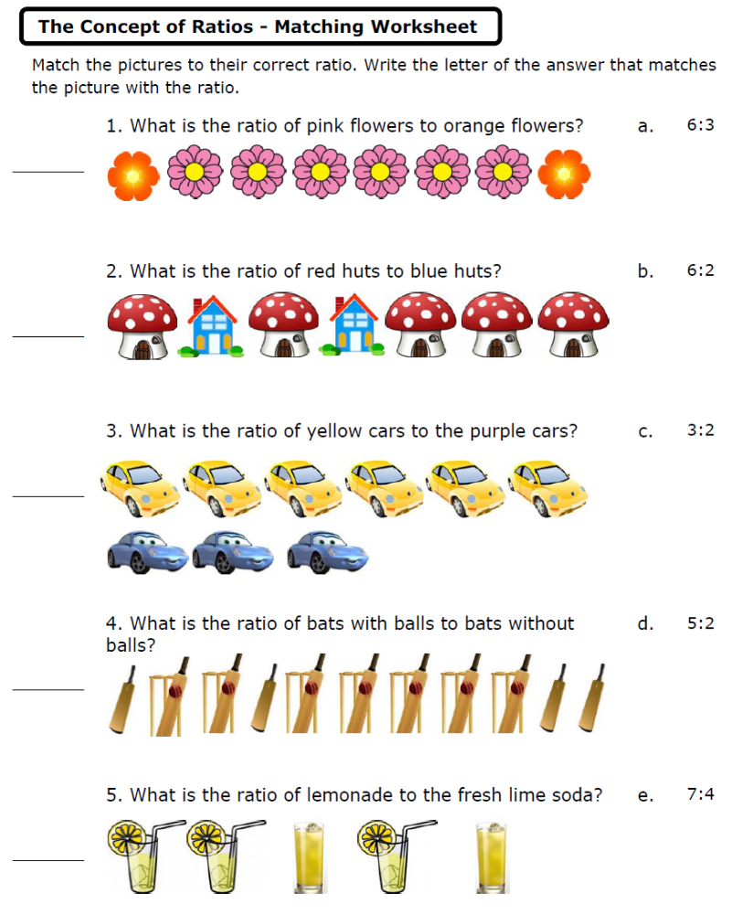

Answer the following questions writing all 3 ratio forms.

- There are 38 cars parked in the parking structure. The parking structure is not full to capacity. There are 13 parking spaces that are empty. What is the ratio of available parking spaces to parked cars?

- There are 17 occupied seats on the bus, 11 seats are empty. What is the ratio of number of occupied seats to empty seats?

- 15 boys and 16 girls took part in the basketball competition. What is the ratio of the number of girls to the number of boys who participate in the competition?

- A group of friends went out for dinner. 19 of the diners ordered vegetarian food and 14 ordered non-vegetarian food. What is the ratio of the number of vegetarian meals to the number of non-vegetarian meals?

- Jenny distributes 33 candies and 37 chocolates to each student in the class on her birthday. What is the ratio of the number of chocolates to candies distributed to each student in the class on her birthday?

- For every 5 boys on a softball team there is 1 girl. What is the ratio of boys to girls?

- The ratio of male to female birds in a bird cage was 5:2. For every _____ males there are_____ females.

- At the carnival the ratio of rides to games was 9:8. For every _____ games there are _____rides.

- In a bag of candy for every 3 chocolate pieces there are 7 sugar pieces. What is the ratio of chocolate pieces to sugar pieces?

10. At the burger shop the ratio of regular sodas sold to diet sodas sold was 7:1. for
every _____ diet sodas sold there is _____ regular soda sold.
Answer the questions below by writing all 3 forms of ratios for each one.
- The instructions on a bottle of juice say it should be mixed with 1 part juice to 6 parts water.
  - What is the ratio of juice to water?

  - What is the ratio of water to juice?

- A recipe has 4 ounces of butter and 9 ounces of sugar.
  - What is the ratio of butter to sugar?

  - What is the ratio of sugar to butter?

- January has 31 days and April has 30 days.
  - What is the ratio of days in January to days in April?

  - What is the ratio of days in April to days in January?

- Sally is 7 years old and Heather is 17 years old.
  - What is the ratio of Sally's age to Heather's age?

  - What is the ratio of Heather's age to Sally's age?

- A hotel has 22 double rooms and 7 single rooms. What is the ratio of single rooms to double rooms?

- Mark has $52 and Frank has $317. What is the ratio of Mark's to Frank's money?

- A class has 13 boys and 16 girls. What is the ratio of girls to boys?

- A street has 11 single-story and 9 two-story houses. What is the ratio of two-story to single-story houses?

- Sam is twice as old as Jack. What is the ratio of Sam's to Jack's ages?

Proportions
A proportion is simply a statement that two ratios are equal. It can be written in two ways: as two equal fractions a/b = c/d; or using a colon, a:b = c:d. The following proportion is read as "twenty is to twenty-five as four is to five."
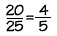
In problems involving proportions, we can use cross products to test whether two ratios are equal and form a proportion. To find the cross products of a proportion, we multiply the outer terms, called the extremes, and the middle terms, called the means.
Here, 20 and 5 are the extremes, and 25 and 4 are the means. Since the cross products are both equal to one hundred, we know that these ratios are equal and that this is a true proportion.
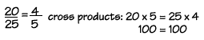
We can also use cross products to find a missing term in a proportion. Here's an example. In a horror movie featuring a giant beetle, the beetle appeared to be 50 feet long. However, a model was used for the beetle that was really only 20 inches long. A 30-inch tall model building was also used in the movie. How tall did the building seem in the movie?
First, write the proportion, using a letter to stand for the missing term. We find the cross products by multiplying 20 times x, and 50 times 30. Then divide to find x. Study this step closely, because this is a technique we will use often in algebra. We are trying to get our unknown number, x, on the left side of the equation, all by itself. Since x is multiplied by 20, we can use the "inverse" of multiplying, which is dividing, to get rid of the 20. We can divide both sides of the equation by the same number, without changing the meaning of the equation. When we divide both sides by 20, we find that the building will appear to be 75 feet tall.
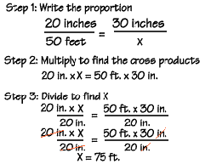
Note that we're using the inverse of multiplying by 20-that is, dividing by 20, to get x alone on one side.
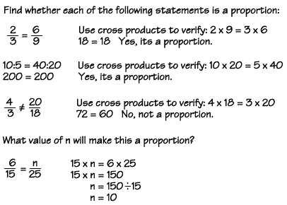
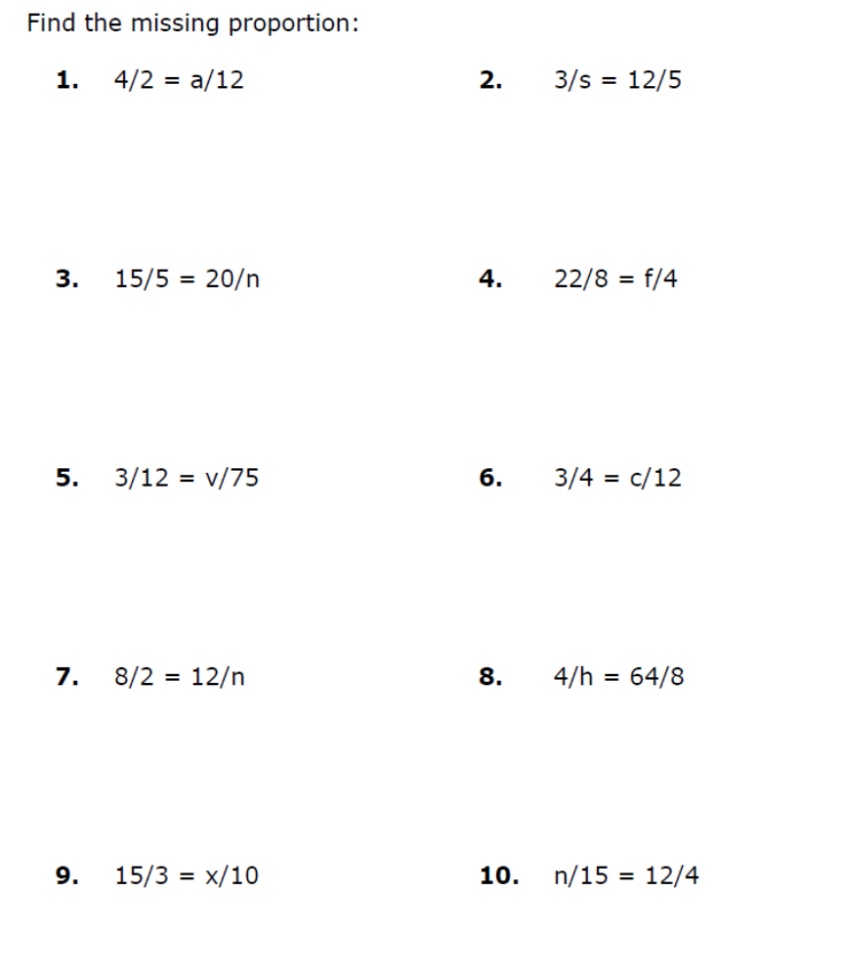

Solve the Proportion Word Problems
- Jose ran 2 miles in 22 minutes. How many minutes will it take him to run 3 miles?

- Mark drank a total of 20 liters of water over 4 days. How many days will it take Joe to consume 35 liters of water?

- The teacher bought 10 books during 5 days of the book fair. After 9 days, how many total books will the teacher have bought?

- Bella ran a total of 16 miles over the course of 8 track practices. How many track practices would it take for Elena to run 20 miles?

- Molly used 22 centimeters of tape to wrap 11 presents. How much tape will she need in all if she he has to wrap 12 presents?

- Ken collected 28 bugs over 4 weeks. After 5 weeks, how many bugs will he have caught?

- Esther baked 24 cookies with 2 scoops of flour. How many scoops of flour does she need in order to bake 36 cookies?

- Mrs. Johnson collected 35 cans of food in 7 days. How many days will take her to collect 50 cans?

- Sally baked 28 brownies with 4 scoops of flour. With 5 scoops of flour, how many cookies can she bake?

- The photographer took 64 photos in 8 minutes. How many photos will he take in 10 minutes?



