Lesson 11: Normal Distributions

Student Outcomes
- Students use tables and technology to estimate the area under a normal curve.
- Students interpret probabilities in context.
- When appropriate, students select an appropriate normal distribution to serve as a model for a given data distribution.

Lesson Notes
In Lesson 10, students first learn how to calculate $z$ scores and are then shown how to use $z$ scores and a graphing calculator to find normal probabilities. Students are then introduced to the process of calculating normal probabilities using tables of standard normal curve areas. In this lesson, students calculate normal probabilities using tables and spreadsheets. They also learn how to use a graphing calculator to find normal probabilities directly (without using $z$ scores) and are introduced to the idea of fitting a normal curve to a data distribution that seems to be approximately normal.

Classwork
Example 1 (7 minutes): Calculation of Normal Probabilities Using $z$ scores and Tables of Standard Normal Areas
In this example, two of the techniques learned in Lesson 10—evaluation of $z$ scores and use of tables of standard normal areas—are combined to find normal probabilities. Consider asking students to work independently or with a partner, and use this as an opportunity to informally assess student progress.
Example 1: Calculation of Normal Probabilities Using $z$ scores and Tables of Standard Normal Areas
The U.S. Department of Agriculture, in its Official Food Plans (www.cnpp.usda.gov), states that the average cost of food for a $14$–$18$-year-old male (on the “Moderate-cost” plan) is $\$261.50$ per month. Assume that the monthly food cost for a $14$–$18$-year-old male is approximately normally distributed with a mean of $\$261.50$ and a standard deviation of $\$16.25$.
- Use a table of standard normal curve areas to find the probability that the monthly food cost for a randomly selected $14$−$18$ year old male is
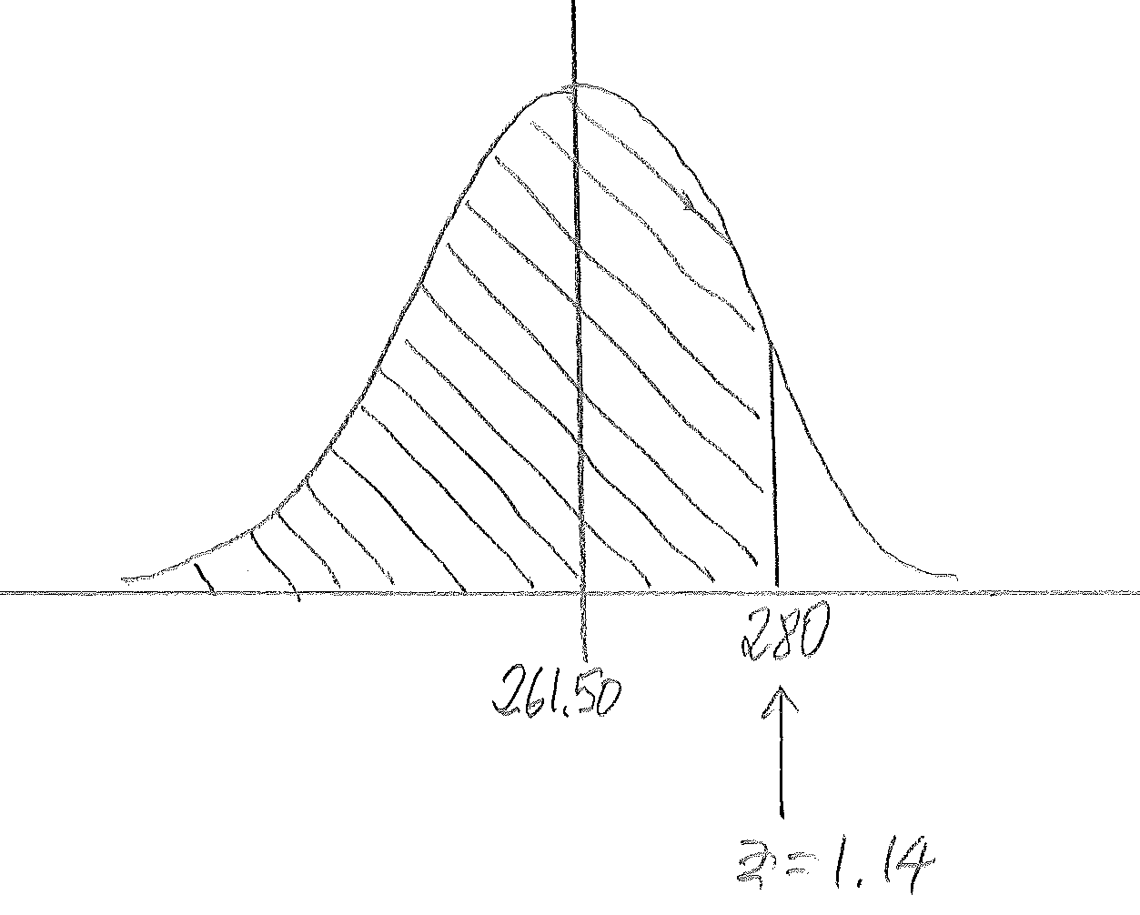
    - less than $\$280$.

$$P\left(<280\right)=0.8729$$

  - more than $\$270$
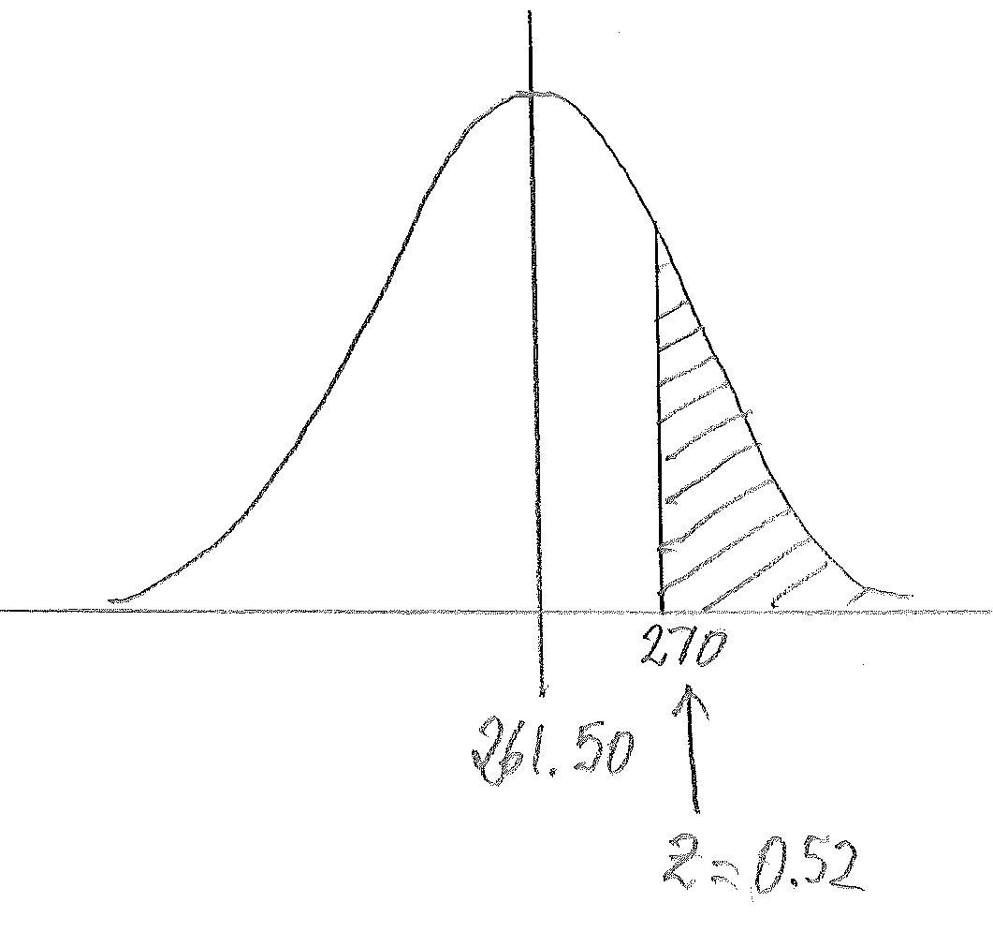
$$P\left(>270\right)=1-0.6985 \\ =0.3015$$

  - more than $\$250$
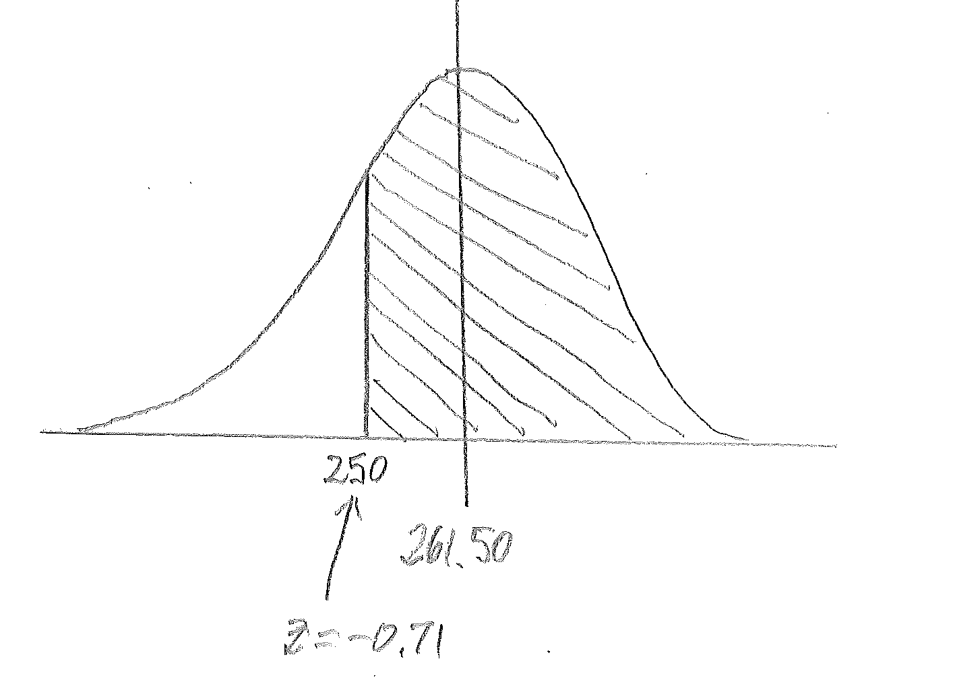
$$P\left(>250\right)=1-0.2389 \\ =0.7611$$

  - between $\$240$ and $\$275$
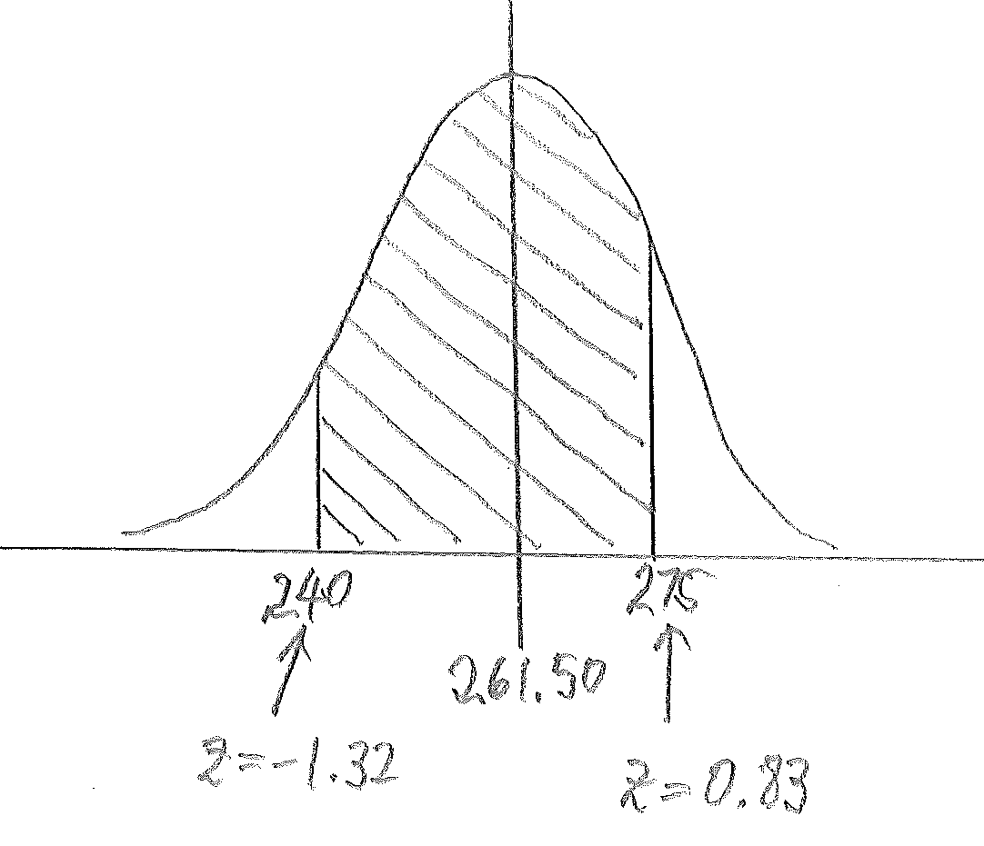
$$P\left(\text{between} 240 \text{and} 275\right)= 0.7967-0.0934 \\ = 0.7033$$

- Explain the meaning of the probability that you found in part (a–iv).
If a very large number of $14$−$18$ year old males were to be selected at random, then you would expect about $70.33\%$ of them to have monthly food costs between $\$240$ and $\$275$.

Exercise 1 (5 minutes)
This exercise provides practice with the approach demonstrated in Example 1. Continue to encourage students to include a normal distribution curve with work shown for each part of the exercise.
MP.4
Exercise 1
The USDA document described in Example 1 also states that the average cost of food for a $14$–$18$ year old female (again, on the “Moderate-cost” plan) is $\$215.20$ per month. Assume that the monthly food cost for a $14$–$18$ year old female is approximately normally distributed with mean $\$215.20$ and standard deviation $\$14.85$.
- Use a table of standard normal curve areas to find the probability that the monthly food cost for a randomly selected $14$−$18$ year old female is
  - less than $\$225$.
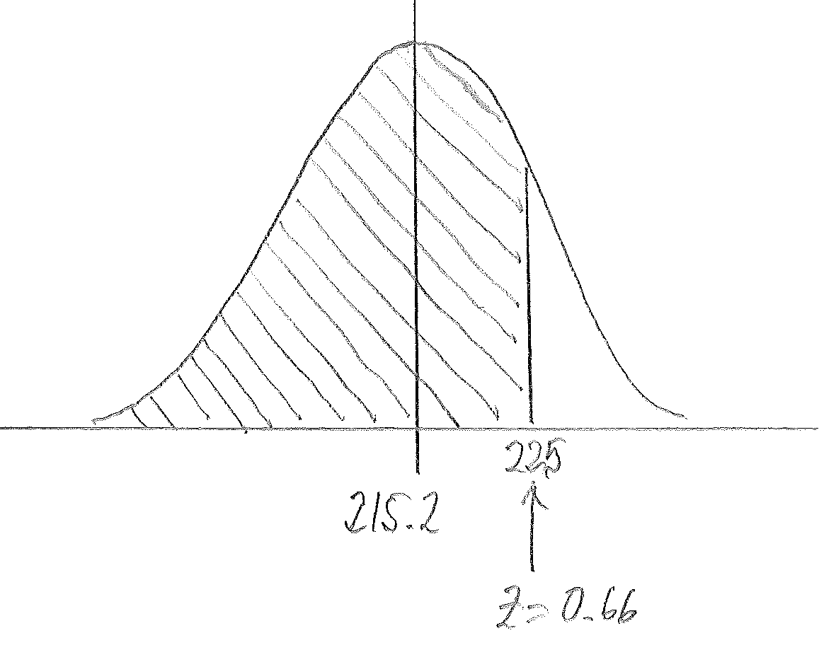
$$P\text{(less than }225)=0.7454$$

  - less than $\$200$.
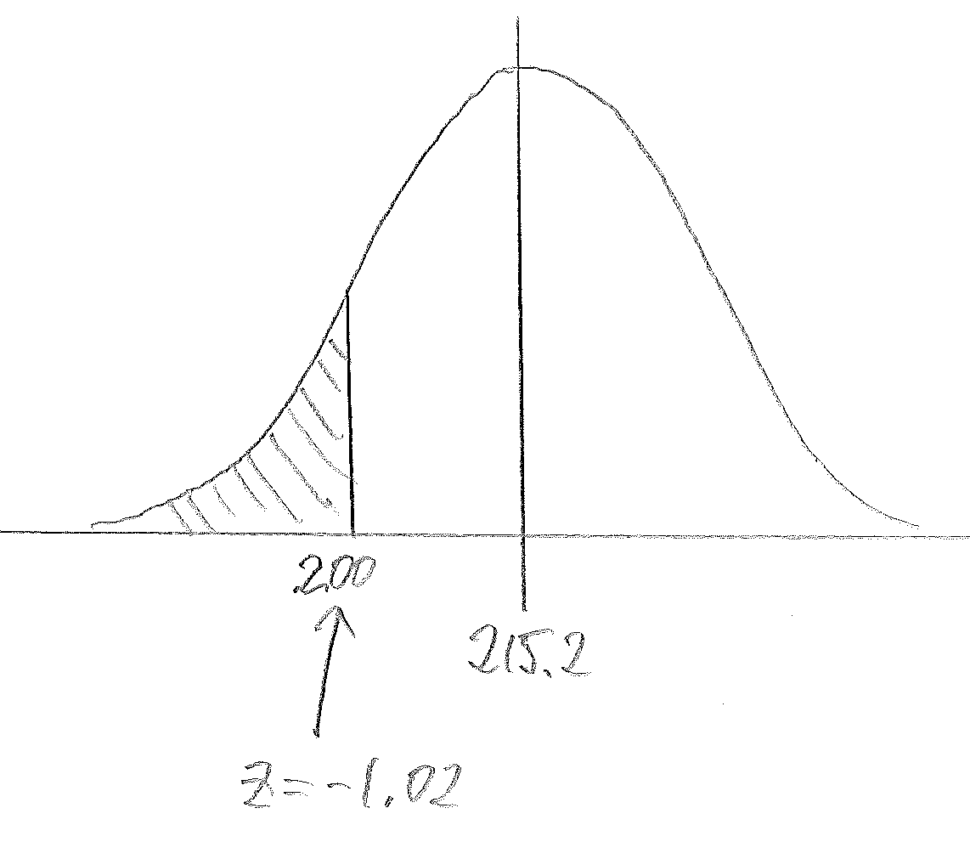
$$P\left(\text{less than} 200\right)=0.1539$$

  - more than $\$250$.
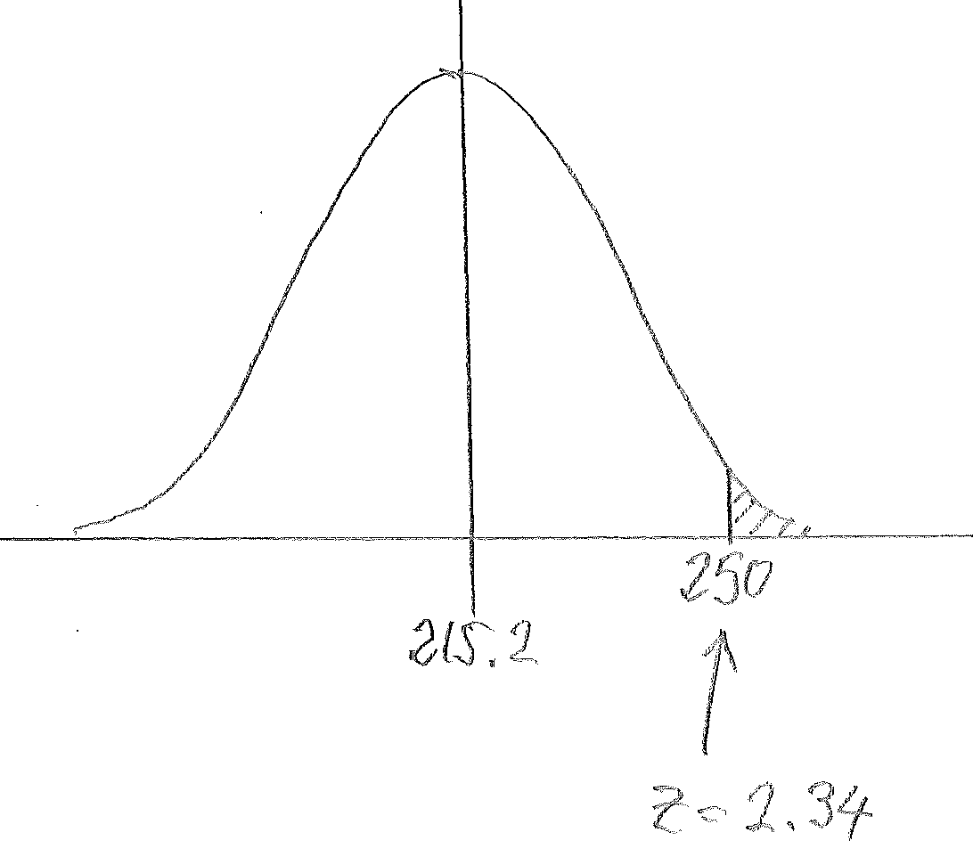
$$P\left(\text{more than} 250\right)=0.0096$$

  - between $\$190$ and $\$220.$
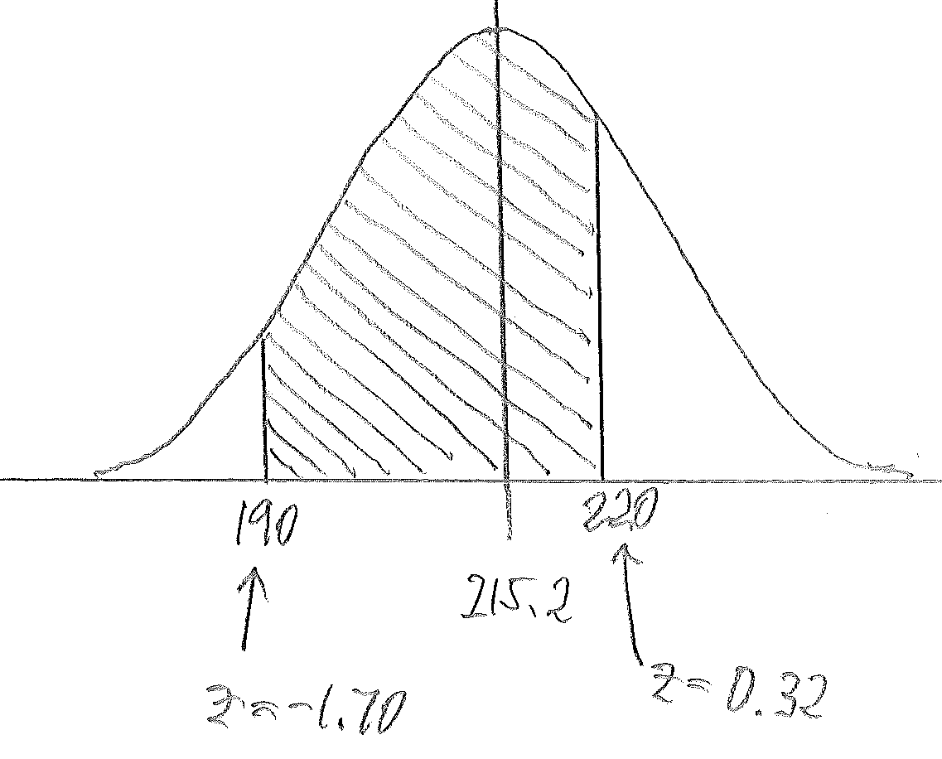
$$P\left(\text{between} 190 \text{and} 220\right)=0.6255-0.0446 \\ =0.5809$$

- Explain the meaning of the probability that you found in part (a–iv).
If a very large number of $14$–$18$ year old females were to be selected at random, then you would expect about $58.09\%$ of them to have monthly food costs between $\$190$ and $\$220$.

Example 2 (5 minutes): Use of a Graphing Calculator to Find Normal Probabilities Directly
In this example, students learn how to calculate normal probabilities using a graphing calculator without using $z$ scores. Use this example to show the class how to do this using a graphing calculator*.

*Calculator note: The general form of this is Normalcdf([left bound],[right bound],[mean],[standard deviation]). The Normalcdf function is accessed using 2nd, DISTR.
Example 2: Use of a Graphing Calculator to Find Normal Probabilities Directly
Return to the information given in Example 1. Using a graphing calculator, and without using $z$ scores, find the probability (rounded to the nearest thousandth) that the monthly food cost for a randomly selected $14$−$18$ year old male is
- between $\$260$ and $\$265$.
$$P\left(\text{between} \$260 \text{and} \$265\right)=0.122.$$
If students are using TI-83 or TI-84 calculators, this result is found by entering Normalcdf$(260, 265, 261.5, 16.25)$.

- at least $\$252$.
$$P\left(≥252\right)=0.721.$$
This result is found by entering Normalcdf$(252, 999, 261.5, 16.25)$ or the equivalent for other brands of calculator. Any large positive number or 1EE99 can be used in place of $999$, as long as the number is at least four standard deviations above the mean.

- at most $\$248$.
$$P\left(≤248\right)=0.203$$
This result is found by entering Normalcdf$(-999, 248, 261.5, 16.25)$ or the equivalent for other brands of calculator. Any large negative number or –1EE99 can be used in place of $-999$, as long as the number is at least four standard deviations below the mean.
Exercise 2 (5 minutes)
MP.5
Here students have an opportunity to practice using a graphing calculator to find normal probabilities directly and reflect on the use of technology compared to the use of tables of normal curve areas.
Exercise 2
Return to the information given in Exercise 1.
        - In Exercise 1, you calculated the probability that the monthly food cost for a randomly selected $14$−$18$ year old female is between $\$190$ and $\$220$. Would the probability that that the monthly food cost for a randomly selected $14$−$18$ year old female is between $\$195$ and $\$230$ be greater than or smaller than the probability for between $\$190$ and $\$220$? Explain your thinking.
The probability would be greater between $\$195$ and $\$230$. If you look at a sketch of a normal curve with mean $\$215.20$ and standard deviation $\$14.85$, there is more area under the curve for the wider interval of $\$195$ to $\$230$.

        - Do you think that the probability that the monthly food cost for a randomly selected $14$−$18$ year old female is between $\$195$ and $\$230$ is closer to $0.50$, $0.75,$ or $0.90$? Explain your thinking.
Closer to $0.75$. Based on my answer to part (a), I expect the probability to be greater than the probability for between $\$190$ and $\$220$, which was $0.5809$, but I do not think it would be as great as $0.90$.

        - Using a graphing calculator, and without using $z$ scores, find the probability (rounded to the nearest thousandth) that the monthly food cost for a randomly selected $14$−$18$ year old female is between $\$195$ and$\$230$. Is this probability consistent with your answer to part (b)?
$$P\left(\text{between} 195 \text{and} 230\right)=0.754$$This probability is close to $0.75$, which was my answer in part (b).

        - How does the probability you calculated in part (c) compare to the probability that would have been obtained using the table of normal curve areas?
The z score for $\$195$ is $z=\frac{195-215.20}{14.85}=-1.36,$ and the $z$ score for $\$230$ is $z=\frac{230-215.20}{14.85}=1.00.$ Using the table of normal curve areas, $P\left(\text{between} 195 \text{and} 230\right)=0.8413-0.0853=0.756.$ This is very close to the answer I got using the graphing calculator.

        - What is one advantage to using a graphing calculator to calculate this probability?
It is a lot faster to use the graphing calculator because I didn’t have to calculate $z$ scores in order to get the probability.

        - In Exercise 1, you calculated the probability that the monthly food cost for a randomly selected $14$–$18$ year old female is at most $\$200$. Would the probability that the monthly food cost for a randomly selected $14$–$18$ year old female is at most $\$210$ be greater than or less than the probability for at most $\$200$? Explain your thinking.
The probability would be greater for at most $\$210$. There is more area under the normal curve to the left of $\$210$ than to the left of $\$200$.

        - Do you think that the probability that the monthly food cost for a randomly selected $14$−$18$ year old female is at most $\$210$ is closer to $0.10$, $0.30$, or $0.50$? Explain your thinking.
Closer to $0.30$. Based on my answer to part (f), I expect the probability to be greater than the probability for at most $\$200$, which was $0.1539$, but I don’t think it would be as great as $0.50$ because $\$210$ is less than the mean of $\$215.20$, and the area to the left of $\$215.20$ is $0.50$.
        - Using a graphing calculator, and without using $z$ scores, find the probability (rounded to the nearest thousandth) that the monthly food cost for a randomly selected $14$−$18$ year old female is at most $\$210$.
$$P\left(≤210\right)=0.363$$

        - Using a graphing calculator, and without using z scores, find the probability (rounded to the nearest thousandth) that the monthly food cost for a randomly selected $14$−$18$ year old female is at least $\$235$.
$$P\left(≥235\right)=0.091$$

Example 3 (5 minutes): Using a Spreadsheet to Find Normal Probabilities
In this example, students learn how to calculate normal probabilities using a spreadsheet. This example and the exercise that follows revisits Example 1 and Exercise 1 but has students use a spreadsheet rather than a table of normal curve areas. Use this example to show the class how to do this using a spreadsheet*.
*Spreadsheet note: Many spreadsheet programs, such as Excel, have a built in function to calculate normal probabilities. In Excel, this can be done by finding the area to the left of any particular cutoff value by typing the following into a cell of the spreadsheet and then hitting the return key:
= NORMDIST(cutoff,mean,stddev,true).
You need to include the true at the end in order to get the area to the left of the cutoff. For example,
= NORMDIST($50,40,10$,true) will give $0.84124$, which is the area to the left of $50$ under the normal curve with mean $40$ and standard deviation $10$.
Example 3: Using a Spreadsheet to Find Normal Probabilities
Return to the information given in Example 1. The U.S. Department of Agriculture, in its Official Food Plans (www.cnpp.usda.gov), states that the average cost of food for a $14$–$18$-year-old male (on the “moderate-cost” plan) is $\$261.50$ per month. Assume that the monthly food cost for a $14$–$18$-year-old male is approximately normally distributed with a mean of $\$261.50$ and a standard deviation of $\$16.25$. Round your answers to four decimal places.
- Use a spreadsheet to find the probability that the monthly food cost for a randomly selected $14$−$18$ year old male is
  - less than $\$280$.
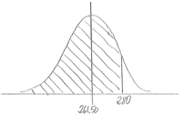
If students are using Excel, this would be found by using
=NORMDIST$(280\text{,} 261.50\text{, }16.25\text{, true})$. The difference between this answer and the answer using the table of normal curve areas is due to rounding in calculating the $z$ score needed in order to use the table.
$$P\left(<280\right)=0.8725$$

  - more than $\$270$.
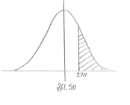
$$P\left(>270\right)= 1-0.6995 \\ = 0.3005$$

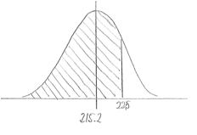
  - more than $\$250.$
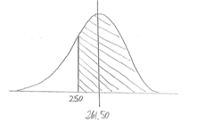
$$P\left(>250\right)= 1-0.2396 \\ = 0.7604$$

  - between $\$240$ and $\$275.$
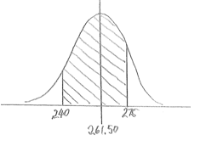
$$P\left(\text{between} 240 \text{and} 275\right)= 0.7969-0.0929 \\ = 0.7040$$

Exercise 3 (5 minutes)
Exercise 3
The USDA document described in Example 1 also states that the average cost of food for a $14$–$18$ year old female (again, on the “moderate-cost” plan) is $\$215.20$ per month. Assume that the monthly food cost for a $14$–$18$ year old female is approximately normally distributed with a mean of $\$215.20$ and a standard deviation of $\$14.85$. Round your answers to $4$ decimal places.
Use a spreadsheet to find the probability that the monthly food cost for a randomly selected $14$−$18$ year old female is
  - less than $\$225.$
$$P\left(\text{less than} 225\right)=0.7454$$

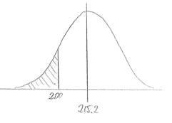
  - less than $\$200$.

$$P\left(\text{less than} 200\right)=0.1530$$

  - more than $\$250$.
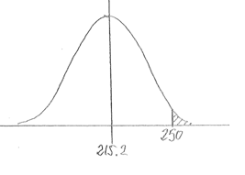
$$P\left(more than 250\right)= 1-0.9904 \\ =0.0096$$

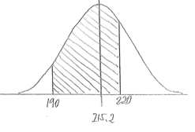
  - between $\$190$ and $\$220$.

$$P\left(\text{between} 190 \text{and} 220\right)= 0.6267-0.0449 \\ = 0.5818$$

Exercise 4 (6 minutes)
Here students are led through the process of choosing a normal distribution to model a given data set. Students might need some assistance prior to tackling this exercise. Teachers may wish to provide a quick review of how to draw a histogram. Students may need to be reminded how to calculate the mean and the standard deviation for data given in the form of a frequency distribution. In fact, this example provides the additional complication that the data are given in the form of a grouped frequency distribution, so the midpoints of the intervals have to be used as the data values.
If time is short you can simply provide students with reminders of these techniques mentioned above, and the exercise can then be finished as part of the homework assignment.

Exercise 4
The reaction times of $490$ people were measured. The results are shown in the frequency distribution below.
Reaction Time (seconds) | $0.1$ to $<0.15$ | $0.15$ to $<0.2$ | $0.2$ to $<0.25$ | $0.25$ to $<0.3$ | $0.3$ to $<0.35$ | $0.35$ to $<0.4$
Frequency | $$9$$ | $$82$$ | $$220$$ | $$138$$ | $$37$$ | $$4$$
        - Construct a histogram that displays these results.
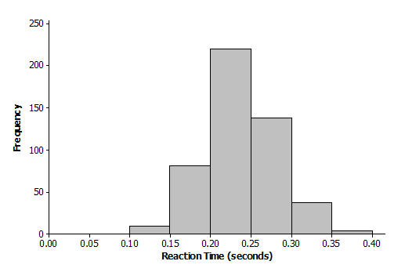

        - Looking at the histogram, do you think a normal distribution would be an appropriate model for this distribution?
Yes, the histogram is approximately symmetric and mound shaped.

        - The mean of the reaction times for these $490$ people is $0.2377,$ and the standard deviation of the reaction times is $0.0457$. For a normal distribution with this mean and standard deviation, what is the probability that a randomly selected reaction time is at least $0.25$?
Using Normalcdf$(0.25,999,0.2377,0.0457)$, you get $P\left(≥0.25\right)=0.394$.

        - The actual proportion of these $490$ people who had a reaction time that was at least $0.25$ is $0.365$ (this can be calculated from the frequency distribution). How does this proportion compare to the probability that you calculated in part (c)? Does this confirm that the normal distribution is an appropriate model for the reaction time distribution?
$0.365$ is reasonably close to the probability based on the normal distribution, which was $0.394$. I think that the normal model was appropriate.

Closing (2 minutes)
Refer to Exercise 3.
- How would you interpret the probability that you found using a calculator in part (c)?
  - Approximately $39.4\%$ of the people had a reaction time of $0.25$ seconds or higher.
Ask students to summarize the main ideas of the lesson in writing or with a neighbor. Use this as an opportunity to informally assess comprehension of the lesson. The Lesson Summary below offers some important ideas that should be included.
Lesson Summary
Probabilities associated with normal distributions can be found using $z$ scores and tables of standard normal curve areas.
Probabilities associated with normal distributions can be found directly (without using $z$ scores) using a graphing calculator.
When a data distribution has a shape that is approximately normal, a normal distribution can be used as a model for the data distribution. The normal distribution with the same mean and the standard deviation as the data distribution is used.
Exit Ticket (5 minutes)

Name Date
Lesson 11: Normal Distributions

Exit Ticket

- SAT scores were originally scaled so that the scores for each section were approximately normally distributed with a mean of $500$and a standard deviation of $100$. Assuming that this scaling still applies, use a table of standard normal curve areas to find the probability that a randomly selected SAT student scores
  - more than $700$.

  - between $440$and $560$.

- In 2012 the mean SAT math score was $514,$ and the standard deviation was $117$. For the purposes of this question, assume that the scores were normally distributed. Using a graphing calculator, and without using $z$ scores, find the probability (rounded to the nearest thousandth), and explain how the answer was determined that a randomly selected SAT math student in 2012 scored
  - between $400$ and $480$.

  - less than $350$.
Exit Ticket Sample Solutions

- SAT scores were originally scaled so that the scores for each section were approximately normally distributed with a mean of $500$and a standard deviation of $100$. Assuming that this scaling still applies, use a table of standard normal curve areas to find the probability that a randomly selected SAT student scores
  - more than $700.$
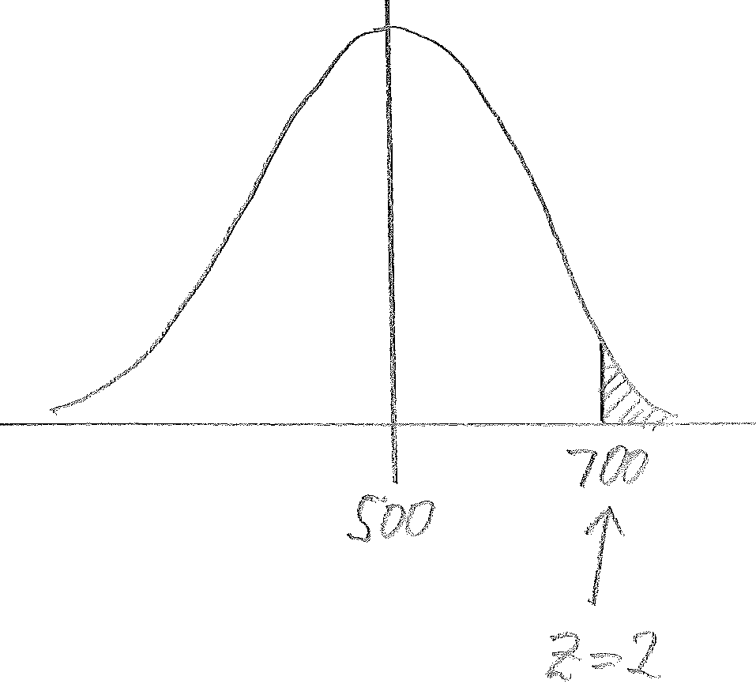
$$P\left(>700\right)= 1-0.9772 \\ = 0.0228$$

  - between $440$ and$560$.
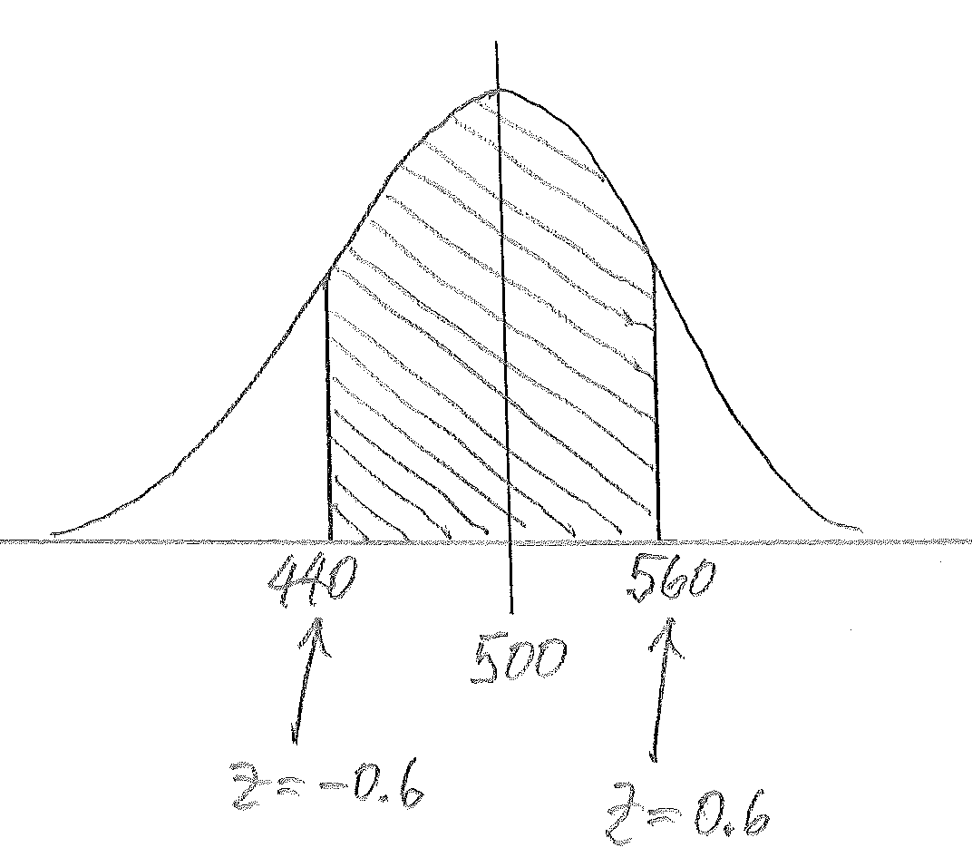
$$P\left(\text{between} 440 \text{and} 560\right)= 0.7257-0.2743 \\ = 0.4514$$

- In 2012 the mean SAT math score was $514$and the standard deviation was $117$. For the purposes of this question, assume that the scores were normally distributed. Using a graphing calculator, and without using $z$ scores, find the probability (rounded to the nearest thousandth), and explain how the answer was determined that a randomly selected SAT math student in 2012 scored
  - between $400$ and $480.$
$$P\left(\text{between} 400 \text{and} 480\right)=0.221$$
I used a TI-84 graphing calculator: Normalcdf$(400, 480, 514, 117)$.

  - less than $350$.
$$P\left(<350\right)=0.081$$
I used a TI-84 graphing calculator: Normalcdf$(0, 350, 514, 117)$.

Problem Set Sample Solutions

- Use a table of standard normal curve areas to find
  - the area to the left of $z=1.88.$
$$0.9699$$

  - the area to the right of$z=1.42.$
$$1-0.9222 = 0.0778$$

  - the area to the left of $z=-0.39.$
$$0.3483$$

  - the area to the right of $z=-0.46.$
$$1-0.3228=0.6772$$

  - the area between $z=-1.22$ and $z=-0.5.$
$$0.3085-0.1112=0.1973$$

- Suppose that the durations of high school baseball games are approximately normally distributed with mean $105$ minutes and standard deviation $11$ minutes. Use a table of standard normal curve areas to find the probability that a randomly selected high school baseball game lasts
  - less than $115$ minutes.
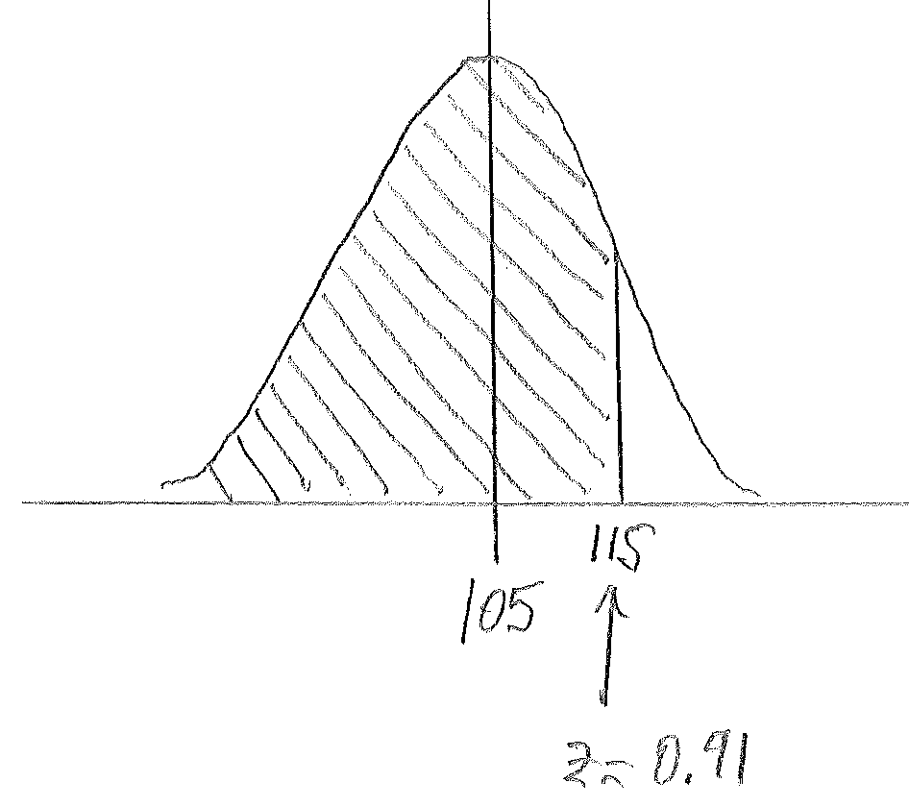
$$P\left(<115\right)=0.8186$$

  - more than $100$minutes.
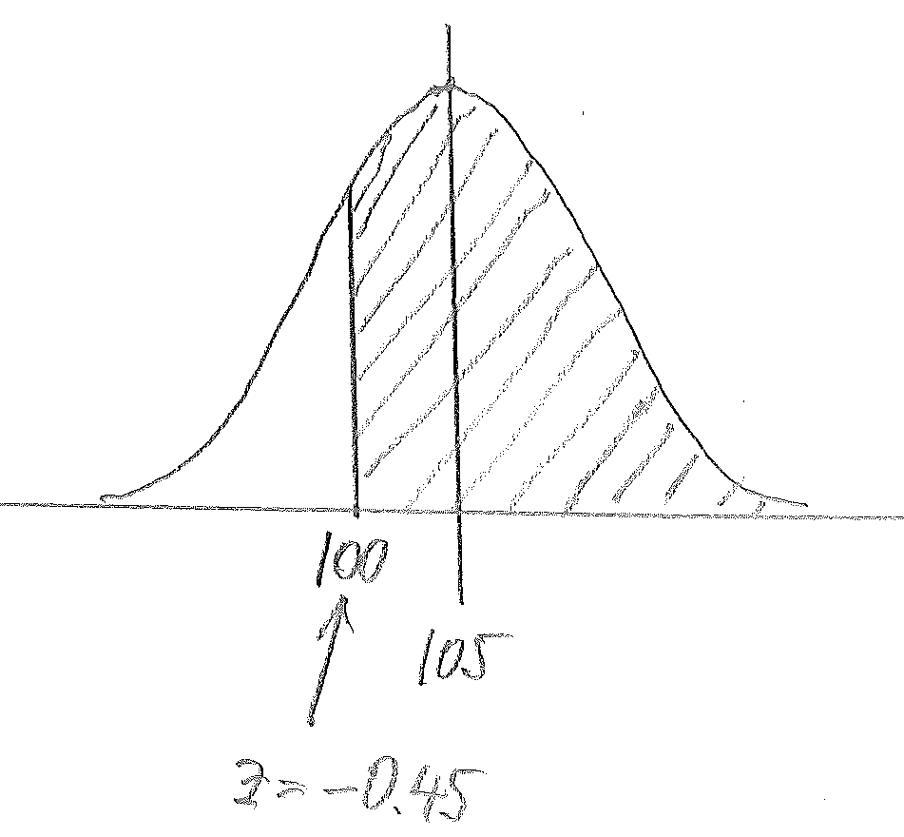
$$P\left(>100\right)= 1-0.3264 \\ = 0.6736$$

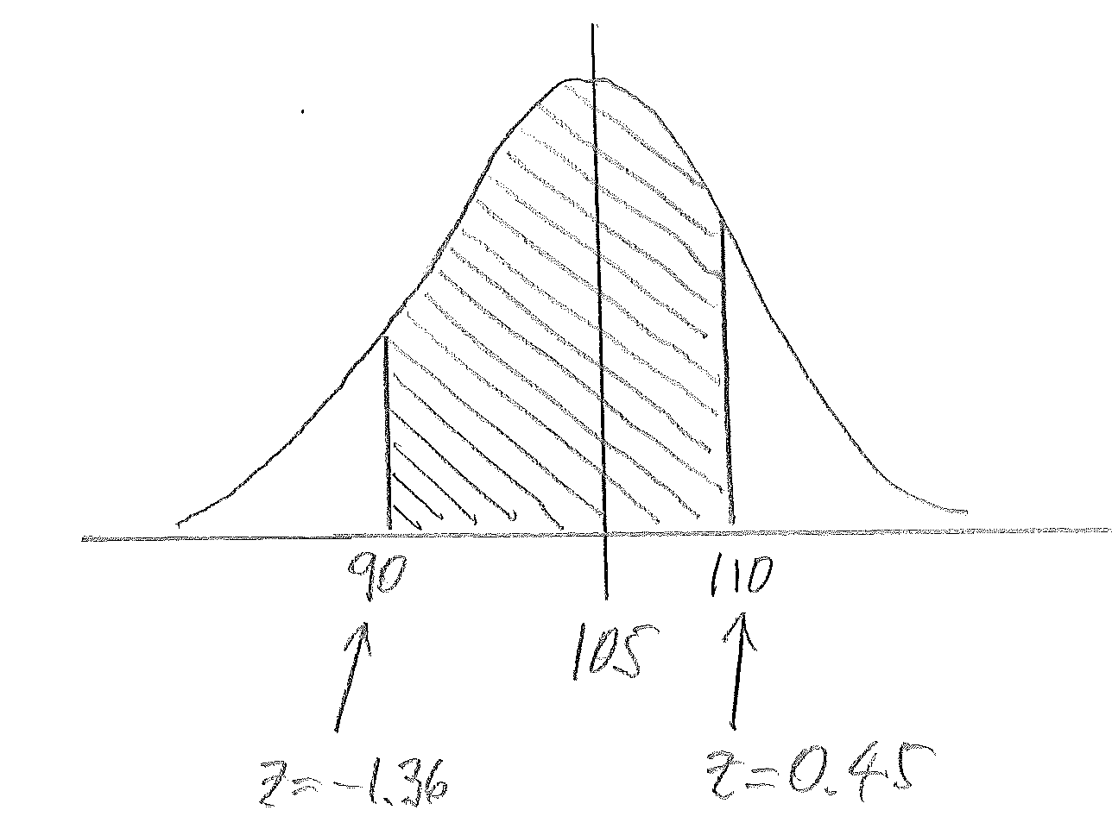
  - between $90$ and $110$ minutes.

$$P\left(\text{between} 90 \text{and} 110\right)= 0.6736-0.0869 \\ = 0.5867$$

- Using a graphing calculator, and without using $z$values, check your answers to Problem 2. (Round your answers to the nearest thousandth.)
  - $P\left(<115\right)=0.818$

  - $P\left(>100\right)=0.675$

  - $P\left(\text{between} 90 \text{and} 110\right)=0.589$

- In Problem 2, you were told that the durations of high school baseball games are approximately normally distributed with mean $105$minutes and standard deviation $11$ minutes. Suppose also that the durations of high school softball games are approximately normally distributed with a mean of $95$ minutes and the same standard deviation, $11$ minutes. Is it more likely that a high school baseball game will last between $100$ and $110$ minutes or that a high school softball game will last between $100$ and $110$ minutes? Answer this question without doing any calculations!
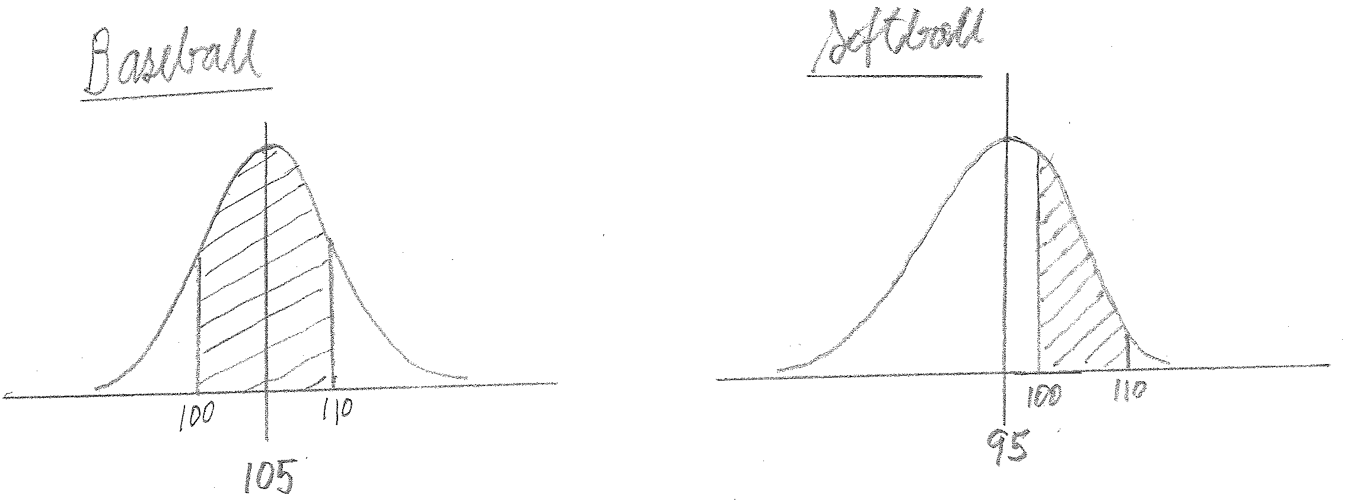
The heights of the two normal distribution graphs are the same; the only difference between the graphs is that the softball graph has a smaller mean. So when the region under the graph between $100$ and $110$ is shaded, you get a larger area for the baseball graph than for the softball graph. Therefore, it is more likely that the baseball game will last between $100$ and $110$ minutes.

- A farmer has $625$ female adult sheep. The sheep have recently been weighed, and the results are shown in the table below.
Weight (pounds) | $140$to $<150$ | $150$ to $<160$ | $160$ to $<170$ | $170$ to $<180$ | $180$to $<190$ | $190$ to $<200$ | $200$to $<210$
Frequency | $$8$$ | $$36$$ | $$173$$ | $$221$$ | $$149$$ | $$33$$ | $$5$$

  - Construct a histogram that displays these results.
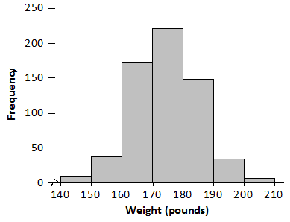

  - Looking at the histogram, do you think a normal distribution would be an appropriate model for this distribution?
Yes. The histogram is approximately symmetric and mound shaped.

  - The weights of the $625$sheep have mean $174.21$ pounds and standard deviation $10.11$ pounds. For a normal distribution with this mean and standard deviation, what is the probability that a randomly selected sheep has a weight of at least $190$ pounds? (Round your answer to the nearest thousandth.)
Using Normalcdf$(190,999,174.21,10.11)$, you get $P\left(≥190\right)=0.059$.

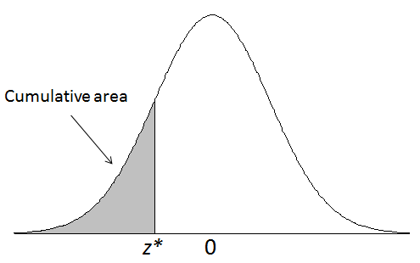

Standard Normal Curve Areas
z | 0.00 | 0.01 | 0.02 | 0.03 | 0.04 | 0.05 | 0.06 | 0.07 | 0.08 | 0.09
–3.8 | 0.0001 | 0.0001 | 0.0001 | 0.0001 | 0.0001 | 0.0001 | 0.0001 | 0.0001 | 0.0001 | 0.0001
–3.7 | 0.0001 | 0.0001 | 0.0001 | 0.0001 | 0.0001 | 0.0001 | 0.0001 | 0.0001 | 0.0001 | 0.0001
–3.6 | 0.0002 | 0.0002 | 0.0001 | 0.0001 | 0.0001 | 0.0001 | 0.0001 | 0.0001 | 0.0001 | 0.0001
–3.5 | 0.0002 | 0.0002 | 0.0002 | 0.0002 | 0.0002 | 0.0002 | 0.0002 | 0.0002 | 0.0002 | 0.0002
–3.4 | 0.0003 | 0.0003 | 0.0003 | 0.0003 | 0.0003 | 0.0003 | 0.0003 | 0.0003 | 0.0003 | 0.0002
–3.3 | 0.0005 | 0.0005 | 0.0005 | 0.0004 | 0.0004 | 0.0004 | 0.0004 | 0.0004 | 0.0004 | 0.0003
–3.2 | 0.0007 | 0.0007 | 0.0006 | 0.0006 | 0.0006 | 0.0006 | 0.0006 | 0.0005 | 0.0005 | 0.0005
–3.1 | 0.0010 | 0.0009 | 0.0009 | 0.0009 | 0.0008 | 0.0008 | 0.0008 | 0.0008 | 0.0007 | 0.0007
–3.0 | 0.0013 | 0.0013 | 0.0013 | 0.0012 | 0.0012 | 0.0011 | 0.0011 | 0.0011 | 0.0010 | 0.0010
–2.9 | 0.0019 | 0.0018 | 0.0018 | 0.0017 | 0.0016 | 0.0016 | 0.0015 | 0.0015 | 0.0014 | 0.0014
–2.8 | 0.0026 | 0.0025 | 0.0024 | 0.0023 | 0.0023 | 0.0022 | 0.0021 | 0.0021 | 0.0020 | 0.0019
–2.7 | 0.0035 | 0.0034 | 0.0033 | 0.0032 | 0.0031 | 0.0030 | 0.0029 | 0.0028 | 0.0027 | 0.0026
–2.6 | 0.0047 | 0.0045 | 0.0044 | 0.0043 | 0.0041 | 0.0040 | 0.0039 | 0.0038 | 0.0037 | 0.0036
–2.5 | 0.0062 | 0.0060 | 0.0059 | 0.0057 | 0.0055 | 0.0054 | 0.0052 | 0.0051 | 0.0049 | 0.0048
–2.4 | 0.0082 | 0.0080 | 0.0078 | 0.0075 | 0.0073 | 0.0071 | 0.0069 | 0.0068 | 0.0066 | 0.0064
–2.3 | 0.0107 | 0.0104 | 0.0102 | 0.0099 | 0.0096 | 0.0094 | 0.0091 | 0.0089 | 0.0087 | 0.0084
–2.2 | 0.0139 | 0.0136 | 0.0132 | 0.0129 | 0.0125 | 0.0122 | 0.0119 | 0.0116 | 0.0113 | 0.0110
–2.1 | 0.0179 | 0.0174 | 0.0160 | 0.0166 | 0.0162 | 0.0158 | 0.0154 | 0.0150 | 0.0146 | 0.0143
–2.0 | 0.0228 | 0.0222 | 0.0217 | 0.0212 | 0.0207 | 0.0202 | 0.0197 | 0.0192 | 0.0188 | 0.0183
–1.9 | 0.0287 | 0.0281 | 0.0274 | 0.0268 | 0.0262 | 0.0256 | 0.0250 | 0.0244 | 0.0239 | 0.0233
–1.8 | 0.0359 | 0.0351 | 0.0344 | 0.0336 | 0.0329 | 0.0322 | 0.0314 | 0.0307 | 0.0301 | 0.0294
–1.7 | 0.0446 | 0.0436 | 0.0427 | 0.0418 | 0.0409 | 0.0401 | 0.0392 | 0.0384 | 0.0375 | 0.0367
–1.6 | 0.0548 | 0.0537 | 0.0526 | 0.0516 | 0.0505 | 0.0495 | 0.0485 | 0.0475 | 0.0465 | 0.0455
–1.5 | 0.0668 | 0.0655 | 0.0643 | 0.0630 | 0.0618 | 0.0606 | 0.0594 | 0.0582 | 0.0571 | 0.0599
–1.4 | 0.0808 | 0.0793 | 0.0778 | 0.0764 | 0.0749 | 0.0735 | 0.0721 | 0.0708 | 0.0694 | 0.0681
–1.3 | 0.0968 | 0.0951 | 0.0934 | 0.0918 | 0.0901 | 0.0885 | 0.0869 | 0.0853 | 0.0838 | 0.0823
–1.2 | 0.1151 | 0.1131 | 0.1112 | 0.1093 | 0.1075 | 0.1056 | 0.1038 | 0.1020 | 0.1003 | 0.0985
–1.1 | 0.1357 | 0.1335 | 0.1314 | 0.1292 | 0.1271 | 0.1251 | 0.1230 | 0.1210 | 0.1190 | 0.1170
–1.0 | 0.1587 | 0.1562 | 0.1539 | 0.1515 | 0.1492 | 0.1469 | 0.1446 | 0.1423 | 0.1401 | 0.1379
–0.9 | 0.1841 | 0.1814 | 0.1788 | 0.1762 | 0.1736 | 0.1711 | 0.1685 | 0.1660 | 0.1635 | 0.1611
–0.8 | 0.2119 | 0.2090 | 0.2061 | 0.2033 | 0.2005 | 0.1977 | 0.1949 | 0.1922 | 0.1894 | 0.1867
–0.7 | 0.2420 | 0.2389 | 0.2358 | 0.2327 | 0.2296 | 0.2266 | 0.2236 | 0.2206 | 0.2177 | 0.2148
–0.6 | 0.2743 | 0.2709 | 0.2676 | 0.2643 | 0.2611 | 0.2578 | 0.2546 | 0.2514 | 0.2483 | 0.2451
–0.5 | 0.3085 | 0.3050 | 0.3015 | 0.2981 | 0.2946 | 0.2912 | 0.2877 | 0.2843 | 0.2810 | 0.2776
–0.4 | 0.3446 | 0.3409 | 0.3372 | 0.3336 | 0.3300 | 0.3264 | 0.3228 | 0.3192 | 0.3156 | 0.3121
–0.3 | 0.3821 | 0.3783 | 0.3745 | 0.3707 | 0.3669 | 0.3632 | 0.3594 | 0.3557 | 0.3520 | 0.3483
–0.2 | 0.4207 | 0.4168 | 0.4129 | 0.4090 | 0.4052 | 0.4013 | 0.3974 | 0.3936 | 0.3897 | 0.3859
–0.1 | 0.4602 | 0.4562 | 0.4522 | 0.4483 | 0.4443 | 0.4404 | 0.4364 | 0.4325 | 0.4286 | 0.4247
–0.0 | 0.5000 | 0.4960 | 0.4920 | 0.4880 | 0.4840 | 0.4801 | 0.4761 | 0.4721 | 0.4681 | 0.4641

z | 0.00 | 0.01 | 0.02 | 0.03 | 0.04 | 0.05 | 0.06 | 0.07 | 0.08 | 0.09
0.0 | 0.5000 | 0.5040 | 0.5080 | 0.5120 | 0.5160 | 0.5199 | 0.5239 | 0.5279 | 0.5319 | 0.5359
0.1 | 0.5398 | 0.5438 | 0.5478 | 0.5517 | 0.5557 | 0.5596 | 0.5636 | 0.5675 | 0.5714 | 0.5753
0.2 | 0.5793 | 0.5832 | 0.5871 | 0.5910 | 0.5948 | 0.5987 | 0.6026 | 0.6064 | 0.6103 | 0.6141
0.3 | 0.6179 | 0.6217 | 0.6255 | 0.6293 | 0.6331 | 0.6368 | 0.6406 | 0.6443 | 0.6480 | 0.6517
0.4 | 0.6554 | 0.6591 | 0.6628 | 0.6664 | 0.6700 | 0.6736 | 0.6772 | 0.6808 | 0.6844 | 0.6879
0.5 | 0.6915 | 0.6950 | 0.6985 | 0.7019 | 0.7054 | 0.7088 | 0.7123 | 0.7157 | 0.7190 | 0.7224
0.6 | 0.7257 | 0.7291 | 0.7324 | 0.7357 | 0.7389 | 0.7422 | 0.7454 | 0.7486 | 0.7517 | 0.7549
0.7 | 0.7580 | 0.7611 | 0.7642 | 0.7673 | 0.7704 | 0.7734 | 0.7764 | 0.7794 | 0.7823 | 0.7852
0.8 | 0.7881 | 0.7910 | 0.7939 | 0.7967 | 0.7995 | 0.8023 | 0.8051 | 0.8078 | 0.8106 | 0.8133
0.9 | 0.8159 | 0.8186 | 0.8212 | 0.8238 | 0.8264 | 0.8289 | 0.8315 | 0.8340 | 0.8365 | 0.8389
1.0 | 0.8413 | 0.8438 | 0.8461 | 0.8485 | 0.8508 | 0.8531 | 0.8554 | 0.8577 | 0.8599 | 0.8621
1.1 | 0.8643 | 0.8665 | 0.8686 | 0.8708 | 0.8729 | 0.8749 | 0.8770 | 0.8790 | 0.8810 | 0.8830
1.2 | 0.8849 | 0.8869 | 0.8888 | 0.8907 | 0.8925 | 0.8944 | 0.8962 | 0.8980 | 0.8997 | 0.9015
1.3 | 0.9032 | 0.9049 | 0.9066 | 0.9082 | 0.9099 | 0.9115 | 0.9131 | 0.9147 | 0.9162 | 0.9177
1.4 | 0.9192 | 0.9207 | 0.9222 | 0.9236 | 0.9251 | 0.9265 | 0.9279 | 0.9292 | 0.9306 | 0.9319
1.5 | 0.9332 | 0.9345 | 0.9357 | 0.9370 | 0.9382 | 0.9394 | 0.9406 | 0.9418 | 0.9429 | 0.9441
1.6 | 0.9452 | 0.9463 | 0.9474 | 0.9484 | 0.9495 | 0.9505 | 0.9515 | 0.9525 | 0.9535 | 0.9545
1.7 | 0.9554 | 0.9564 | 0.9573 | 0.9582 | 0.9591 | 0.9599 | 0.9608 | 0.9616 | 0.9625 | 0.9633
1.8 | 0.9641 | 0.9649 | 0.9656 | 0.9664 | 0.9671 | 0.9678 | 0.9686 | 0.9693 | 0.9699 | 0.9706
1.9 | 0.9713 | 0.9719 | 0.9726 | 0.9732 | 0.9738 | 0.9744 | 0.9750 | 0.9756 | 0.9761 | 0.9767
2.0 | 0.9772 | 0.9778 | 0.9783 | 0.9788 | 0.9793 | 0.9798 | 0.9803 | 0.9808 | 0.9812 | 0.9817
2.1 | 0.9821 | 0.9826 | 0.9830 | 0.9834 | 0.9838 | 0.9842 | 0.9846 | 0.9850 | 0.9854 | 0.9857
2.2 | 0.9861 | 0.9864 | 0.9868 | 0.9871 | 0.9875 | 0.9878 | 0.9881 | 0.9884 | 0.9887 | 0.9890
2.3 | 0.9893 | 0.9896 | 0.9898 | 0.9901 | 0.9904 | 0.9906 | 0.9909 | 0.9911 | 0.9913 | 0.9916
2.4 | 0.9918 | 0.9920 | 0.9922 | 0.9925 | 0.9927 | 0.9929 | 0.9931 | 0.9932 | 0.9934 | 0.9936
2.5 | 0.9938 | 0.9940 | 0.9941 | 0.9943 | 0.9945 | 0.9946 | 0.9948 | 0.9949 | 0.9951 | 0.9952
2.6 | 0.9953 | 0.9955 | 0.9956 | 0.9957 | 0.9959 | 0.9960 | 0.9961 | 0.9962 | 0.9963 | 0.9964
2.7 | 0.9965 | 0.9966 | 0.9967 | 0.9968 | 0.9969 | 0.9970 | 0.9971 | 0.9972 | 0.9973 | 0.9974
2.8 | 0.9974 | 0.9975 | 0.9976 | 0.9977 | 0.9977 | 0.9978 | 0.9979 | 0.9979 | 0.9980 | 0.9981
2.9 | 0.9981 | 0.9982 | 0.9982 | 0.9983 | 0.9984 | 0.9984 | 0.9985 | 0.9985 | 0.9986 | 0.9986
3.0 | 0.9987 | 0.9987 | 0.9987 | 0.9988 | 0.9988 | 0.9989 | 0.9989 | 0.9989 | 0.9990 | 0.9990
3.1 | 0.9990 | 0.9991 | 0.9991 | 0.9991 | 0.9992 | 0.9992 | 0.9992 | 0.9992 | 0.9993 | 0.9993
3.2 | 0.9993 | 0.9993 | 0.9994 | 0.9994 | 0.9994 | 0.9994 | 0.9994 | 0.9995 | 0.9995 | 0.9995
3.3 | 0.9995 | 0.9995 | 0.9995 | 0.9996 | 0.9996 | 0.9996 | 0.9996 | 0.9996 | 0.9996 | 0.9997
3.4 | 0.9997 | 0.9997 | 0.9997 | 0.9997 | 0.9997 | 0.9997 | 0.9997 | 0.9997 | 0.9997 | 0.9998
3.5 | 0.9998 | 0.9998 | 0.9998 | 0.9998 | 0.9998 | 0.9998 | 0.9998 | 0.9998 | 0.9998 | 0.9998
3.6 | 0.9998 | 0.9998 | 0.9999 | 0.9999 | 0.9999 | 0.9999 | 0.9999 | 0.9999 | 0.9999 | 0.9999
3.7 | 0.9999 | 0.9999 | 0.9999 | 0.9999 | 0.9999 | 0.9999 | 0.9999 | 0.9999 | 0.9999 | 0.9999
3.8 | 0.9999 | 0.9999 | 0.9999 | 0.9999 | 0.9999 | 0.9999 | 0.9999 | 0.9999 | 0.9999 | 0.9999

