Lesson 6: Interpreting the Standard Deviation

Student Outcomes
- Students calculate the standard deviation of a sample with the aid of a calculator.
- Students compare the relative variability of distributions using standard deviations.

Lesson Notes
Students use a calculator to compute the mean and the standard deviation of a data set and compare the variability of data sets where the differences in variability are less obvious than in previous lessons. Additionally, students continue to refine their knowledge of standard deviation and how it measures a typical deviation from the mean.

Classwork
Example 1 (10 minutes)
Use a calculator to find the mean and standard deviation.
Example 1
Your teacher will show you how to use a calculator to find the mean and standard deviation for the following set of data.
A set of eight men have heights (in inches) as shown below.
$$67.0 70.9 67.6 69.8 69.7 70.9 68.7 67.2$$

Indicate the mean and standard deviation you obtained from your calculator to the nearest hundredth.
Mean: $68.98$ inches
Standard Deviation: $1.59$ inches
Show students the steps to calculate the mean and the standard deviation of a data set using a calculator or statistical software. The following instructions outline the steps of the statistical features for the TI-83 or TI-84 calculators (one of several calculators used by high school students):
- From the home screen, press STAT, ENTER to access the stat editor.
- If there are already numbers in L1, clear the data from L1 by moving the cursor to “L1” and pressing CLEAR, ENTER.
- Move the cursor to the first element of L1, type the first data value, and press ENTER. Continue entering the remaining data values to L1 in the same way.
- Press 2ND, QUIT to return to the home screen.
- Press STAT, select CALC, select 1-Var Stats, and press ENTER.
- The screen should now show summary statistics for your data set. The mean is the $\overline{x}$ value, and the standard deviation for a sample is the $s_{x}$ value.
Note: Instructions may vary based on the type of calculator or software used. The instructions above are based on using data stored in L1. If data is stored in another list, it will need to be referred to after selecting 1-Var Stats in step 5. For example, if data was entered in L2:
5. Press STAT, select CALC, select 1-Var Stats, and then refer to L2. This is done by pressing 2ND, L2 (i.e., “2ND” and then the “2” key). The screen will display 1-Var Stats L2. Then, press ENTER.

Exercise 1 (5 minutes)
Students should practice finding the mean and standard deviation on their own.
Exercise 1
- The heights (in inches) of nine women are as shown below.
$$68.4 70.9 67.4 67.7 67.1 69.2 66.0 70.3 67.6$$

Use the statistical features of your calculator or computer software to find the mean and the standard deviation of these heights to the nearest hundredth.
Mean: $68.29$ inches
Standard Deviation: $1.58$ inches

Exploratory Challenge/Exercises 2–5
Exercise 2 (5 minutes)
Be sure that students understand how the numbers that are entered relate to the dot plot given in the example as they enter the data into a calculator.
Ask students the following question to determine if they understand the dot plot:
- What is the meaning of the single dot at $4$?
  - Only one person answered all four questions.
A common misconception is that a student answered Question 4 of the survey and not that a person answered four questions.
Allow students to attempt the problem independently. Sample responses are listed on the next page. If needed, scaffold with the following:
- The dot plot tells us that one person answered $0$ questions, two people answered $1$ question, four people answered $2$ questions, two people answered $3$ questions, and one person answered $4$ questions.
- We can find the mean and the standard deviation of these results by entering these numbers into a calculator:
$$0 1 1 2 2 2 2 3 3 4$$

Exploratory Challenge/Exercise 2–5
- A group of people attended a talk at a conference. At the end of the talk, ten of the attendees were given a questionnaire that consisted of four questions. The questions were optional, so it was possible that some attendees might answer none of the questions, while others might answer $1$,$2$,$3$, or all$4$ of the questions (so, the possible numbers of questions answered are $0$,$1$,$2$, $3$, and $4$).
Suppose that the numbers of questions answered by each of the ten people were as shown in the dot plot below.
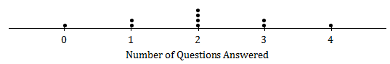

Use the statistical features of your calculator to find the mean and the standard deviation of the data set.
Mean: $2$questions
Standard Deviation: $1.15$questions

Exercise 3 (5 minutes)
Students should practice finding the standard deviation on their own. The data is uniformly distributed in this problem, and its standard deviation will be compared to Exercise 2.

- Suppose the dot plot looked like this:
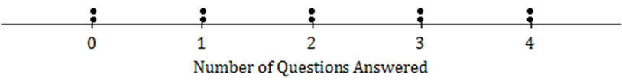

  - Use your calculator to find the mean and the standard deviation of this distribution.
Mean: $2$ questions
Standard Deviation: $1.49$ questions

  - Remember that the size of the standard deviation is related to the size of the deviations from the mean. Explain why the standard deviation of this distribution is greater than the standard deviation in Exercise 2.
The points in Exercise 3 are generally farther from the mean than the points in Exercise 2, so the standard deviation is larger. Notice there is greater clustering of the points around the central value and less variability in Exercise 2.

Optionally, draw the following on the board, and compare the diagrams to re-enforce the idea.
Mound Shaped:  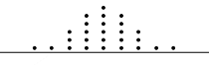 | Uniform:  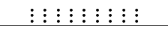

Exercise 4 (5 minutes)
MP.1

Students work on this question individually and then compare notes with a neighbor. Students construct the plot and evaluate (without calculating) the mean and standard deviation of the data set where there is no variability.

- Suppose that all ten people questioned answered all four questions on the questionnaire.
  - What would the dot plot look like?

  - What is the mean number of questions answered? (You should be able to answer without doing any calculations!)
Mean: $4$ questions

  - What is the standard deviation? (Again, don’t do any calculations!)
The standard deviation is $0$ because all deviations from the mean are $0$. There is no variation in the data.

Exercise 5 (7 minutes)
Again, it would be a good idea for students to think about this themselves and then to discuss the problem with a neighbor.
MP.2

- Continue to think about the situation previously described where the numbers of questions answered by each of ten people was recorded.
  - Draw the dot plot of the distribution of possible data values that has the largest possible standard deviation. (There were ten people at the talk, so there should be ten dots in your dot plot.) Use the scale given below.
Place the data points as far from the mean as possible.
  - Explain why the distribution you have drawn has a larger standard deviation than the distribution in Exercise 4.
The standard deviation of this distribution is larger than that of the one in Exercise 4 because the deviations from the mean here are all greater than or equal to the deviations from the mean in Exercise 4.

Note for Exercise 5(a): The answer to this question is not necessarily obvious, but one way to think of it is that by moving one of the dots from $0$ to $4$, we are clustering more of the points together; the points at zero are isolated from those at $4$, but by moving one dot from $0$ to $4$, there are now fewer dots suffering this degree of isolation than there were previously.

Closing (3 minutes)

Lesson Summary
- The mean and the standard deviation of a data set can be found directly using the statistical features of a calculator.
- The size of the standard deviation is related to the sizes of the deviations from the mean. Therefore, the standard deviation is minimized when all the numbers in the data set are the same and is maximized when the deviations from the mean are made as large as possible.

Exit Ticket (5 minutes)

Name ___________________________________________________ Date____________________
Lesson 6: Interpreting the Standard Deviation

Exit Ticket

- Use the statistical features of your calculator to find the mean and the standard deviation to the nearest tenth of a data set of the miles per gallon from a sample of five cars.
$$24.9 24.7 24.7 23.4 27.9$$

- Suppose that a teacher plans to give four students a quiz. The minimum possible score on the quiz is $0$, and the maximum possible score is $10$.
  - What is the smallest possible standard deviation of the students’ scores? Give an example of a possible set of four student scores that would have this standard deviation.

  - What is the set of four student scores that would make the standard deviation as large as it could possibly be? Use your calculator to find this largest possible standard deviation.

Exit Ticket Sample Solutions

- Use the statistical features of your calculator to find mean and the standard deviation to the nearest tenth of a data set of the miles per gallon from a sample of five cars.
$$24.9 24.7 24.7 23.4 27.9$$
Mean: $25.1$ miles per gallon, to the nearest tenth
Standard Deviation: $1.7$ miles per gallon, to the nearest tenth

- Suppose that a teacher plans to give four students a quiz. The minimum possible score on the quiz is $0$, and the maximum possible score is $10$.
  - What is the smallest possible standard deviation of the students’ scores? Give an example of a possible set of four student scores that would have this standard deviation.
The minimum possible standard deviation is $0$. This will come about if all the students receive the same score (e.g., if every student scores an $8$ on the quiz).

  - What is the set of four student scores that would make the standard deviation as large as it could possibly be? Use your calculator to find this largest possible standard deviation.
$0$,$0$,$10$,$10$
Standard Deviation: $5.77$, to the nearest hundredth

Problem Set Sample Solutions
Students must have access to a graphing calculator to complete the Problem Set.

- At a track meet, there are three men’s $100$ m races. The times for eight of the sprinters are recorded to the nearest $\frac{1}{10}$ of a second. The results of the three races for these eight sprinters are shown in the dot plots below.

Race 1
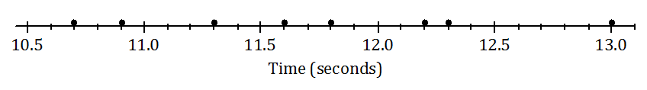

Race 2
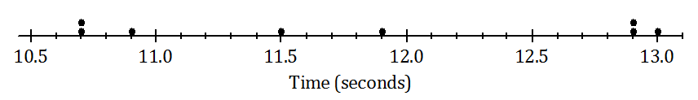

Race 3
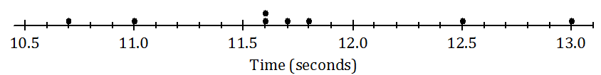

  - Remember that the size of the standard deviation is related to the sizes of the deviations from the mean. Without doing any calculations, indicate which of the three races has the smallest standard deviation of times. Justify your answer.
Race 3 has the smallest standard deviation because several race times are clustered around the mean.

  - Which race had the largest standard deviation of times? (Again, don’t do any calculations!) Justify your answer.
Race 2 has the largest standard deviation because the race times are spread out from the mean.

  - Roughly what would be the standard deviation in Race 1? (Remember that the standard deviation is a typical deviation from the mean. So, here you are looking for a typical deviation from the mean, in seconds, for Race 1.)
Around $0.5$–$1.0$ second would be a sensible answer.

  - Use your calculator to find the mean and the standard deviation for each of the three races. Write your answers in the table below to the nearest thousandth.
 | Mean | Standard Deviation
Race 1 | $$11.725$$ | $$0.767$$
Race 2 | $$11.813$$ | $$1.013$$
Race 3 | $$11.738$$ | $$0.741$$

  - How close were your answers (a)–(c) to the actual values?
Answers will vary based on students’ responses.

- A large city, which we will call City A, holds a marathon. Suppose that the ages of the participants in the marathon that took place in City A were summarized in the histogram below.
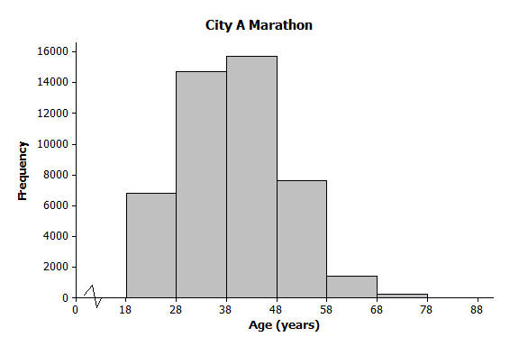

  - Make an estimate of the mean age of the participants in the City A marathon.
Around $40$ years would be a sensible estimate.

  - Make an estimate of the standard deviation of the ages of the participants in the City A marathon.
Between $8$ and $15$ years would be a sensible estimate.
A smaller city, City B, also held a marathon. However, City B restricts the number of people of each age category who can take part to $100$. The ages of the participants for one race are summarized in the histogram below. The ages of the participants are summarized in the histogram below.
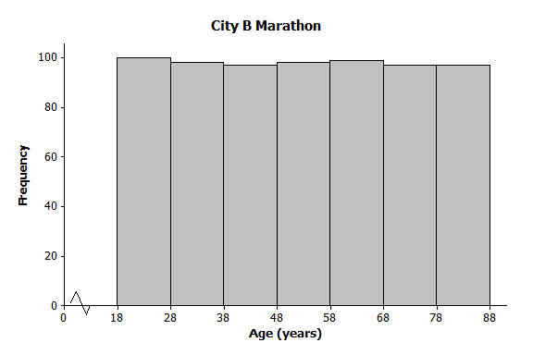

  - Approximately what was the mean age of the participants in the City B marathon? Approximately what was the standard deviation of the ages?
Mean is around $53$ years; standard deviation is between $15$ and $25$ years.

  - Explain why the standard deviation of the ages in the City B marathon is greater than the standard deviation of the ages for the City A marathon.
In City A, there is greater clustering around the mean age than in City B. In City B, the deviations from the mean are generally greater than in City A, so the standard deviation for City B is greater than the standard deviation for City A.

