Lesson 8: Comparing Distributions

Classwork
Exploratory Challenge 1: Country Data
A science museum has a “Traveling Around the World” exhibit. Using 3D technology, participants can make a virtual tour of cities and towns around the world. Students at Waldo High School registered with the museum to participate in a virtual tour of Kenya, visiting the capital city of Nairobi and several small towns. Before they take the tour, however, their mathematics class decided to study Kenya using demographic data from 2010 provided by the United States Census Bureau. They also obtained data for the United States from 2010 to compare to data for Kenya.
The following histograms represent the age distributions of the two countries.
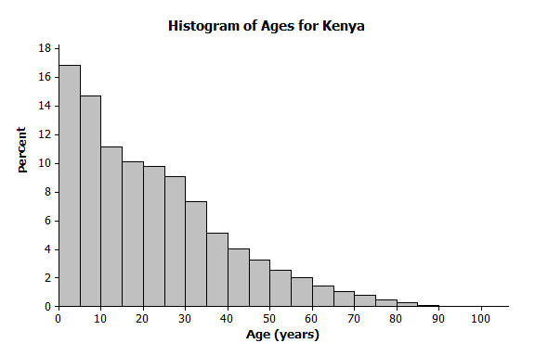 | 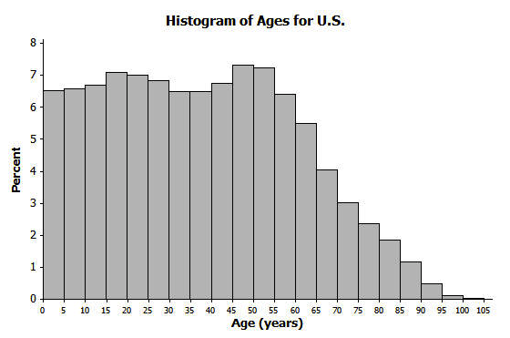

Exercises 1–8
- How do the shapes of the two histograms differ?

- Approximately what percent of people in Kenya are between the ages of $0$ and $10$ years?

- Approximately what percent of people in the United States are between the ages of $0$ and $10$ years?

- Approximately what percent of people in Kenya are $60$ years or older?

- Approximately what percent of people in the United States are $60$ years or older?

- The population of Kenya in 2010 was approximately $41$ million people. What is the approximate number of people in Kenya between the ages of $0$ and $10$ years?

- The population of the United States in 2010 was approximately $309$ million people. What is the approximate number of people in the United States between the ages of $0$ and $10$ years?

- The Waldo High School students started planning for their virtual visit of the neighborhoods in Nairobi and several towns in Kenya. Do you think they will see many teenagers? Will they see many senior citizens who are $70$ or older? Explain your answer based on the histogram.

Exploratory Challenge 2: Learning More about the Countries using Box Plots and Histograms
A random sample of $200$ people from Kenya in 2010 was discussed in previous lessons. A random sample of $200$ people from the United States is also available for study. Box plots constructed using the ages of the people in these two samples are shown below.
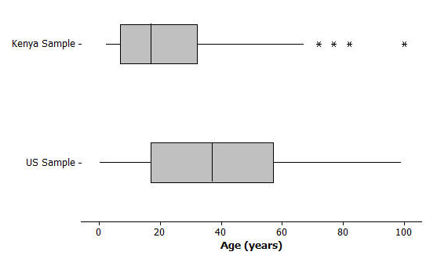
Exercises 9–16
- Adrian, a senior at Waldo High School, stated that the box plots indicate that the United States has a lot of older people compared to Kenya. Would you agree? How would you describe the difference in the ages of people in these two countries based on the above box plots?

- Estimate the median age of a person in Kenya and the median age of a person in the United States using the box plots.

- Using the box plot, $25\%$ of the people in the United States are younger than what age? How did you determine that age?

- Using the box plots, approximately what percent of people in Kenya are younger than $18$ years old?

- Could you have estimated the mean age of a person from Kenya using the box plot? Explain your answer.

- The mean age of people the United States is approximately 38 years. Using the histogram, estimate the percentage of people in the United States who are younger than the mean age in the United States.

- If the median age is used to describe a “typical” person in Kenya, what percent of people in Kenya are younger than the median age? Is the mean or median age a better description of a “typical” person in Kenya? Explain your answer.

- What is the IQR of the ages in the sample from the United States? What is the IQR of the ages in the sample from Kenya? If the IQRs are used to compare countries, what does a smaller IQR indicate about a country? Use Kenya and the United States to explain your answer.

Lesson Summary
- Histograms show the general shape of a distribution.
- Box plots are created from the $5$-number summary of a data set.
- A box plot identifies the median, minimum, and maximum values, and the upper and lower quartiles.
- The interquartile range (IQR) describes how the data is spread around the median; it is the length of the interval that contains $50\%$ of the data values.
- The median is used as a measure of the center when a distribution is skewed or contains outliers.

Problem Set

The following box plot summarizes ages for a random sample from a made up country named Math Country.
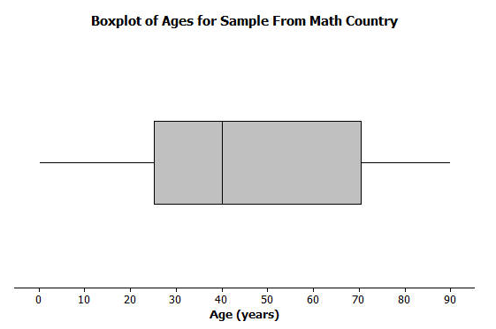

- Make up your own sample of forty ages that could be represented by the box plot for Math Country. Use a dot plot to represent the ages of the forty people in Math Country.
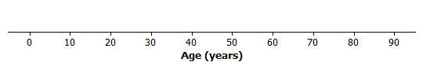

- Is the sample of forty ages represented in your dot plot of Math Country the only sample that could be represented by the box plot? Explain your answer.

- The following is a dot plot of sixty ages from a random sample of people from Japan in 2010.
Draw a box plot over this dot plot.

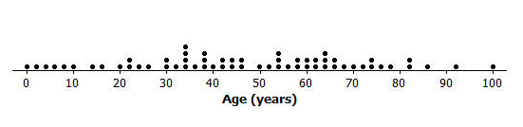

- Based on your box plot, would the median age of people in Japan be closer to the median age of people in Kenya or the United States? Justify your answer.

- What does the box plot of this sample from Japan indicate about the possible differences in the age distributions of people from Japan and Kenya?

