Lesson 8: Comparing Distributions

Student Outcomes
- Students compare two or more distributions in terms of center, variability, and shape.
- Students interpret a measure of center as a typical value.
- Students interpret the IQR as a description of the variability of the data.
- Students answer questions that address differences and similarities for two or more distributions.

Classwork
Exploratory Challenge 1 (5 minutes): Country Data
Discuss the two histograms of ages for Kenya and the United States.
Exploratory Challenge 1: Country Data
A science museum has a “Traveling Around the World” exhibit. Using 3D technology, participants can make a virtual tour of cities and towns around the world. Students at Waldo High School registered with the museum to participate in a virtual tour of Kenya, visiting the capital city of Nairobi and several small towns. Before they take the tour, however, their mathematics class decided to study Kenya using demographic data from 2010 provided by the United States Census Bureau. They also obtained data for the United States from 2010 to compare to data for Kenya.
The following histograms represent the age distributions of the two countries.
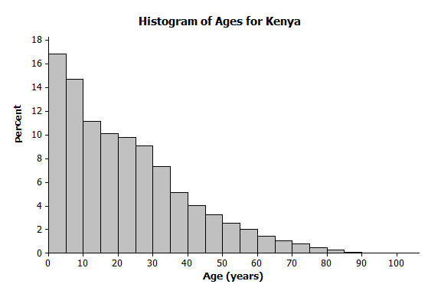 | 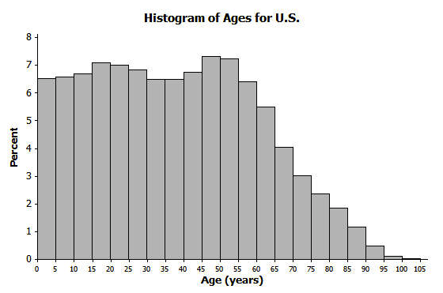

Review with students what each interval of ages represents. For example, the first interval represents people whose ages are $0≤x<5$. Pose the following questions:
- What percent of people in Kenya are younger than $5$?
  - About $17\%$
- What ages are represented by the intervals along the horizontal axis?
  - If $x$ represents age, then the first interval would be $0≤x<5$, the second interval would be
$5≤x<10$, etc.
- What does the first bar ($0≤x<5$) mean in the U.S. histogram?
  - The percent of people in the U.S. who are younger than $5$

Exercises 1–8 (13 minutes)
Allow students to work independently or in small groups on Exercises 1–8. Then, discuss and confirm answers as a class.
Exercises 1–8
- How do the shapes of the two histograms differ?
The bars in the Kenya histogram slowly decline; the distribution is skewed with a tail to the right. The bars in the U.S. histogram are even for a while, then show a more rapid decline.

- Approximately what percent of people in Kenya are between the ages of $0$ and $10$ years?
Approximately $32\%$ ($17\%$ are ages $0$ to $5$ years, and $15\%$ are ages $5$ to $10$ years.)

- Approximately what percent of people in the United States are between the ages of $0$ and $10$ years?
Approximately $13\%$

- Approximately what percent of people in Kenya are $60$ years or older?
Approximately $5\%$

- Approximately what percent of people in the United States are $60$ years or older?
Approximately $20\%$

- The population of Kenya in 2010 was approximately $41$ million people. What is the approximate number of people in Kenya between the ages of $0$ and $10$ years?
$32\%$ of $41$ million people is approximately $13,120,000$ people.

- The population of the United States in 2010 was approximately $309$ million people. What is the approximate number of people in the United States between the ages of $0$ and $10$ years?
$13\%$ of $309$ million people is approximately $40,170,000$ people.

- The Waldo High School students started planning for their virtual visit of the neighborhoods in Nairobi and several towns in Kenya. Do you think they will see many teenagers? Will they see many senior citizens who are $70$ or older? Explain your answer based on the histogram.
Adding a portion of the percent of people in the $10$ to $14$ years old group and the percent of people $15$ to $19$ years old approximates the estimate of the percent of teenagers. About $15\%$ represents teenagers. Students are likely to see teenagers as this is relatively large percent of the population. According to the histogram, approximately $3\%$ of the population in Kenya is $70$ or older. As a result, students are unlikely to see many senior citizens $70$ or older.

Exploratory Challenge 2 (5 minutes): Learning More about the Countries using Box Plots and Histograms
Verbally introduce the box plots of Kenya ages and United States ages.
Exploratory Challenge 2: Learning More about the Countries using Box Plots and Histograms
A random sample of $200$ people from Kenya in 2010 was discussed in previous lessons. A random sample of $200$ people from the United States is also available for study. Box plots constructed using the ages of the people in these two samples are shown below.
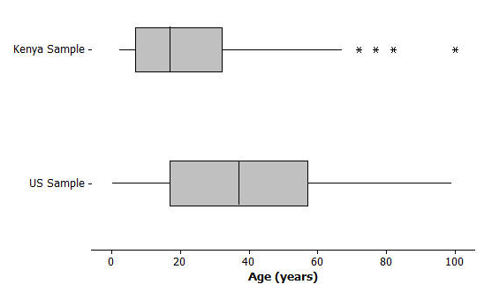
Then discuss:
- What information is displayed in a box plot?
MP.3
  - Median, minimum, and maximum values, quartiles, and IQR are displayed.
- What does the (*) represent on the box plot for Kenya?
  - It represents extreme values or outliers.
- Can we find this same information in the histograms from Example 1?
  - No. Median, Q1, Q2, and minimum and maximum are not clear from a histogram. It could only be used to estimate these values.
- Remind students that the histogram represents the entire population of Kenya, whereas the box plot only represents a sample of $200$ people.

Exercises 9–16 (15 minutes)
Allow students to work independently or in small groups on Exercises 9–16. Then, discuss and confirm answers as a class.
Exercises 9–16
- Adrian, a senior at Waldo High School, stated that the box plots indicate that the United States has a lot of older people compared to Kenya. Would you agree? How would you describe the difference in the ages of people in these two countries based on the above box plots?
Yes, the population of the United States has a much greater percent of people in the older age intervals.
- Estimate the median age of a person in Kenya and the median age of a person in the United States using the box plots.
The median Kenyan age is slightly less than $20$ years, while the median U.S. age is slightly less than $40$ years.

- Using the box plot, $25\%$ of the people in the United States are younger than what age? How did you determine that age?
$25\%$ are younger than approximately $18$ years. I used the value of Q1, or the first quartile.

- Using the box plots, approximately what percent of people in Kenya are younger than $18$ years old?
Approximately $50\%$ of the people in Kenya are less than $18$ years old.

- Could you have estimated the mean age of a person from Kenya using the box plot? Explain your answer.
No, the box plot does not provide an estimate of the mean age.

- The mean age of people in the United States is approximately $38$ years. Using the histogram, estimate the percent of people in the United States who are younger than the mean age in the United States.
Approximately $50\%$ of the U.S. population is less than $38$ years old.

- If the median age is used to describe a “typical” person in Kenya, what percent of people in Kenya are younger than the median age? Is the mean or median age a better description of a “typical” person in Kenya? Explain your answer.
$50\%$ of the people in Kenya are less than the median age. The median is a better indicator of a typical age because the distribution is skewed.

- What is the IQR of the ages in the sample from the United States? What is the IQR of the ages in the sample from Kenya? If the IQRs are used to compare countries, what does a smaller IQR indicate about a country? Use Kenya and the United States to explain your answer.
The IQR for the United States is $58-18=40$ years; the IQR for Kenya is $36-7=31$ years. A smaller IQR indicates that more of the sample is around the median age, which you can see from looking at the histogram.

Closing (2 minutes)

Lesson Summary
- Histograms show the general shape of a distribution.
- Box plots are created from the $5$-number summary of a data set.
- A box plot identifies the median, minimum, and maximum values, and the upper and lower quartiles.
- The interquartile range (IQR) describes how the data is spread around the median; it is the length of the interval that contains $50\%$ of the data values.
- The median is used as a measure of the center when a distribution is skewed or contains outliers.

Exit Ticket (5 minutes)
Name ___________________________________________________ Date____________________
Lesson 8: Comparing Distributions

Exit Ticket

- Using the histograms of the population distributions of the United States and Kenya in 2010, approximately what percent of the people in the United States were between $15$ and $50$ years old? Approximately what percent of the people in Kenya were between $15$ and $50$ years old?

- What $5$-year interval of ages represented in the 2010 histogram of the United States age distribution has the most people?

- Why is the mean age greater than the median age for people in Kenya?

Exit Ticket Sample Solutions

- Using the histograms of the population distributions of the United States and Kenya in 2010, approximately what percent of the people in the United States were between $15$ and $50$ years old? Approximately what percent of the people in Kenya were between $15$ and $50$ years old?
Approximately $47\%$ of people in the United States were between $15$ and $50$ years old. Approximately $48\%$ of people in Kenya were between $15$ and $50$ years old.

- What $5$-year interval of ages represented in the 2010 histogram of the United States age distribution has the most people?
The $5$-year interval of ages with the most people is the people $45$ to $50$ years old.

- Why is the mean age greater than the median age for people in Kenya?
The mean age is a balance point. The distribution is skewed to the right, and the value of the mean is affected by the older ages in the upper tail of the Kenya population histogram. The mean is greater than the median in this case.

Problem Set Sample Solutions

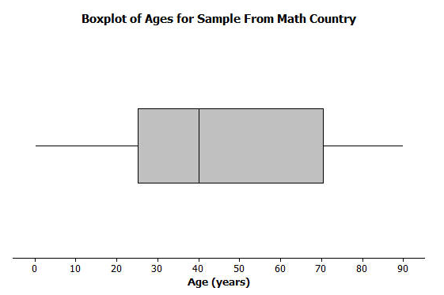
The following box plot summarizes ages for a random sample from a made up country named Math Country.

- Make up your own sample of forty ages that could be represented by the box plot for Math Country. Use a dot plot to represent the ages of the forty people in Math Country.
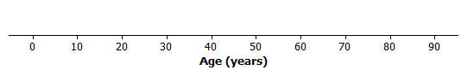
Many possible dot plots would be correct. Analyze individually. Ten of the ages need to be between $0$ and $25$ years old, ten of the ages need to be between $25$ and $40$ years old, ten of the ages need to be between $40$ and $70$ years old, and ten of the ages need to between $70$ and $90$ years old.

- Is the sample of forty ages represented in your dot plot of Math Country the only sample that could be represented by the box plot? Explain your answer.
There are many possible dot plots that might be represented by this box plot. Any data set with the same $5$-number summary would result in this same box plot.

- The following is a dot plot of sixty ages from a random sample of people from Japan in 2010.
Draw a box plot over this dot plot.
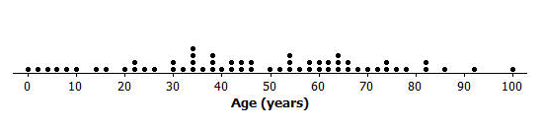
The following is the box plot of the ages of the sample of people from Japan:
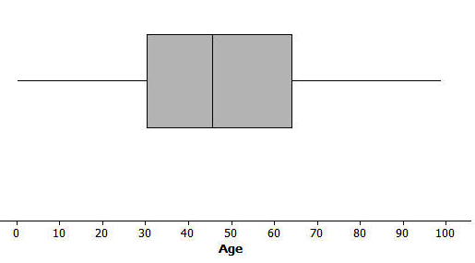

- Based on your box plot, would the median age of people in Japan be closer to the median age of people in Kenya or the United States? Justify your answer.
The median age of Japan would be closer to the median age of the United States than to the median age of Kenya. The box plot indicates that the median age of Japan is approximately $45$ years old. This median age is even greater than the median age of the United States.

- What does the box plot of this sample from Japan indicate about the possible differences in the age distributions of people from Japan and Kenya?
A much greater percent of the people in Japan are in the older age groups than is the case for Kenya.

