Name: ________________________________ Date: ________________________
Integers Applications
- Hunter used a number line to add. He started counting at 10, and then he counted until he was on the number -4 on the number line.
  - If Hunter is modeling addition, what number did he add to 10? Use the number line below to model your answer.

  - Write a real-world story problem that would fit this situation.

  - Use absolute value to express the distance between 10 and -4.

- Every month, Ms. Thomas pays her car loan through automatic payments (withdrawals) from her savings account. She pays the same amount on her car loan each month. At the end of the year, her savings account balance changed by −$2,931 from payments made on her car loan.
  - What is the change in Ms. Thomas’ savings account balance each month due to her car payment?

  - Describe the total change to Ms. Thomas’ savings account balance after making six monthly payments on her car loan. Model your answer using a number sentence.

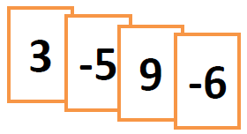
- Leah and Maya are playing an integer card game in which the sum of the cards in their hand represents their total score. The cards in Leah’s hand are shown to the right:
Leah’s Hand
3, -5, 9, -6

  - What is the total score of Leah’s Hand? Support your answer by showing your work.

  - Leah picks ups two more cards, but they do not affect her overall point total. State the value of each of the two cards and tell why they do not affect her overall point total.

  - Complete Leah’s new hand to make this total score equal zero. What must be the value of the “?” card? Explain how you arrived at your answer.

- The table below shows the temperature changes Monday morning in Bedford, New York over a 4-hour period after a cold front came through.
  - If the beginning temperature was −13°F at 5:00 a.m., what was the temperature at 9:00 a.m.?
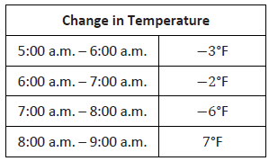
  - The same cold front hit Hartford, Connecticut the next morning. The temperature dropped by 7°F each hour from 5:00 a.m. – 9:00 a.m. What was the beginning temperature at 5:00 a.m. if the temperature at 9:00 a.m. was −10°F?

  - In answering part (b), Josiah and Kate used different methods. Josiah said his method involved multiplication, while Kate said she did not use multiplication. Both students arrived at the correct answer. How is this possible? Explain.

