Name: ________________________________ Date: ________________________
Integers – Real World Applications Part II
Classwork

Example 1: A Look at Sea Level
The picture below shows three different people participating in activities at three different elevations. With a partner, discuss what you see. What do you think the word elevation means in this situation?

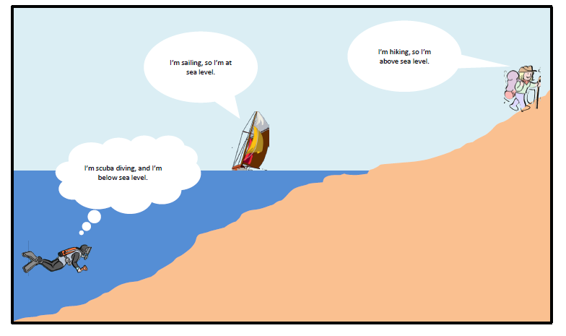

Exercises
Refer back to Example 1. Use the following information to answer Exercises 1 and 2.
- The diver is 30 feet below sea level.
- The sailor is at sea level.
- The hiker is 2 miles (10,560 feet) above sea level.

1. Write an integer to represent each situation.

2. Use an appropriate scale to graph each of the following situations on the number line to the right. Also, write an integer to represent both situations.

a. A hiker is 15 feet above sea level.

b. A diver is 20 feet below sea level.

3. For each statement there are two related statements: i and ii. Determine which related statement is expressed correctly (i and ii), and circle it. Then correct the other related statement so that both parts, i and ii, are stated correctly.

a. A submarine is submerged 800 feet below sea level.

i. The depth of the submarine is −800 feet below sea level.

ii. 800 feet below sea level can be represented by the integer −800.

b. The elevation of a coral reef with respect to sea level is given as −250 feet.

i. The coral reef is 250 feet below sea level.

ii. The depth of the coral reef is −250 feet below sea level.

Problem Set
1. Write an integer to match the following descriptions:
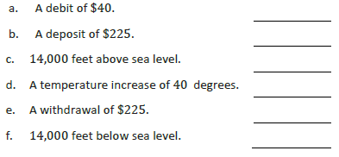

For questions 2–4, read each statement about a real-world situation and the two related statements in parts (a) and (b) carefully. Circle the correct way to describe each real-world situation; possible answers include either (a), (b), or both (a) and (b).

2. A whale is 600 feet below the surface of the ocean water.
a. The depth of the whale is 600 feet from the water’s surface.
b. The whale is −600 feet below the surface of the ocean water.

3. The elevation of an iceberg with respect to sea level is given as −125 feet.
a. The iceberg is 125 above sea level.
b. The iceberg is 125 feet below sea level.

4. Alex’s body temperature decreased by 2℉.
a. Alex’s body temperature dropped 2℉.
b. The integer −2 represents the change in Alex’s body temperature in degrees Fahrenheit.

5. A credit of $35 and a debit of $40 are applied to your bank account.
a. What is an appropriate scale to graph a credit of $35 and a debit of $40? Explain your reasoning.

b. What integer represents “a credit of $35” if zero represents the original balance? Explain.

c. What integer describes “debit of $40” if zero represents the original balance? Explain.

d. Based on your scale, describe the location of both integers on the number line.

e. What does zero represent in this situation?

Name: ________________________________ Date: ________________________
Integers – Real World Applications Part II
Exit Ticket
1. Write a story problem that includes both integers −110 and 120.

2. What does zero represent in your story problem?

3. Choose an appropriate scale to graph both integers on the vertical number line.
Label the scale.

4. Graph both points on the vertical number line.

Name: ________________________________ Date: ________________________
Integers – Real World Applications Part II
Exploratory Challenge Station Record Sheet

