Name: ________________________________ Date: ________________________
Rational Numbers Applications
- Mariah and Shane both started to work on a math problem and were comparing their work in math class. Are both of their representations correct? Explain, and finish the math problem correctly to arrive at the correct answer.
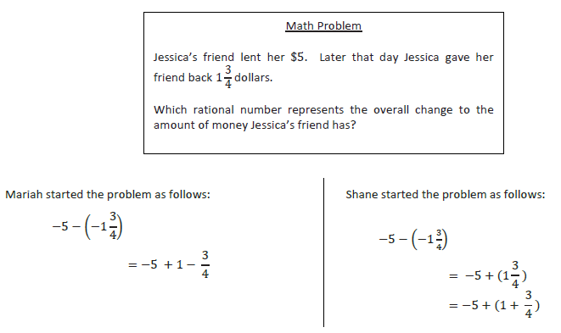
___________________________________________________________________________________________________________________________
___________________________________________________________________________________________________________________________
___________________________________________________________________________________________________________________________
___________________________________________________________________________________________________________________________
___________________________________________________________________________________________________________________________
___________________________________________________________________________________________________________________________

- Evaluate the expression below using the properties of operations.
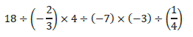

- a. Given the expression below, what will the sign of the product be? Justify your answer.

- Give a value for 𝐴 that would result in a positive value for the expression.

- Give a value for 𝐴 that would result in a negative value for the expression.

