Name: ________________________________ Date: ________________________
Percent Applications – Part I
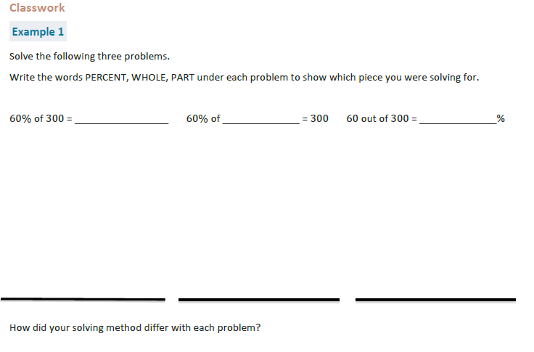

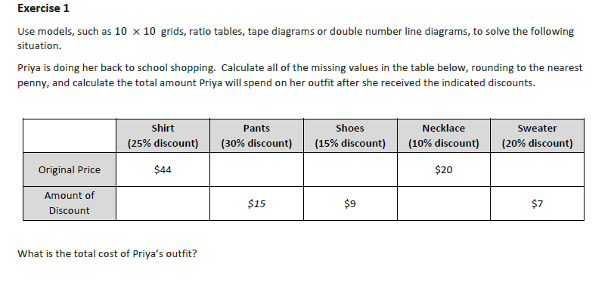

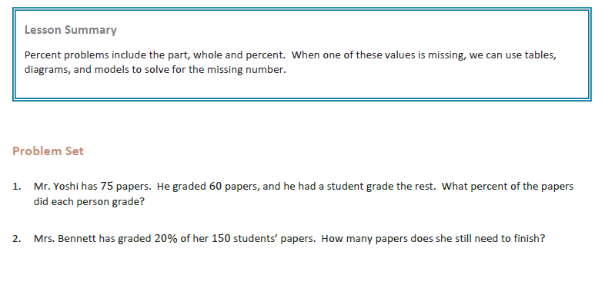

Name: ________________________________ Date: ________________________
Percent Applications – Part I

Exit Ticket

Jane paid $40 for an item after she received a 20% discount. Jane’s friend says this means that the original price of the item was $48.

a. How do you think Jane’s friend arrived at this amount?

b. Is her friend correct? Why or why not?

