Name: ________________________________ Date: ________________________
Percent Applications – Part III
Classwork

Exploratory Challenge 1
Claim: To find 10% of a number all you need to do is move the decimal to the left once.
Use at least one model to solve each problem (e.g., tape diagram, table, double number line diagram, 10×10 grid).
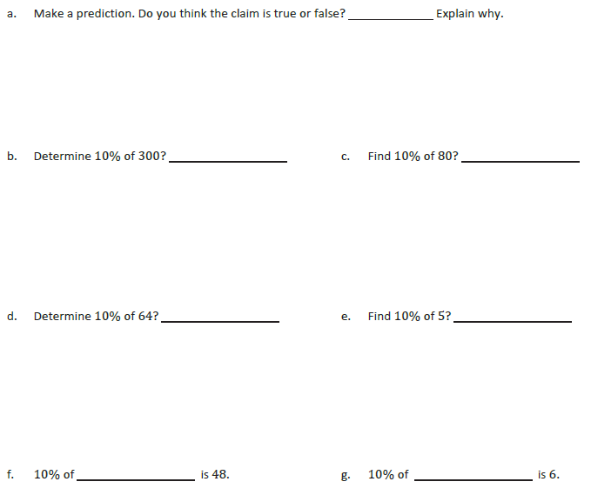

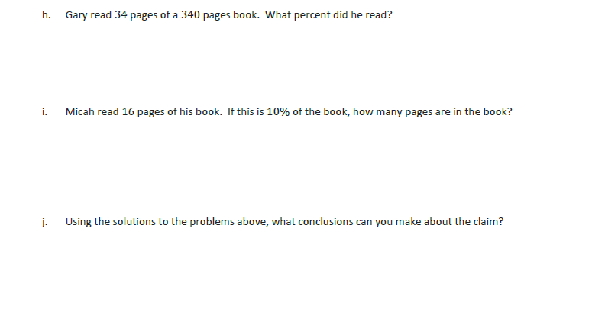
Exploratory Challenge 2
Claim: If an item is already on sale and then there is another discount taken off the new price, this is the same as saving the sum of the two discounts from the original price.
Use at least one model to solve each problem (e.g., tape diagram, table, double number line diagram, 10×10 grid).
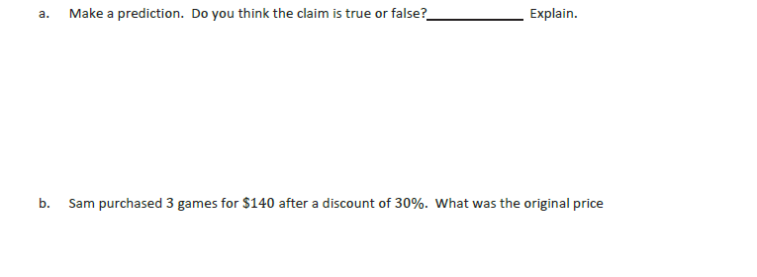

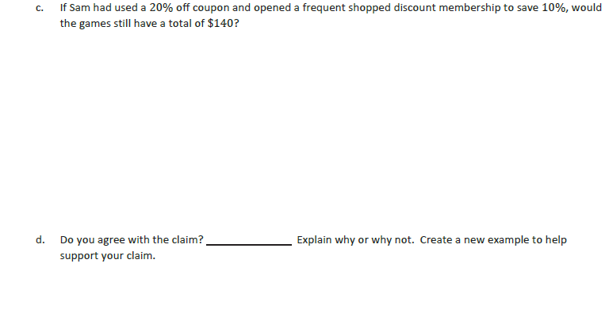

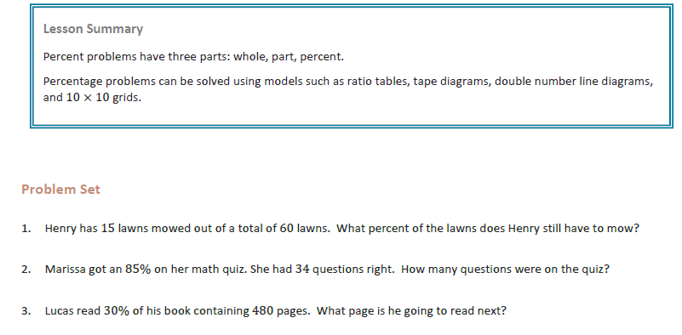

Name: ________________________________ Date: ________________________
Percent Applications – Part III

Exit Ticket

Angelina received two discounts on a $50 pair of shoes. The discounts were taken off one after the other. If she paid $30 for the shoes, what was the percent discount for each coupon? Is there only one answer to this question?

