Name: ________________________________ Date: ________________________
Proportions Applications
- Josiah and Tillery have new jobs at YumYum’s Ice Cream Parlor. Josiah is Tillery’s manager. In their first year, Josiah will be paid $14 per hour and Tillery will be paid $7 per hour. They have been told that after every year with the company, they will each be given a raise of $2 per hour. Is the relationship between Josiah’s pay and Tillery’s pay rate proportional? Explain your reasoning using a table.

- A recent study claimed that in any given month, for every 5 text messages a boy sent or received, a girl sent or received 7 text messages. Is the relationship between number of text messages sent or received by boys proportional to the number of text messages sent or received by girls? Explain your reasoning using a graph on the coordinate plane.

- When a song is sold by an online music store, the store takes some of the money and the singer gets the rest. The graph below shows how much money a pop singer makes given the total amount of money brought in by one popular online music store from sales of the song.
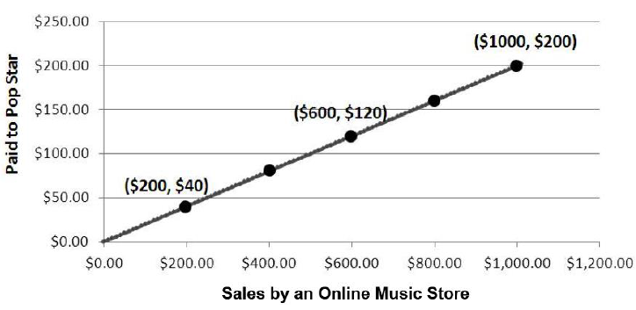

- Identify the constant of proportionality between dollars earned by the pop singer and dollars brought in by sales of the song.

- Write an equation relating dollars earned by the pop singer, y, to dollars brought in by sales of the song, x.

- According to the proportional relationship, how much money did the song bring in from sales in the first week, if the pop star earned $800 that week?

- Describe what the point (0, 0) on the graph represents in terms of the situation being described by the graph.

- Which point on the graph represents the amount of money the pop singer gets for $1 in money brought in from sales of the song by the store?

