Name: ________________________________ Date: ________________________
Tax, Commissions, Fees, and Other Real-World Percent Problems
Classwork

Opening Exercise
How are each of the following percent applications different, and how are they the same? First, describe how percents are used to solve each of the following problems. Then, solve each problem. Finally, compare your solution process for each.
a. Silvio earns 10% for each car sale he makes while working at a used car dealership. If he sells a used car for $2,000, what is his commission?

b. Tu’s family stayed at a hotel for 10 nights on their vacation. The hotel charged a 10% room tax, per night. How much did they pay in room taxes if the room cost $200 per night?

c. Eric bought a new computer and printer online. He had to pay 10% in shipping fees. The items totaled $2,000. How much did the shipping cost?

d. Selena had her wedding rehearsal dinner at a restaurant. The restaurant’s policy is that gratuity is included in the bill for large parties. Her father said the food and service were exceptional, so he wanted to leave an extra 10% tip on the total amount of the bill. If the dinner bill totaled $2,000, how much money did her father leave as the extra tip?

Exercises 1–4
Show all work; a calculator may be used for calculations.

The school board has approved the addition of a new sports team at your school.
- The district ordered 30 team uniforms and received a bill for $2,992.50. The total included a 5% discount.
  - The school needs to place another order for two more uniforms. The company said the discount will not apply because the discount only applies to orders of $1,000 or more. How much will the two uniforms cost?

  - The school district does not have to pay the 8% sales tax on the $2,992.50 purchase. Estimate the amount of sales tax the district saved on the $2,992.50 purchase. Explain how you arrived at your estimate.

  - A student who loses a uniform must pay a fee equal to 75% of the school’s cost of the uniform. For a uniform that cost the school $105, will the student owe more or less than $75 for the lost uniform? Explain how to use mental math to determine the answer.

  - Write an equation to represent the proportional relationship between the school’s cost of a uniform and the amount a student must pay for a lost uniform. Use u to represent the uniform cost and s to represent the amount a student must pay for a lost uniform. What is the constant of proportionality?

- A taxpayer claims the new sports team caused his school taxes to increase by 2%.
  - Write an equation to show the relationship between the school taxes before and after a 2% increase. Use 𝑏 to represent the dollar amount of school tax before the 2% increase and 𝑡 to represent the dollar amount of school tax after the 2% increase.

  - Use your equation to complete the table below, listing at least 5 pairs of values.
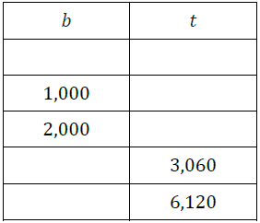
  - On graph paper, graph the relationship modeled by the equation in part (a). Be sure to label the axes and scale.

  - Is the relationship proportional? Explain how you know.

  - What is the constant of proportionality? What does it mean in the context of the situation?

  - If a tax payer’s school taxes rose from $4,000 to $4,020, was there a 2% increase? Justify your answer using your graph, table, or equation.

- The sports booster club sold candles as a fundraiser to support the new team. They earn a commission on their candle sales (which means they receive a certain percentage of the total dollar amount sold). If the club gets to keep 30% of the money from the candle sales, what would the club’s total sales have to be in order to make at least $500?

- Christian’s mom works at the concession stand during sporting events. She told him they buy candy bars for $0.75 each and mark them up 40% to sell at the concession stand. What is the amount of the mark up? How much does the concession stand charge for each candy bar?

Directions: With your group, brainstorm solutions to the problems below. Prepare a poster that shows your solutions and math work. A calculator may be used for calculations.

- For the next school year, the new soccer team will need to come up with $600.
  - Suppose the team earns $500 from the fundraiser at the start of the current school year, and the money is placed for one calendar year in a savings account earning 0.5% simple interest annually. How much money will the team still need to raise to meet next year’s expenses?

  - Jeff is a member of the new sports team. His dad owns a bakery. To help raise money for the team, Jeff’s dad agrees to provide the team with cookies to sell at the concession stand for next year’s opening game. The team must pay back the bakery $0.25 for each cookie it sells. The concession stand usually sells about 60 to 80 baked goods per game. Using your answer from part (a), determine a percent markup for the cookies the team plans to sell at next year’s opening game. Justify your answer.

  - Suppose the team ends up selling 78 cookies at next year’s opening game. Find the percent error in the number of cookies that you estimated would be sold in your solution to part (b).

Problem Set
- A school district’s property tax rate rises from 2.5% to 2.7% to cover a $300,000 budget deficit (shortage of money). What is the value of the property in the school district to the nearest dollar? (Note: Property is assessed at 100% of its value.)

- Jake’s older brother Sam has a choice of two summer jobs. He can either work at an electronics store or at the school’s bus garage. The electronics store would pay him to work 15 hours per week. He would make $8 per hour plus a 2% commission on his electronics sales. Sam could earn $300 per week working 15 hours cleaning buses. Sam wants to take the job that pays him the most. How much in electronics would Sam have to sell for the job at the electronics store to be the better choice for his summer job?

- Sarah lost her science book. Her school charges a lost book fee equal to 75% of the cost of the book. Sarah received a notice stating she owed the school $60 for the lost book.
  - Write an equation to represent the proportional relationship between the school’s cost for the book and the amount a student must pay for a lost book.
  - What is the constant or proportionality? What does it mean in the context of this situation?
  - How much did the school pay for the book?

- In the month of May, a certain middle school has an average daily absentee rate of 8% each school day. The absentee rate is the percent of students who are absent from school each day.
  - Write an equation that shows the proportional relationship between the number of students enrolled in the middle school and the average number of students absent each day. Let 𝑠 represent the number of
  - Use your equation to complete a table. List 𝟓 possible values for 𝒔 and 𝒂.
  - Identify the constant of proportionality, and explain what it means in the context of this situation.
  - Based on the absentee rate, determine the number of students absent on average from school if there are 𝟑𝟓𝟎 students enrolled in the middle school.

- The equation shown in the box below could relate to many different percent problems. Put an “X” next to each problem that could be represented by this equation. For any problem that does not match this equation, explain why it does not.
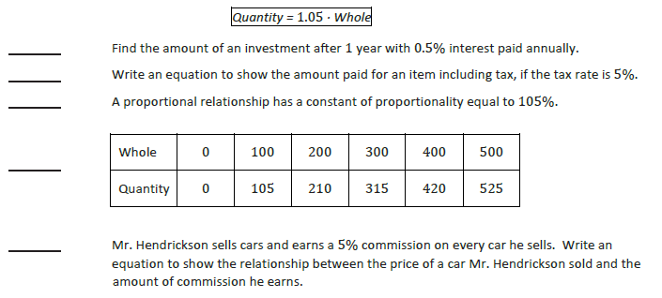
Name: ________________________________ Date: ________________________
Tax, Commissions, Fees, and Other Real-World Percent Problems
Exit Slip

Lee works selling electronics. He earns a 5% commission on each sale he makes.

- Write an equation that shows the proportional relationship between the dollar amount of electronics Lee sells, 𝑑, and the amount of money he makes in commission, 𝑐.

- Express the constant of proportionality as a decimal.

- Explain what the constant of proportionality means in the context of this situation.

- If Lee wants to make $100 in commission, what is the dollar amount of electronics he must sell?

